,, • , - 'J ·
II
(I
t' I ii
,.

LIMITED LIABILITY COMPANY OPERATING AGREEMENT
of

BERNSTEIN FAMILY REALTY, LLC

a Florida limited liability company

t I I " I) )
• I ' '

OPERATING AGREEMENT OF BERNSTEIN FAMILY REALTY, LLC

This Limited Liability Company Agreement (the "Agreement") is made and entered into as of the day of June, 2008, by and among BERNSTEIN FAMILY REALTY, LLC, a Florida limited liability company (the "Company"); STANFORD TRUST COMPANY, Trustee of the DANIEL BERNSTEIN IRREVOCABLE TRUST dated September 7, 2006, STANFORD TRUST COMPANY,
Trustee of the JAKE BERNSTEIN IRREVOCABLE TRUST dated September 7, 2006, and STANFORD TRUST COMPANY, Trustee ofthe JOSHUA Z. BERNSTEIN IRREVOCABLE TRUST
dated September 7, 2006, and any subsequent transferee as the Members ("Members"). The Members are herein sometimes referred to individually as a "Member" and collectively as "Members.

WITNESSETH:

WHEREAS, Articles of Organization for BERNSTEIN FAMILY REALTY, LLC (the "Company") were filed with the Florida Department of State on June 2, 2008.

WHEREAS, the Members desire to reduce their agreements to writing, to set forth the rights and obligations of the Members and the Manager.

NOW, THEREFORE, the Members and the Company hereby agree as follows:

ARTICLE I DEFINITIONS
The following terms used in this Agreement shall have the following meanings:

- "Act"shall mean the Florida Limited Liability Company Act at F.S § 608.401, etseq and all amendments to the Act.

- "Articles of Organization" shall mean the Articles of Organization of BERNSTEIN FAMILY REALTY, LLC, as filed with the Department of State of Florida on June 2, 2008, and as may be amended from time to time.

- "Capital Contribution" shall mean any contribution to the capital of the Company in cash or the fair market value of property by a Member whenever made, riet of any liabilities secured by such contributed property.

- "Capital Account" as of any given date shall mean the Capital Contribution to the Company by a Member as adjusted up to such date pursuant to Article VIII.

- "Code" shall mean the Internal Revenue Code of 1986 or corresponding provisions of subsequent superseding federal revenue laws.

LIMITI!D LIABILITY COMPANY 0Pl!RATINO AGREBMBNT OP
BERNSTEIN FAMILY REALTY, LLC

'• • 1 ' . ' I
- "Company'' shall refer to BERNSTEIN FAMILY REALTY, LLC, a limited liability company formed under the laws of the State of Florida.

- "Distributable Cash" shall mean all cash, revenues and funds received by the Company from Company operations, less the sum of the following to the extent paid or set aside by the Company:
(i) all principal and interest payments on indebtedness of the Company and all other sums paid to lenders; (ii) all cash expenditures incurred in the normal operation of the Company's business; and (iii) such Reserves as the Managers deem reasonably necessary for the proper operation of the Company's business.

- "Entity" shall mean any general partnership, limited liability partnership, limited partnership, limited liability limited partnerships, limited liability company, corporation, joint venture, trust, business trust, cooperative, association, foreign trust or foreign business organization.

(i) "Gifting Member" shall mean any Member who gifts, bequeaths or otherwise transfers for no consideration (by operation oflaw or otherwise, except with respect to bankruptcy) all or any part of its Membership Interest.

(j) "Initial Capital Contribution" shall mean the initial contribution to the capital of the Company pursuant to this Agreement.

- "Interest" shall mean "Percentage Interest" unless otherwise specifically agreed or in the case of special allocations.

  - "Majority Interesf' shall mean the Interests of Members, which in the aggregate exceed
50% of all Interests.

- "Manager" shall mean one or more managers designated as such pursuant to this Agreement or by subsequent vote of the Members. References to the Manager in the singular or as him, her, it, itself, or other like references shall also, where the context so requires, be deemed to include the plural orthe masculine or feminine reference, asthe case may be. Any Person may be named a Manager pursuant to this Agreement

- "Member" shall mean each of the parties who executes a counterpart of this Agreement as a Member and each of the parties who may hereafter become Members. To the extent a Manager has purchased a Membership Interest in the Company, he will have all the rights of a Member with respect to such Membership Interest, and the term "Member" as used herein shall include a Manager to the extent he has purchased such Membership Interest in the Company. If a Person is a Member immediately prior to the purchase or other acquisition by such Person of an Transferee Interest, such Person shall have all the rights of a Member with respect to such purchased or otherwise acquired Membership Interest or Transferee Interest, as the case may be.

- "Membershipinterestu shall mean a Member's entire interest in the Company including such Member's Transferee Interest and, the right to participate in the management of the business and affairs of the Company, including the right to vote on, consent to, or otherwise participate in any decision or action of or by the Members granted pursuant to this Agreement and the Act.

' ' ' . ' ' I ' .
,

- "NetIncome"and "Net Losses" shall mean the income, gain, loss, deductions and credits of the Company in the aggregate or separately stated, as appropriate, determined in accordance with sound accounting principles employed under the cash method of accounting at the close of each fiscal year on the Company's tax return filed for federal income tax purposes.

- "Operating Agreement" (or ''Agreement") shall mean this Operating Agreement of
BERNSTEIN FAMILY REALTY, LLC, as originally executed and as amended from time to time.

- "Percentage Interest' shall mean, for any Member, the percentage interest that the Capital Account of the Member bears to the total Capital Accounts of all of the Members of the Company, as set forth at Section 9.1 herein, and Exhibit A, as may be changed from time to time by the unanimous vote of the Members.

- "Person" shall mean any individual or Entity, and the heirs, executors, administrators, legal representatives, successors, and assigns of such "Person" where the context so permits.

- "Reserves" shall mean funds set aside or amounts allocated to reserves which shall be maintained in amounts reasonably deemed sufficient by the Managers for working capital and to pay taxes, insurance, debt service or other costs or expenses incident to the ownership or operation of the Company's business.

- "SellingMember" shall mean any Member or Transferee which sells, assigns, pledges, hypothecates or otherwise transfers for consideration _all or any portion of its Membership Interest or Transferee Interest.

(v) "Transferee"shall be person who has not been admitted by the Company as a Member Partner, but, by virtue of a Transfer of an Interest in the Company to said person, said person is entitled to a pro rata share of one or more of the Company's items of income, losses, credits, and distributions of the Company's assets pursuant to this Agreement and the Act, but said person shall not have, and is not entitled to any right to participate in the management or affairs of the Company, including, the right to vote on, consent to or otherwise participate in any decision of the Members or Manager.

(w) Member.
"Transferring Member" shall collectively mean a Selling Member and a Gifting

(x) "Treasury Regulations" shall include proposed, temporary and final regulations promulgated under the Code.

ARTICLE II FORMATION OF COMPANY
  - Organization.

BERNSTEIN FAMILY REALTY, LLC, has been organized as a Florida limited liability company by executing and delivering the Articles of Organization to the Florida Department of State in accordance with and pursuant to the Act.

. ' . , ' ' '
' '

  - Name.

The name of the Company is BERNSTEIN FAMILY REALTY, LLC, and all business of the Company shall be conducted under that name unless a majority of the Members agree to the filing and use of a fictitious name.

  - Principal Place of Business.

The initial principal place of business of the Company shall be 950 Peninsula Corporate Circle, Suite 3010, Boca Raton, Florida 33431. The Company may locate its places of business and registered office at any other place or places as the Manager may deem advisable.

  - Registered Office and Registered Agent.

The Company's initial registered office shall be at the office of its registered agent in Florida, and the name ofits initial registered agent shall be Donald R. Tescher, 2101 Corporate Blvd.,Suite 107, Boca Raton, Florida, 33431. The registered office and registered agent may be changed by filing the address of the new registered office and/or the name of the new registered agent with the Florida Department of State pursuant to the Act.

2.5 Term.

The term of the Company has filed Articles of Organization with the Florida Department of State, and shall have perpetual existence, unless the Company is earlier dissolved in accordance with either the pro".'isions of this Agreement or the Act.

ARTICLE III

BUSINESS OF COMPANY

The business of the Company shall be to engage in management of investments, and closely­ held business or real estate ventures, and such lawful activities as are reasonably necessary or useful to the furtherance of the forgoing purpose (the "Business").

ARTICLE IV

NAMES AND ADDRESSES OF MEMBERS

The names and addresses of the Members are listed on Exhibit A attached hereto and incorporated herein, as amended from time to time.

ARTICLE V

RIGHTS AND DUTIES OF MANAGERS

5.1 Management.

. ' . . ' ' I

5.1.1 General. The business and affairs of the Company shall be managed by its Managers. The Managers shall direct, manage, and control the business of the Company. Except for situations in which the approval of the Members is expressly required by this Agreement or by nonwaivable provisions of the Act, the Managers shall have exclusive, sole, full and complete authority, power and discretion to manage and control the business, affairs and properties of the Company, to make all decisions regarding those matters, and to perform any and all other acts or activities customary or incident to the management of the Company's business. At any time when there is more than one Manager, any one Manager may take any action permitted to be taken by the Managers, unless the approval of more than one of the Managers is expressly required pursuant to this Agreement or the Act. The Managers may create a Board of Directors, and may also appoint individuals with or without titles, including the titles of General Manager, Executive Director, President, Vice President, Treasurer, Secretary and Assistant Secretary, to act on behalf of the Company with such power and authority as the Managers or Board of Directors may delegate to any such Person.

5.1.2 InltlalManagers!Deslgnatlon of Managers/Voting. The Members agree that the initial Manager of the Company is SIMON BERNSTEIN. Unless otherwise specifically agreed herein, business deciions of the Company shall be made by said Manager. The Members shall vote their Interests such that only the aforementioned person is Manager of the Company for so long as he is alive and not mentally disabled or incompetent. After proper notice, in the event of death or mental disability or incompetence of the Manager, the Members shall vote on and elect a new Manager.

  - Certain Powers of Managers.

Without limiting the generality of Section 5.01, the Manager (or, ifmore than one Manager, then the Managers) shall have power and authority, on behalf of the Company to do the following:

- To acquire or lease property from any Person as the Managers may determine, whether or not such Person is directly or indirectly affiliated or connected with any Manager or Member;

- To borrow money for the Company from banks, other lending institutions, the Managers, Mem bers, or affiliates of the Managers or Members on such terms as the Managers deem appropriate, and in connection therewith, to hypothecate, encumber and grant security interests in the assets of the Company to secure repayment of the borrowed sums. No debt shall be contracted or liability incurred
by or on behalf of the Company except by the Managers, or to the extent permitted under the Act, by agents or employees of the Company expressly authorized to contract such debt or incur such liability by the Managers;

(c) business;
To purchase liability and other insurance to protect the Company's property and

- To hold and own Company real and personal properties in the name of the Company;

- To invest Company funds in time deposits, shorMerm governmental obligations, commercial paper or other investments;

' ' . . : ' ' I

(f) To sell or otherwise dispose ofall or substantially all of the assets of the Company as part of a single transaction or plan as long as such disposition is not in violation of or a cause of a default under any other agreement to whic the Company may be bound;

- To execute on behalf of the Company all instruments and documents, including, without limitation, checks; drafts; notes and other negotiable instruments; mortgages or deeds of trust; security agreements; financing statements; documents providing for the acquisition, mortgage or disposition of the Company's property; assignments, bills of sale; leases; and any other instruments or documents necessary to the business of the Company;

- To employ accountants, legal counsel, managing agents or other experts to perform services for the Company;

- To enter into any and all other agreements on behalf of the Company, in such forms as the Managers may approve; and

- To do and perform all other acts as may be necessary or appropriate to the conduct of the Company's business.

Unless authorized to do so by this Agreement or by the Managerof the Company, no attorney-in­ fact, employee or other agent of the Company shall have any power or authority to bind the Company in any way, to pledge its credit or to render it liable for any purpose. No Member shall have any power or authority to bind the Company unless the Member has been authorized by the Manager to act as an agent of the Company in accordance with the previous sentence.

  - Liability for Certain Acts.

Each Manager shall perform his duties as Manager in good faith, in a manner he or she reasonably believes to be in the best interests of the Company, and with such care as an ordinarily prudent person in a like position would use under similar circumstances. A Manager shall not be liable to the Company or to any Member for any loss or damage sustained by the Company or any Member, unless the loss or damage shall have been the result of fraud, deceit, gross negligence, willful misconduct, unlawful acts, or a wrongful taking by the Manager.

  - No Exclusive Duty to Company.

A Member or Manager shall not be required to manage the Company as his or her sole and exclusive function and may have other business interests and engage in activities in addition to those relating to the Company. Neither the Company nor any Member shall have any right, by virtue of this Agreement, to share or participate in such other investments or activities of a Manager or to the income or proceeds derived therefrom.

  - Bank Accounts.

The Manager may from time to time open bank accounts in, the name of the Company, and the Manager shall be the sole signatory thereon, unless Members owning a Majority Interest determine otherwise.

. . ., ' . .

5.6 Indemnity of the Managers, Employees and Other Agents.

The Company shall, to the maximum extent permitted under the Act, indemnify and make advances for expenses to Managers, its employees, and other agents.

  - Resignation.

Any Manager of the Company may resign at any time by giving written notice to the Members of the Company. The resignation of any Manager shall take effect upon receipt of notice thereof or at such later date specified in such notice; and, unless otherwise specified therein, the acceptance of such resignation shall not be necessary to make it effective. The resignation of a Manager who is also a Member shall not affect the Manager's rights as a Member and shall not constitute a withdrawal of a Member.

  - Removal.

A Manager shall not be subject to removal by vote of the Members except, if at all, pursuant to the provisions of this Agreement, as it may be amended by agreement of all of the Members.

  - Vacancies.

To the extent not expressly provided for in Section 5.1.2 "Voting Agreement of Members," and only to said extent, if any: Any vacancy occurring for any reason in the number of Managers of the Company may be filled by the affirmative vote of Members holding a majority of the Percentage Interests present at an election at a meeting of Members called for that purpose or by the Members' unanimous written consent. A Manager elected to fill a vacancy shall be elected for the unexpired term of their predecessor in office and shall hold office until the expiration of such term and until their successor shall be elected and qualified or until the Manager's earlier death, resignation or removal. A Manager chosen to fill a position resulting from an increase in the number of Managers shall hold office until his successor shall be elected and qualified, or until his earlier death, resignation or removal.

5.10 Salaries.

Each Manager shall receive annual compensation (the "Management Fee,,) if such compensation is agreed to by a majority of the Percentage Interest of the Members in writing, and and shall be entitled to reimbursement ofreasonable and necessary expenses advanced on behalf of the Company.

ARTICLE VI

RIGHTS AND OBLIGATIONS OF MEMBERS

6.1 Limitation of Liability.

Each Member's liability to the Company shall be limited as set forth in this Agreement, the Act and other applicable law.

"

  - Company Liability. A Member will not be personally liable for any debts, obligations, liabilities or losses of the Company, whether arising in contract, tort, or otherwise, solely by reason of being a Member, beyond his respective Capital Contributions or any obligation of the Member under Sections 8.1 and 8.2 hereunder, except as provided in Section 6.7 or as otherwise required by law.

  - List of Members.

Upon the written request of any Member, the Managers shall provide a list showing all of the names, addresses and Membership Interests and Transferee Interests in the Company.

  - Approval of Sale of Al/ Assets. The Managers shall have the right, to approve the sale, exchange or other disposition of all, or substantially all, of the Company's assets which is to occur as part of a single transaction or plan.

  - Company Books.

The Managers shall maintain and preserve, duringthe term ofthe Company, the accounts, books, and other relevant Company documents described in Section 9.9. Upon reasonable written request, each Member and Transferee shall have the right, at any time during ordinary business hours, as reasonably determined by the Manager, to inspect and copy, at the requesting Member' s or Transferee's expense, the Company documents required to be maintained under Section 608.4101 of the Act, and such other documents which the Managers, in their reasonable discretion, deem appropriate.

  - Priority and Return of Capital.

Except as may be expressly provided in Article IX, no Member or Transferee shall have priority over any other Member or Transferee, either asto the return of Capital Contributions or as to Net Profits, Net Losses or distributions; provided that this Section shall not applyto loans which a Member has made to the Company.

6.7 Liability of a Member to the Company.

A Member who receives a distribution or return in whole or in part of its contribution is liable to the Company only to the extent provided by the Act.

ARTICLE VII

MEETINGS OF MANAGERS AND MEMBERS

7.1 Meetings.

Meetings of the Managers, for any purpose or purposes, may be called by any Manager. Meetings of the Members for any purpose or purposes, may be called by any Members holding at least 51% of the Percentage Interests of the Members.

7.2 Place of Meetings.

" ' . '
. ,

The Managers may designate any location within the U.S., either within or outside the State of Florida, as the place of meeting for any meeting of the Members. If no designation is made, or if a special meeting be otherwise called, the place of meeting shall be the principal place of business of the Company.

7.3 Notice of Meetings.

Except as provided in Section 7.04, written notice stating the place, day and hour of the meeting and the purpose or purposes for which the meeting is called shall be delivered not less than five (5) nor more than thirty (30) days before the date of the meeting, either personally or by mail, by or at the direction of the Managers or Member or Members calling the meeting, to each Member or Manager entitled to vote at such meeting. If mailed, such notice shall be deemed to be delivered two (2) calendar days after being deposited in the United States mail, certified mail return receipt requested, addressed to the Member or to the Manager at its address as it appears on the books of the Company, with postage therein prepaid. Notice may also be given by telegram, teletype or facsimile, or other form of electronic communication. Managers and Members may participate in and hold meetings whereby all conference telephone or similar communications equipment whereby all persons participating in the meeting can hear each other. Participation by communications equipment shall constitute presence as the meeting, unless a Member or Manager is participating in the meeting for the express purpose of objecting to the transaction of any business on the ground the meeting is not lawfully called or convened.

7.4 Meeting of All Members and Meetings of All Managers. Ifall of the Members or all of the Managers shall meet at any time and place, and consent to the holding of a meeting at such time and place, such meeting shall be valid without call or notice, and at such meeting lawful action may be taken.

7.5 Record Date.

For the purpose of determining Members entitled to notice of or to vote at any meeting of Members or any adjournment thereof, or Members entitled to receive payment of any distribution, or in order to make a determination of Members for any other purpose, the date on which notice of the meeting is mailed or the date on which the resolution declared such distribution is adopted, as the case may be, shall be the record date for such determination of Members. When a determination of Members entitled to vote at any meeting of Members has been made as provided in this Section, such determination shall apply to any adjournment thereof.

  - Quorum.

Members holding at least fifty percent (50%) of all Percentage Interests, represented in person or by proxy, shall constitute a quorum at any meeting of Members, and if there is more than one Manager then serving, then a majority of the number of the then-serving Managers shall constitute a quorum at a meeting of the Managers, who shall be represented in person, and shall constitute a quorum at any meeting.

  - Manner of Acting.

' • " ' ' . ' ' '

Ifa quorum is present, the affirmative vote of a majority of all of the Members represented at the meeting, who must hold a majority Percentage Interest in the Company, shall be the act of the Members, unless the vote of a greater or lesser proportion or number is otherwise required by the Act, or by this Agreement. Unless otherwise expressly provided herein or required under applicable law, only Members who have a Membership Interest may vote or consent upon any matter and their vote or consent, as the case may be, shall be counted in the determination of whether the matter was approved by the Members.

  - Proxies.

At all meetings of Members, a Member may vote in person or by proxy executed in writing by the Member or by a duly authorized attorney-in-fact. Such proxy shall be filed with the Managers of the Company before or at the time of the meeting. No proxy shall be valid after eleven (11) months from the date ofits execution, unless otherwise provided in the proxy. Managers shall not be able to vote by Proxies.

  - Action by Members Without a Meeting.

Action required or permitted to be taken at a meeting of Members may be taken without a meeting ifthe action is evidenced by one or more written consents describing the action taken, signed by each Member entitled to vote and delivered to the Managers of the Company for inclusion in the minutes or for filing with the Company records. Action taken under this Section is effective when all Members entitled to vote have signed the consent, unless the consent specifies a different effective date.

  - Waiver of Notice.

When any notice is required to be given to any Member, a waiver thereof in writing signed by the person entitled to such notice, whether before, at, or after the time stated therein, shall be equivalent to the giving of such notice.

ARTICLE VIII

CONTRIBUTIONS TO THE COMPANY AND CAPITAL ACCOUNTS

  - Members' Initial Capital Contributions.

Each Member shall contribute such amount as is set forth on the books and records of the Company. No interest shall accrue on any Capital Contribution and the Member shall not have the right to withdraw or be repaid any Capital Contribution except as provided in this Agreement.

  - Additional Contributions.

A Member may, but shall not be obligated to, make such additional Capital Contributions as shall be determined by the Managers. Such additional Capital Contributions shall be reflected in the Account of the Contributing Member and shall not be a part of any other Member's Capital Account absent written agreement of the Members. After the making of any such determination, the Managers

. . ' . .

shall give written notice to each Member of the amount ofrequired additional contribution, if any, and each Member may deliver to the Company its pro rata share thereof (in proportion to the respective Percentage Interest of the Member on the date such notice is given) no later than thirty (30) days following the date such notice is given. None of the terms, covenants, obligations or rights contained in this Section 8.2 is or shalJ be deemed to be for the benefit of any person or entity other than the Members and the Company, and no such third person shall under any circumstances have any right to compel any actions or payments by the Managers and/or the Members.

  - Capital Accounts.

    - A separate Capital Account wiIJ be maintained for each Member. Each Member's Capital Account will be increased by (1) the amount of money contributed by such Member to the Company; (2) the fair market value of property contributed by such Member to the Company (net of liabilities secured by such contributed property that the Company is considered to assume ortake subject
to under Code Section 752); (3) allocations to such Member of Net Profits and Net Losses; and (4) allocations to such Member ofincome described in Code Section 705(a)(l)(B). Each Member's Capital Account will be decreased by (1) the amount of money distributed to such Member by the Company;
(2) the fair market value of property distributed to such Member by the Company (net of liabilities secured by such distributed property that such Member is considered to assume or take subject to under Code Section 752); (3) allocations to such Member of expenditures described in Code Section 705(a)(2)(B); and (4) allocations to the account of such Member of Company loss and deduction as set forth in such Regulations, taking into account adjustments to reflect book value.

    - In the event of a permitted sale or exchange of a Membership Interest or a Transferee Interest in the Company, the Capital Account of the transferor shall become the Capital Account of the Transferee to the extent it relates to the transferred Membership Interest or Transferee Interest in accordance with Section 1.704-1(b) (2) (iv) of the Treasury Regulations.

    - The manner in which Capital Accounts are to be maintained pursuant to this Section 8.3 is intended to comply with the requirements of Code Section 704(b) and the Treasury Regulations promulgated thereunder. If the Company determines that the manner in which Capital Accounts are to be maintained pursuant to the preceding provisions of this Section 8.3 should be modified in order to comply with Code Section 704(b) and the Treasury Regulations, then notwithstanding anything to the contrary contained in the preceding provisions of this Section 8.3, the method in which Capital Accounts are maintained shall be so modified; provided, however, that any change in the manner of maintaining Capital Accounts shall not materially alter the economic agreement between or among the Members as set forth in this Agreement.

    - Except as otherwise required in the Act (and subject to Sections 8.1 and 8.2), no Member or Transferee shall have any liability to restore all or any portion of a deficit balance in such Member's or Transferee's Capital Account.

  - Withdrawal or Reduction of Members' Contributions to Capital.

    - A Member or Transferee Interest Holder shaH not receive out of the Company's property any part of its Capital Contribution until all liabilities of the Company, except liabilities to

.. .. . ' . . .

Members on account of their Capital Contributions, have been paid or there remains property of the Company sufficient to pay them.

    - A Member or Transferee Interest Holder, irrespective of the nature of its Capital Contribution, has only the right to demand and receive cash in return for its Capital Contribution.

    - Notwithstanding anything to the contrary in this Agreement, a Member may withdraw from the Company only at the time or upon the occurrence of an event specified in this Agreement or in the Articles of Organization. No such event is specified in either the Articles of Organization or in this Agreement at the date hereof. A Member which violates the withdrawal prohibition in this Section shall be liable for breach of this Agreement and shall become a Transferee. A withdrawing Member shall not have a right to receive the fair value of receive the withdrawing member's Interest in the Company as of the date of the resignation but rather, shall have only such rights as a Transferee would have to receive distributions as are made by the Company in the discretion of the Managers.

ARTICLE IX

ALLOCATIONS, INCOME TAX, DISTRIBUTIONS, ELECTIONS AND REPORTS

  - Allocations of Income and Lossesfrom Operations.

The Net Income and Net Losses of the Company for each fiscal year, and each Member or Transferee's share of Cash Flow, will be allocated in accordance with the Percentage Interests schedule set forth in Exhibit A attached hereto, and, except as provided therein, the Percentage Interests of Members shall be proportionate to the amount of their Capital Accounts as determined hereinabove.
  - Special Tax Provisions As to Extraordinary Allocations, if Any, to Capital
Allocations of Net Income and Net Losses other than those set forth above shall be made based upon the determinations of the tax accountants and attorneys employed by the Company, giving regard to the intention expressed hereinabove and otherwise herein, with respect to special or priority allocations if any, and with regard to federal partnership tax and capital accounting principles described in Section
8.3 hereinabove.

  - Distributions.

Within the discretion of the Managers as to amounts, if any, and as to timing, the Managers may distribute Cash Flow to the Members, in accordance with their Percentage Interests .

  - Limitation upon Distributions.

    - No distributions or return of contributions shall be made and paid if, after the distribution or return of distribution is made either

      - the Company would be insolvent; or

      - the net assets of the Company would be less than zero.

    - The Managers may base a determination that a distribution or return of contribution may be made under Section 9.4(a) in good faith reliance upon a balance sheet and profit and loss statement of the Company represented to be correct by the person having charge of its books of account or certified by an independent public or certified public accountant or firm of accountants to fairly reflect the financial condition of the Company.

9.5 TaxAccounting Principles.

The income and losses of the Company shall be determined in accordance with sound tax accounting principles applied on a consistent basis using generally accepted tax accounting principles as applied consistent with the Code.

9.6 Interest on and Return of Capital Contributions.

No Member shall be entitled to interest on its Capital Contribution or to a return of its Capital Contribution, except as otherwise provided in this Agreement.

9.7 Loans to Company.

Nothing in this Agreement shall prevent any Member from making secured or unsecured loans to the Company by agreement with the Company, provided that such loans ar arms-length transactions, containing terms customary in the lending industry at the time such loans were made.

9.8 Accounting Period.

The Company's accounting period shall be the calendar year ("Fiscal Year").

  - Records, Audits and Reports.

At the expense of the Company, the Managers shall maintain records and accounts of the operations and expenditures of the Company. At a minimum, the Company shall keep at its principal place of business the following records:

    - A current list of the full name and last known address of each Member and Transferee setting forth the amount of cash each Member and Transferee has contributed, a description and statement of the agreed value of the other property or services, each Member and Transferee has contributed or has agreed to contribute in the future, and the date on which each became a Member or Transferee, and their respective Percentage Interest in the Company;

    - A copy of the Articles of Organization of the Company and all amendments thereto together with executed copies of any powers of attorney pursuant to which any amendment has be executed;

    - Copies ofthe Company's federal, state, and local income tax returns and reports, if any, for the three most recent years;

" ' . ' . ' '

    - Copies of the Company's currently effective written Agreement, all amendments thereto, and copies of any financial statements of the Company for the three most recent years;

- Notices of and minutes of every Member and Managers meeting,

- Any written consents obtained from Members for actions taken by Members without a meeting; and

- Unless contained in the Articles of Organization or the Agreement, a writing prepared by the Managers setting out the following:

  - The times at which or events on the happening of which any additional contributions agreed to be made by each Member and Transferee are to be made.

  - Any right of a Member or Transferee to receive distributions of include a return on all or any part of the Member or Transferee's contributions.

  - Any power of a Member or Transferee to grant the right to become an assignee of any part of the Member's or Transferee's interest, and the terms and condition of the power.

9.I 0 Returns and Other Elections.

The Managers shall cause the preparation and timely filing of tax returns required to be filed by the Company pursuant to the Code and all other tax returns deemed necessary and required in each jurisdiction in which the Company does business. Copies of such returns, and pertinent information therefrom, shall be furnished to the Members within a reasonable time after the end of the Company's fiscal year upon the Members' written request. All elections permitted to be made by the Company under federal or state laws shall be made by the Managers in their sole discretion. It is the intention of the Members that the Company shall be taxed as a "Partnership" for federal, state, and local income tax purposes.

9.11 Tax Matters Partner.

SIMON BERNSTEIN is designated the "Tax Matters Partner" (as defined in Code Section 6231), and is authorized and required to represent the Company (at the Company's expense), either directly, or through accounting or tax representatives, in connection with all examinations for the Company's affairs by tax authorities, including; without limitation administrative and judicial proceedings, and to expend Company funds forprofessional services and costsassociated therewith. The Members agree to cooperate with each other and to do or refrain from doing any and aJl things reasonably required to conduct such proceedings.

ARTICLE X TRANSFERABILITY
  - General.

"

    - Transferees Not Members, Generally. Except as otherwise set forth in Section 10.1.2, or with the consent of all of the Members, neither a Member nor a Transferee shall have the right, as to all or any part of its Membership Interest or Transferee Interest to:

      - sell, assign, pledge, hypothecate, transfer, exchange orotherwise transfer for consideration (collectively, "sell" or, as context requires "selling"); or

      - gift, bequeath or otherwise transfer for no consideration (whether or not by operation of law, except in the case of bankruptcy) (collectively, "gift").

Absent the written consent of all Members to the contrary or otherwise provided by law, the Interest of the Transferee shall be a Non-Voting Interest.

10.1.2 Transferees Whoare Lineal Descendants of a Member. Any Transferees who are lineal descendants of both SHIRLEY BERNSTEIN and SIMON BERNSTEIN, either directly, or indirectly, as beneficiaries of a Trust, or other entity beneficially owned solely for or by that Member (including, but not limited to a revocable trust established by a Member for the sole lifetime benefit of the Member or the Member's descendants) shall be Members upon their written agreement to be bound by the terms of this Agreement and shall be subject to the voting agreements described in Article V, hereinabove.

  - Right of First Refusal.

- If a Selling Member desires to sell all or any portion ofits Membership Interest in the Company to a third party purchaser, the Selling Member shall obtain from such third party purchaser a bona fide written offer to purchase such Interest, stating the terms and conditions upon which the purchase is to be made and the consideration offered; provided, however, the offer shall include a "tag along" or "take along'' provision, pursuant to which, all Members have the right to se11 apro-rata portion (determined in accordance with the Percentage Interests ofall ofthe Members) oftheir Interests to the third party. The Selling Member or Transferee shall give written notification to the remaining Members, by certified mail or personal delivery, of its intention to so transfer such Interest, furnishing to the remaining Members a copy of the written offer to purchase such Interest.

- Each of the remaining Members, on a basis pro rata to their Percentage Interests or on a basis pro rata to the Percentage Interests of those remaining Members exercising their rights of first refusal, shall have the right to exercise a right of first refusal to purchase all (but not less than all) of the Interest proposed to be purchased by the third party and sold by the Selling Member and the "tag along Members"upon the same terms and conditions as stated in the aforesaid written offer to purchase by giving written notification to the Selling Member and the "tag along Members", by certified mail or personal delivery, of the intention to do so within thirty (30) days after receiving written notice from the Selling Member. Subject to the following paragraph, the failure of the remaining Members to so notify the Selling Member and the "tag along Members" of their desire to exercise this right of first refusal within said thirty (30) day period shall result in the termination of the right of the first refusal and the Selling Member and the "tag along Members" shall be entitled to consummate the sale of its Interest in the Company to such third party purchaser, provided that the sale shall be consummated within sixty
- days following the expiration of the aforesaid thirty (30) day period. In the event the remaining

. '

Members (or any one or more of the remaining Memhers) give written notice to the Selling Member and the "tag along Members'' of their desire to exercise this right of first refusal and to purchase all of the Interests of the Selling Member and the "tag along Membersn offered upon the same terms and conditions as are stated in the aforesaid written offer to purchase, the remaining Members shall have the right to designate the time, date and place of closing, provided that the date of closing shall be within sixty (60) days after written notification to the Selling Member of the remaining Member or Members' election to exercise their right of the first refusal. In the event that two (2) or more Members give written notice oftheir desire to exercise their right of first refusal, absent an agreement between all the Members so exercising such right, each such Member exercising their right of first refusal shall be entitled to purchase that percentage of the selling Member'sshare according to the proportion that their Percentage Interests bears to the total Percentage Interests exercising such right of first refusal. The Members shall communicate with each other during the pendency of any offer made in accordance with the terms of this Section 10.2 in order to effectuate the intent of this Section.

- As a condition to the Company recognizing the effectiveness of either the sale or gift of an Interest in the Company (including, in both cases, a Transferee Interest), the remaining Members may require the Selling Member, Gifting Member and/or the proposed purchaser, donee or successor-in-interest, asthe case may be, to execute, acknowledge and deliver tothe remaining Members such instruments of transfer, assignment and assumption and such other certificates, representations and documents, and to perform all such other acts which the remaining Members' may deem necessary or desirable to:

(l) verify the purchase, gift or transfer, as the case may be;

  - confirm that the person desiring, to acquire an Interest in the Company, or to be admitted as a Member, has accepted, assumed and agreed to be subject and bound by all of the terms, obligations and conditions of the Agreement (whether such Person is to be admitted as a new Member or as a Transferee);

  - maintain the status of the Company as a partnership for federal tax purposes; and

  - assure compliance with any applicable state and federal laws including securities laws and regulations.

- Any sale or gift of a Membership Interest or Transferee Interest in compliance with this Article X shaJJ be deemed effective upon the last day of the calendar month in which all the terms and conditions hereof relating thereto have been satisfied. The admission of a Member in compliance with this Article X shall be deemed effective as of the last day of the calendar month in which the remaining Members' consent thereto was given. The Selling Member hereby indemnifies the Company and the remaining Members against any and all loss, damage, or expense (including, without limitation, tax liabilities or loss of tax benefits) arising directly or indirectly as a result of any transfer or purported transfer in violation of this Article X.

I0.3 Permitted Transfer to Descendants & Spouse/Mandatory Offer at Death.

.'

    - No Mandatory OfferAt Death. !fa Member's Interest is Transferred to a lineal descendant of the Member or Member's spouse, to a Trust or other entity beneficially owned solely fo or by that Member, that Member's spouse, orthe lineal descendant of that Member or Member's spouse, the Transferee shall not be required to sell or offer to sell his or her Interest, shall be eligible to become a Member pursuant to Sections 10.1.1 and 10.1.2 above, and shall be subject to the voting agreements described in Article V, above. If Members of the Company are trusts for the lifetime benefit of the lineal descendants of a Member either directly or indirectly, then the successors in interest to the Interests in the Company pursuant to the terms of such trusts shall be considered as Members hereof (regardless of indirect ownership as trust beneficiaries) as long as the beneficial interests are owned by the lineal descendants of the Member or their spouses, and said persons shall be subject to the voting agreements described in Article V, above.
    - Mandatory Offer At Death. Except with transfers described in 10.3.1., above, the death of any Member or Transferee who owns an Interest shall constitute an offer by the Member's Estate, Trust, or other legal successor in interest, to sell all of the Member's Interest to the Company (the "Offer") at its fair market value {determined as of the date of death). The Company shall have one hundred eighty {180) days in which to accept the Offer at an agreed price, which acceptance shall be made by delivery of written notice thereof to the legal representative of the estate of the Member or Transferee, by certified mail or personal delivery, within said one hundred eighty (180) day period. If the Company does not elect to purchase the Interest within said one hundred eighty {180) day period, the remaining Members shall have the right, but are not required to, purchase the remaining part, or all, as the case may be, of the Interest at its fair market value (as determined herein) determined as of the date of death, in proportion to their existing Interests. Such right to purchase shall be exercised by deJivery of written notice thereof, by certified mail or personal delivery, during the thirty (30) days immediately after the one hundred eighty (180) day period (the "30 Day Period"). Ifany such Member does not desire to purchase his/her or its full proportionate part of the Interest offered for sale, but the remaining Members desire to purchase all of the Interest offered for sale, said Members shall then have the right to purchase said Interest proportionally in accordance with their respective Interests and the Members shall communicate with each other during the 30 Day Period in order to effectuate the intent of this Section I 0.3. Except as provided in Section 10.1.2 and 10.1.3, to the extent that any part, or all, of an Interest is not purchased under the provisions of this Section 10.3, the deceased's Member's Interest shall become a Transferee's Interest, if not owned beneficially or directly by another Member hereof. The purchase price shall be as agreed by the parties, and, unless otherwise agreed, shall be paid in cash at the closing, which shall occur no later than thirty (30) days after the end of the 30 Day Period. For purposes of this Agreement, the "fair market value" of an Interest is equal to its Percentage Interest multiplied by the value of the Company (as agreed by the parties). Ifthe value of the Company is not agreed to by the parties, then for purposes of this Agreement "fair market value" of a Member's Interest shall be determined without reduction for minority, lack of marketability or other entity/Company level discounts, based upon a reasonable appraisal procedure to determine the fair market value of the Company's assets. The appraisal procedure shall be agreed upon by the Member and Company. Ifthe parties cannot agree to an appraisal procedure, then an MAI appraiser shall be selcted by the Personal Representative ofthe deceased Member's estate, and if the Company does not agree as to that appraiser, then the Company shall select its own appraiser and each MAI appraiser then shall select a third MAI appraiser and the average of all three (3) appraisals shall be the fair market value of the Interest. As set

LIMITED LIABILITY COMPANY OPERATINO AGREEMENT OP
BERNSTEIN FAMILY REALTY, LLC 17

forth hereinabove, fair market value" of a Member's Interest shall be determined without reduction for minority, lack of marketability or other entity/Company level discounts.

  - Transferee Not Member in Absence of Unanimous Consent.

    - Except asprovided in Section 10.1.2and 10.1.3, if all ofthe remaining Members do not approve by unanimous written consent of the proposed, sale or gift of the Transferring Member's Membership Interest to atransferee or donee which is not a Member immediately prior to the sale or gift, then the proposed transferee or donee shall have no right to participate in the management of the business and affairs of the Company or to become a Member. The transferee or donee shall be merely a Transferee entitled solely to economic rights to profits, losses and distributions and shall have no voting rights under this Agreement or in matters relating to the Company and its business; provided, however, any sale of a Transferee's interest in the Company should be subject to Section 10.2. No transfer of a Member's Interest in the Company (including any transfer of the Transferee Interest or any other transfer which has not been approved by unanimous written consent of the Members) shall be effective unless and until written notice (including the name and address of the proposed transferee or donee and the date of such transfer) has been provided to the Company and the nontransferring Member(s).

    - Upon and contemporaneously with any sale or gift of a Transferring Member's Interest in the Company which does not at the same time transfer the balance of the rights associated with the Transferee Interest transferred by the Transferring Member (including, without limitation, the rights of the Transferring Member to participate in the management of the business and affairs of the Company), all remaining rights and interest which were owned by the Transferring Member immediately prior to such sale or gift or which were associated with the transferred Interest shall immediately lapse until the remaining Members, by unanimous written consent, reinstate such rights to the Transferee who did not previously obtain the unanimous written consent, reinstating such rights to a successor or transferee of such Transferee.

ARTICLE XI ADDITIONAL MEMBERS
From the date of the formation of the Company, any Person or Entity acceptable to the Members
by their unanimous vote thereof may become a Member in this Company for such consideration as the Members by their unanimous votes shall determine, subject to the terms and conditions of this Agreement. No new Members shall be entitled to any retroactive allocation of profits losses, income or expense deductions incurred by the Company. The Manager(s) may, at their option, at the time a Member is admitted, close the Company books (as though the Company's tax year has ended) or make pro rata allocations of income, loss, and expense deductions to a new Member for that portion of the Company's tax year in which a Member was admitted in accordance with the provisions of Code Section 706(d) and the Treasury Regulations promulgated thereunder.

' •

ARTICLE XII DISSOLUTION AND TERMINATION
12.l Dissolution.

events:
- The Company shall be dissolved upon the occurrence of any of the following

  - by the unanimous written consent of all Members; or

- the sale, transfer or assignment of substantially all of the assets of the Company; or

- as otherwise required by law.

  - Winding Up,Liquidation and Distribution of Assets.

    - Upon dissolution, an accounting shall be made by the Company's independent accountant of the accounts ofthe Company and of the Companisassets, liabilities and operations, from the date of the last previous accounting until the date of dissolution. The Managers shall immediately proceed to wind up the affairs of the Company.

shall:
    - Ifthe Company is dissolved and its affairs are to be wound up, the Maagers

      - Sell or otherwise liquidate all of the Company's assets as promptly as practicable (except to the extent the Managers may determine to distribute any assets to the Members in kind),

      - Allocate any profit or loss resulting from such salesto the Member's and Transferees' Capital Accounts in accordance with Article IX hereof.

      - Discharge all liabilities ofthe Company, including liabilities to Members and Transferees who are creditors, to the extent other-wise permitted by law, other than liabilities to Members and Transferees for Distributions, and establish such Reserves as may be reasonably necessary to provide for contingent liabilities of the Company (for purposes of determining the Capital Accounts of the Members and Transferees, the amounts of such Reserves shall be deemed to be an expense of the Company),

      - Distribute the remaining assets in the following order:

        - Ifany assets ofthe Company are to be distl'ibuted in kind, the net fair market value of such assets as of the date of dissolution shall be determined by independent appraisal or by agreement of all of the Members. Such assets shall be deemed to have been sold as of the date of dissolution for their fair market value, and

. ·,.

the Capital Accounts of the Members and Transferees shall be adjusted pursuant to the provisions of Article IX and Section 8.3 of this Agreement to reflect such deemed sale.

- To the Members and Transferees, pro rata, in accordance with the positive balance (if any) of each Member's and Transferee's Capital Account (as determined after taking into account all Capital Account adjustments forthe Company's taxable year during, which the liquidation occ.urs) shall be distributed to the Members and Transferee either in cash or in kind, as determined by the Managers, with any assets distributed in kind being valued for: thispurpose'at their fair market value as determined pursuant to Section 12.2(b)(i).

- Thereafter, to the Members and Transferee's pro mll!, in accordance with their respective Percentage Interests.

- Notwithstanding anything to the contrary in this Agreement, upon a liquidation within the meaning of Section l.704-l (b)(2)(ii)(g) of the Treasury Regulations, if any Member has a Deficit Capital Account (after giving effect to all contributions, distributions, aJlocations and other Capital Account adjustments for all taxable years, including the year during which such liquidation occurs), such Member shall have no obligation to make any Capital Contribution, and the negative balance of such Member's Capital Account shall not be considered a debt owed by such Member to the Company or to any other Person for any purpose whatsoever.

- Upon completion of the winding up, liquidation and distribution of the assets, the Company shall be deemed terminated.

- The Manager(s) shall comply with all requirements of applicable law pertaining to the winding up of the affairs of the Company and the final distribution of its assets.

  - Articles of Dissolution.

When all debts, liabilities and obligations of the Company have been paid and discharged or adequate provisions have been made therefor and all of the remaining property and assets of the Company have been distributed among its members in accordance with their respective rights and interests, a Articles of Dissolution of the Company shall be filed with the Florida Department of State.

  - Effect of Filing Articles of Dissolution.

Upon the filing of Articles of Dissolution with the Florida Department of State, and upon issuance of the Certificate of Dissolution by the Department of the State, the existence of the Company shall cease, except for the purpose of suits, of the proceedings and appropriate action as provided in the Act. The Managers shall have authority to distribute any Company property discovered after dissolution, convey real estate and take such other action as may be necessary on behalf of and in the name of the Company.

  - Return of Contribution Nonrecourse to Other Members.

·. ·. ' I

Except as provided by law or as expressly provided in this Agreement, upon dissolution, each Member and Transferee shall look solely to the assets of the Company for the return of its Capital Contribution. If the Company property remaining after the payment or discharge of the debts and liabilities of the Company is insufficient to return the cash contribution of one or more Members or Transferees, such Member(s) or Transferee(s) shall have no recourse against any other Member or Transferee, except as otherwise provided by law.

ARTICLE XIII MISCELLANEOUS PROVISIONS
  - Notices.

Any notice, demand, or communication required or permitted to be given by any provision of this Agreement shall be deemed to have been sufficiently given or served for all purposes if delivered personally or by express mail or courier service (with receipt acknowledged) to the party or to an executive officer of the party to whom the same is directed, if telecopied (with receipt acknowledged) to the party or an executive officer of the party to whom the same is directed or, if sent by registered or certified mail, postage and charges prepaid, addressed to the Member's and/or Company's address, as appropriate, which is set forth in this Agreement. Except as otherwise provided herein any such notice shall be deemed to be given two (2) business days after the date on which the same was deposited in the United States mail, addressed and sent as aforesaid, if sent by mail or upon confirmation of receipt if
delivered by telecopier, personal delivery or courier service.
;,

  - Books of Account and Records.

Proper and complete records and books of account shall be kept or shall be caused to be kept by the Managers in which shall be entered fully and accurately all transactions relating. to the Company's business in such detail and completeness as is customary and usual for businesses of the type engaged in by the Company. Such books and records shall be maintained as provided in Section 9.9. The books and records shall at all times be maintained at the principal place of business of the Company. Additionally, the Managers shall promptly distribute to all Members, copies of the Company' financial statements on an annual basis.

  - Application of Florida Law.

This Agreement and its interpretation shall be governed exclusively by its terms and by the laws of the State of Florida, and specifically the Act.

  - Waiver of Action /or Partition.

Each Member and Transferee irrevocably waives during the term of the Company any right that it may have to maintain any action for partition with respect to the property of the Company.

  - Amendments.

', . '

This Agreement may not be amended except in writing by the affirmative vote of a majority of the Members of the Company which vote must include the affirmative vote of the Manager. Any amendment changing either the Percentage Interests of the Members or any provision within Article V requires the unanimous vote of the Members.

  - Execution of Additional Instruments.

Each Member hereby agrees to execute such other and further statements of interest and holdings, designations and other instruments necessary to comply with an laws, rules or regulations.

  - Construction.

Whenever the singular number is used in this Agreement and when required by the context, the same shall include the plural and vice versa, and the masculine gender shall include the feminine and neuter genders and vice versa.

  - Headings.

The headings in this Agreement are inserted for convenience only and are in no way intended to describe, interpret, define, or limit the scope, extent or intent of this Agreement or any provision thereof

  - Waivers.

The failure of any patty to seek redress for default of or to insist upon the strict performance of any covenant of condition of this Agreement shall not prevent a subsequent act, which would have originally constituted a default, from having the effect of an original default.

13.I 0 Rights and Remedies Cumulative.

The rights and remedies provided by this Agreement are cumulative and the use of any one right or remedy by any party shah not preclude or waive the right to use any other remedy. Said rights and remedies are given in addition to any other legal rights that parties may have.

  - Severablllty.

Ifany provision of this Agreement orthe application thereof to any person or circumstance shall be invalid, illegal or unenforceable to any extent, the remainder of this Agreement and the application thereof shall not be affected and shall be enforceable to the fullest extent permitted by law.

  - Heirs, Successors and Assigns.

Each and all of the covenants, terms, provisions and agreement herein contained shall be binding upon and inure to the benefit of the parties hereto and, to the extent permitted by this Agreement, their respective heirs, legal representatives, successors and assigns.

  - Creditors.

•, '·. J • • f ••

None of the provisions of this Agreement shall be for the benefit of or enforceable by any creditors of the Company.
  - Counterparts.
This Agreement may be executed in counterparts, each of shall be deemed an original but all of which shall constitute one and the same instrument.
  - Conflict of Interest Waiver. The Members and the Company acknowledge that the law firm of TESCHER & SPALLINA, P.A. has represented the Company in connection with the drafting of this Agreement and the formation and structuring of the Company, and that said law firm also represents one or more of the Managers and Trustees. The Company and its Members acknowledge that they have been advised that there are material income tax consequences and economic ramifications from being a Member in the Company, that they fully understand the tax consequences and economic ramifications of a Member's investment in the Company, and that they have been encouraged to consult with separate and independent counsel to advise them on Company and Member issues including this Agreement and the formation of the Company. The Company and the Members hereby waive any conflicts of interest with respect to the foregoing law firm's representation ofthe Company and the afore described Members and owners ofinterests in entity Members, in connection with the services set forth in this Section.

===================
INWITNESS WHEREOF, the parties hereto have caused their signatures to be set forth below on the day and year first above written.

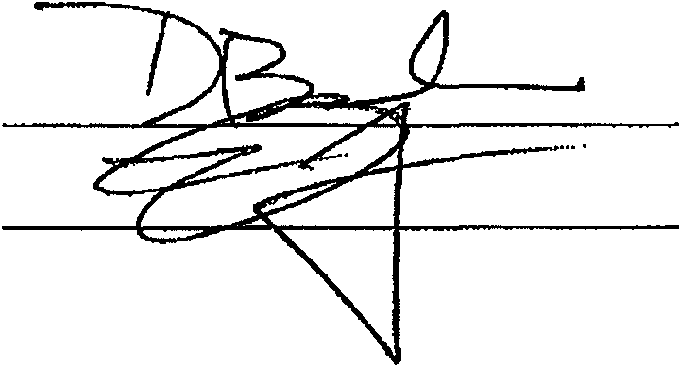Witnesses: COMPANY:

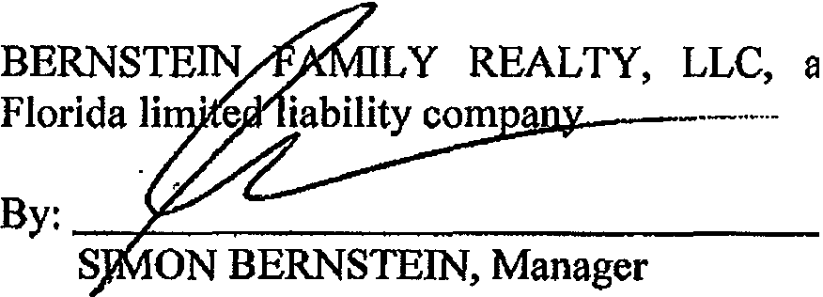

MEMBERS:

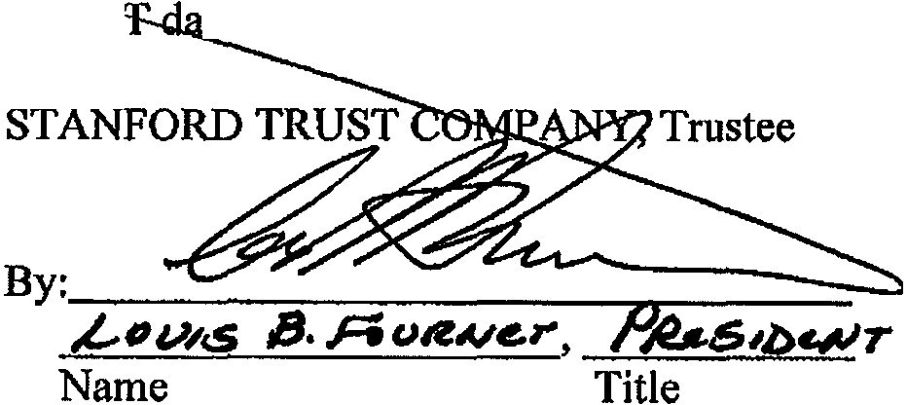DANIEL TRUS
BERNSTEIN IRREVOCABLE
ted September 7, 2006

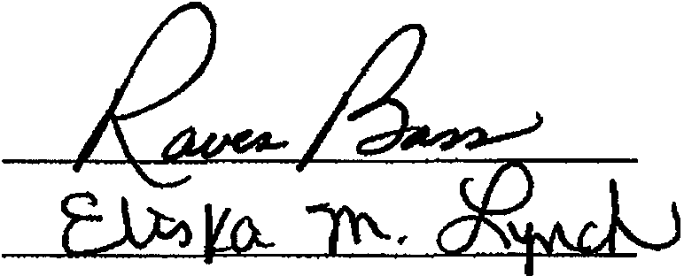

'• ' .I
' ,

JAKE BERNSTEIN IRREVOCABLE TRUST
dated September 7, 2006

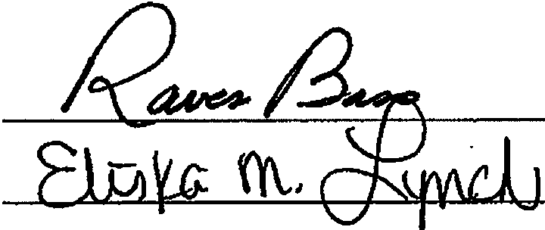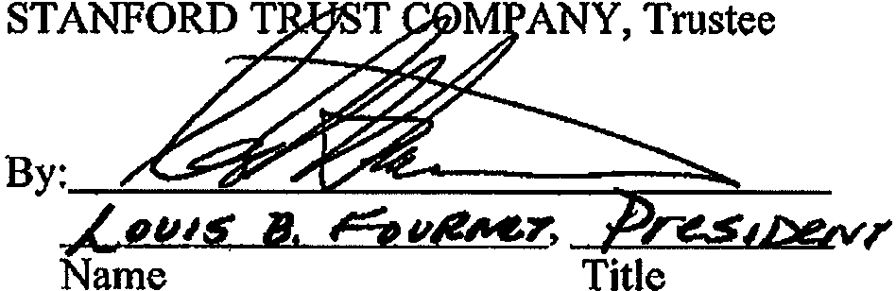

JOSHUA Z. BERNSTEIN IRREVOCABLE
TRUST dated September 7, 2006

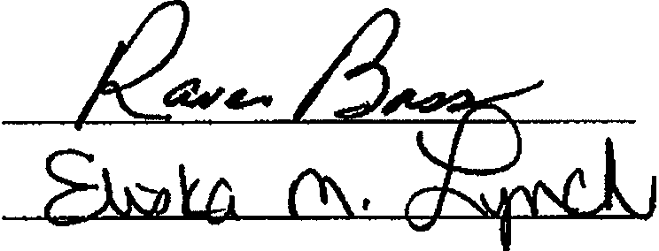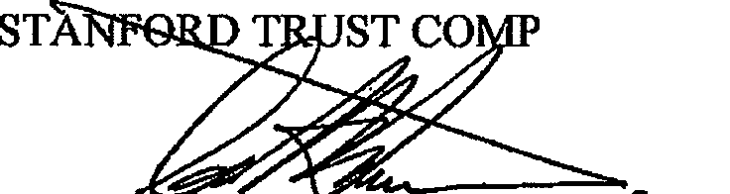ANY, Trustee

By: _;_;;;; _;;:_ -,t.+----
,L_,,,,,'S iJ. 6v 41

Title
Name

----------·-·----------·-

f:IWPDATA\drt\Jlermtein, Shirley & Simon\Bomslein family Really, LLC\Bernslein Family Really LLC OperalingAgreement.1vpd

I I -i • ' 1, ' ' .,

BERNSTEIN FAMILY REALTY, LLC OPERATING AGREEMENT

EXHIBIT A

Member(s)

DANIEL BERNSTEIN IRREVOCABLE
TRUST dated September 7, 2006

JAKE BERNSTEIN IRREVOCABLE
TRUST dated September 7, 2006

JOSHUA Z. BERNSTEIN IRREVOCABLE
TRUST dated September 7, 2006
Percentage Capital Interest* Contributions

33.34% $33.34

33.33% $33.33

33.33% $33.33

The addresses of all of the Members is 950 Peninsula Corporate Circle, Suite 3010, Boca Raton, Florida 33487.

*proportionate to capital accounts of Members

AGREEMENT OF LIMITED PARTNERSHIP OF BERNSTEIN FAMILY INVESTMENTS, LLLP

)

)

AGREEMENT OF LIMITED PARTNERSHIP OF BERNSTEIN FAMILY INVESTMENTS, LLLP

This is an Agreement of Limited Partnership ("Agreement") dated this 2(lday of b\<11;j , 2008, by and between BERNSTEIN HOLDINGS, LLC, a Florida limited liability company ( he "General Partner"); and SIMON L. BERNSTEIN, Trustee of the SIMON L. BERNSTEIN TRUST AGREEMENT dated May 20, 2008 and SHIRLEY BERNSTEIN, Trustee of the SHIRLEY BERNSTEIN TRUST AGREEMENT dated May 20, 2008, together with aQy individual, partnership,
corporation, trust, estate or other entity subsequently admitted as Limited Partners, referred to as the "Limited Partners," and individually as a "Limited Partner". The General Partner and the Limited Partners are herein sometimes referred to individually as a "Partner" and collectively as "Partners."

The parties agree as follows:

1. Formation. BERNSTEIN FAMILY INVESTMENTS, LLLP, a limited partnership under the Revised Uniform Limited Partnership Act of Florida ("Act"), became effective on February 15, 2008, the date of filing of the Certificate of Limited Partnership with the Florida Secretary of State by the General Partner. Except as otherwise provided in this Agreement, the Act shall govern the rights and liabilities of the Partners. The limited partnership has elected to be a Florida limited liability limited partnership.
)

- Name. The name of the Partnership is BERNSTEIN FAMILY INVESTMENTS, LLLP. The General Partner may, in its discretion, change the name of the Partnership and adopt such trade or fictitious names as it may deem appropriate.

- Definitions. In this Agreement, the following terms have the following meanings unless the context otherwise requires:

to time.
  - "Act" means the Revised Uniform Limited Partnership Act of Florida, asamended from time

  - "Adjusted Capital Account Deficit" means, with respect to any Partner, the deficit balance, if any, in such Partner's Capital Account as of the end of the relevant fiscal year, after giving effect to the following adjustments:

    - Credit to such Capital Account any amounts which such Partner is obligated to restore (pursuant to the terms of such Partner's promissory note or otherwise) or is deemed to be obligated to restore pursuant to the penultimate sentences of Regulations Sections 1.704-2(g)( 1) and 1.704-2(i)(5); and

    - Debit to such Capital Account the items described in Sections 1.704--
) l (b)(2)(ii)(d)(4), l.704-l (b)(2)(ii)(d)(5), and l.704- l (b)(2)(ii)(d)(6) of the Regulations.

The foregoing definition of Adjusted Capital Account Deficit is intended to comply with the provisions of Section 1.704-1 (b)(2)(ii)(d) of the Regulations and shall be interpreted consistently therewith.

  - "Aggregate Capital Contribution" means the net fair market value of all contributions made to the capital of the Partnership by a Partner pursuant to Section z.

to time.
  - "Agreement" means this Agreement of Limited Partnership, as it may be amended from time

  - "Capital Account" means, with respect to any Partner, the Capital Account maintained for such Partner in accordance with.the following provisions:

3.5. I To each Partner's Capital Account there shall be credited such Partner's Capital Contributions, such Partner's distributive share of Profits and any items in the nature ofincome or gain which are specially allocated pursuant to Section 9.3 or Section 9.4 hereof, and the amount of any Partnership liabilities assumed by such Partner or which are secured by any Partnership Property distributed to such Partner.

    - To each Partner's Capital Account there shall be debited the amount of cash and the Gross Asset Value of any Partnership Property distributed to such Partner pursuant to any provision of this Agreement, such Partner's distributive share of Losses and any items in the nature of expenses or losses which are specially allocated pursuant to Section 9.3 or Section 9.4 hereof, and the amount of any liabilities of such Partner assumed by the Partnership or which are secured by any property contributed by such Partner to the Partnership.
)

    - In the event all or a portion of an Interest in the Partnership is transferred in accordance with the terms of this Agreement, the transferee shall succeed to the Capital Account of the transferor to the extent it relates to the transferred Interest.

    - In determining the amount ofany liability for purposes of Sections 3.5.1, and 3.5.2 hereof, there shall be taken into account Code Section 752(c) and any other applicable provisions of the Code and Regulations.

The foregoing provisions and the other provisions of this Agreement relating to the maintenance of Capital Accounts are intended to comply with Regulations Section 1.704-1(b), and shall be interpreted and applied in a manner consistent with such Regulations. In the event the General Partner shall determine that it is prudent to modify the manner in which the Capital Accounts, or any debits or credits thereto (including, without limitation, debits or credits relating to liabilities that are secured by contributed or distributed property or that are assumed by the Partnership, the General Partner, or Partners), are computed in order to comply with such Regulations, the General Partner may make such modification, provided that it is not likely to have a material effect on the amounts distributable to a Partner pursuant to Section I 0.3 hereofupon the dissolution of the Partnership. The General Partner also

) AGREEMENT OF LIMITED PARTNERSHIP OF

shall (i) make any adjustments that are necessary or appropriate to maintain equality between the Capital Accounts of the Partners and the amount of Partnership capital reflected on the Partnership's balance sheet, as computed for book purposes, in accordance with Regulations Section 1.704-1(b)(2)(iv)(g), and
(ii) make any appropriate modifications in the event unanticipated events (for example, the acquisition by the Partnership of oil or gas properties) might otherwise cause this Agreement not to comply with Regulations Section 1.704-1(b).

  - "Capital Contributions" means, with respect to a Partner, the amount of money and the initial Gross Asset Value of any property (other than money) contributed to the Partnership with respect to the Partnership Interest held by such Partner. The principal amount of a promissory note which is not readily traded on an established securities market and which is contributed to the Partnership by the maker of the note (or a person related to the maker of the note within the meaning of Regulations Section I.704-l (b)(2)(ii)(c)) shall not be incl uded in the Capital Account of any Partner until the Partnership makes a taxable disposition of the note or until (and to the extent) principal payments are made on the note, all in accordance with Regulations Section l.704-l (b)(2)(iv)(d)(2).

  - "Certificate" means the certificate oflimited partnership required by the Act to be filed with the Department of State of Florida, as it may be amended from time to time.

  - "Code" means the Internal Revenue Code of 1986, as amended, or subsequent revenue laws.

  - "Depreciation" means, for each Fiscal Year, an amount equal to the depreciation,
_) amortization, or other cost recovery deduction allowable with respect to an asset for such Fiscal Year,
except that if the Gross Asset Value of an asset differs from its adjusted basis for federal income tax pu rposes at the beginni ng of such Fiscal Year, Depreciation shall be an amount which bears the same ratio to such beginning Gross Asset Value as the federal income tax depreciation, amortization, or other cost recovery deduction for such Fiscal Year bears to such beginning adjusted tax basis; provided, however, that if the adjusted basis for federal income tax purposes of an asset at the beginning of such Fiscal Year is zero, Depreciation shall be determined with reference to such beginning Gross Asset Value using any reasonable method selected by the General Partner.

  - "Event of Withdrawal" means an event described as such in Fla.Stats.§620.1603, or successor provision thereto.

3.1 1 "Fiscal Year" means (i) the period commencing on the effective date of this Agreement and ending on the last day of the Partnership's taxable year, (ii) any subsequent twelve (12) month period commencing on day after the last day of the partnership's taxable year and ending on the last day of the partnership's taxable year, or (iii) any portion of the period described in clause (ii) for which the
Partnership is required to allocate Profits, Losses, and other items of Partnership income, gain, loss, or deduction pursuant to Section 2 hereof.

herein.
  - "General Partner" means BERNSTEIN HOLDINGS, LLC, and its successors as provided

) AGREEMENT OF LIMITED PARTNERSHIP OF

  - "Gross Asset Value" means, with respect to any asset, the asset's adjusted basis for federal income tax purposes, except as follows:

    - The initial Gross Asset Value of any asset contributed by a Partner to the Partnership shall be the gross fair market value of such asset, as determined by the contributing Partner and the General Partner, provided that, ifthe contributing Partner is a General Partner, the determination of the fair market value of a contributed asset shall be determined by appraisal;

    - The Gross Asset Values of all Partnership assets shall be adjusted to equal their respective gross fair market values, as determined by the General Partner, as of the following times: (a) the acquisition of an additional Interest in the Partnership by any new or existing Partner in exchange for more than a de minimis Capital Contribution; (b) the distribution by the Partnership to a General Partner or Partner of more than a de minimis amount of Partnership Property as consideration for an Interest in the Partnership; and (c) the l iquidation of the Partnership within the meaning of Regulations Section l.704-l(b)(2)(ii)(g): provided, however, that the adjustments pursuant to clauses (a) and (b) above shall be made only if the General Partner reasonably determines that such adjustments are necessary or appropriate to reflect the relative economic interests of the General Partner and Partners in the Partnership;

    - The Gross Asset Value of any Partnership asset distributed to a Partner shall be adjusted to equal the gross fair market value of such asset on the date of distribution as determined by the distributee and the General Partner, provided that, if the distributee is a General Partner, the deter­ mination of the fair market value of the distributed asset shall be determined by appraisal; and
)

    - The Gross Asset Values of Partnership assets shall be increased (or decreased) to reflect any adjustments to the adjusted basis of such assets pursuant to Code Section 734(b) or Code Section 743(b), but onlyto the extent that such adjustments are taken into account in determining Capital Accounts pursuant to Regulations Section 1.704-l (b)(2)(iv)(m) and Sections 3.26.6 and 9.3.7 hereof; provided, however, that Gross Asset Values shall not be adjusted pursuant to this Section 3.1 3.4 to the extent the General Partner determiners that an adjustment pursuant to Section 3.13.2 hereof is necessary or appropriate in connection with a transaction that would otherwise result in an adjustment pursuant to this Section 3.13.4.

Ifthe Gross Asset Value ofan asset has been determined or adjusted pursuantto Section 3.13.l , Section 3.13.2, or Section 3.1 3.4 hereof, such Gross Asset Value shall thereafter be adjusted by the Depreciation taken into account with respect to such asset for purposes of computing Profits and Losses.

  - "Involuntary Transfer" means any involuntary sale, transfer, encumbrance or other disposition, by or in which any Partner or assignee of a Partnership Interest shall be deprived or divested of any right, title or interest in or to any Partnershi p Interest, or portion thereof, to any Person or governmental entity other than a Partner, including, without limitation, (i) any sale in connection with the execution of a judgment pursuant to court order, (ii) a transfer or sale in connection with a bankruptcy or a transfer or sale by a receiver, (iii) any transfer to ajudgment creditor pursuant to court

AGREEMENT OF LIMITED PARTNERSHIP OF
)
BERNSTEIN FAMII.Y INVESTMENTS, LLLP 4

order, (iv) any transfer in connection with a reorganization, insolvency or similar proceeding, (v) any transfer to a public officer or agency pursuant to any abandoned property or escheat law, or (vi) any transfer to the spouse or former spouse of a Partner or assignee of a Partnership Interest as the result of or incident to any dissolution of marriage, marital separation, or similar event (notwithstanding such transfer is pursuant to a marital or property settlement agreement).

  - "Limited Partners" means those Persons identified on the Signature Pages of this Agreement as limited partners and all other Persons who shall be admitted to the Partnership as Substitute Limited Partners as provided in this Agreement and no other Person.

  - "Net Cash From Operations" means the gross cash proceeds from Partnership operations (including sales and dispositions in the ordinary course of business) less the portion thereof used to pay or establish reserves for all Partnership expenses, debt payments, capital improvements, replacements, and contingencies, all as determined by the General Partner. "Net Cash From Operations" shall not be reduced by depreciation, amortization, cost recovery deductions, or similar allowances, but shall be
increased by any reductions of reserves previously established pursuant to the first sentence of this Section .lJ..Qand Section 3.17 hereof. Net Cash from Operations shall include income-type items derived from Partnership investment assets (e.g., dividends, interest, and partnership operating distributions).

  - "Net Cash From Sales or Refinancings" means the net cash proceeds from all sales and other dispositions (other than in the ordinary course of business) and all refinancings of Property, from any insurance payments or damage recoveries, other than under policies commonly referred to as a rent insurance paid to the Partnership in respect of its capital assets, and from any exercise by a governmental authority of any right of eminent domain, condemnation or similar right or power with respect to the capital assets of the Partnership, less any portion thereofused to establish reserves, all as determined by the General Partner. "Net Cash From Sales or Refinancings" shall include all principal and interest payments with respect to any note or other obligation received by the Partnershi p in connection with sales and other dispositions (other than in the ordinary course of business) of Partnership Property.
)

  - "Partner Nonrecourse Debt" has the meaning set forth in Section I.704-2(b)(4) of the Regulations.

  - "Partner Nonrecourse Debt Minimum Gain" means an amount, with respect to each Partner Nonrecourse Debt, equal to the Partnership Minimum Gain that would result ifsuch Partner Nonrecourse Debt were treated as a Nonrecourse Liability, determined in accordance with Section I .704-2(i)(3) of the Regulations.

  - "Partner Nonrecourse Deductions" has the meaning set forth in Sections I .704-2(i)( I ) and I .704-2(i){2) of the Regulations.

  - "Partners" means collectively the General Partner and all Limited Partners.

  - "Partnership" means BERNSTEIN FAMILY INVESTMENTS, LLLP.

) AGREEMENT OF LIMITED PARTNERSHIP OF

  - "Partnership Interest" means a Partner's percentage interest in the profits, losses, and property of the Partnership, which percentage is to be determined in accordance with the relative contributions to the capital of the Partnership as made by the Partner and the other Partners from time to time.

  - "Partnership Minimum Gain" has the meaning set forth in Sections l .704-2(b)(2) and l.704-2(d).

  - "Person" means an individual, corporation, partnership, association, trust, estate or any other entity.

  - "Profits" and "Losses" means, for each Fiscal Year, an amount equal to the Partnership's taxable income or loss for such year or period, determined in accordance with Code Section 703(a)(for this purpose, all items of income, gain, loss, or deduction required to be stated separately pursuant to Code Section 703(a)(l) shall be included in taxable income or Joss), with the following adjustments:

    - Any income of the Partnership that is exempt from federal income tax and not otherwise taken into account in computing Profits and Losses pursuant to this Section 3.26 shall be added to such taxable income or loss;

    - Any expenditures of the Partnership described in Code Section 705(a)(2)(B) or treated as Code Section 705(a)(2)(B) expenditures pursuant to Regulations Section 1.704-1(b)(2)(iv)(i). and not otherwise taken into account in computing Profits or Losses pursuant to this Section 3.26 shall be subtracted from such taxable income or loss;
)

    - In the event the Gross Asset Value of any Partnership asset is adjusted pursuant to Section 3.1 3.2 or Section 3.13.3 hereof, the amount of such adjustment shall be taken into account as gain or Joss from the disposition of such asset for purposes of computing Profits or Losses;

    - Gain or loss resulting from any disposition of Partnership Property with respect to which gain or loss is recognized for federal income tax purposes shall be computed by reference to the Gross Asset Value of the property disposed of, notwithstanding that the adjusted tax basis of such property differs from its Gross Asset Value;

    - In lieu ofthe depreciation, amortization, and other cost recovery deductions taken into account in computing such taxable income or loss, there shall be taken into account Depreciation for such fiscal year or other period, computed in accordance with Section 3.9 hereof;

    - To the extent an adjustment to the adjusted tax basis of any Partnership asset pursuant to Code Section 734(b) or Code Section 743(b) is required pursuant to Regulations Section 1.704-l(b)(2)(iv)(m)(4) to be taken into account in determining Capital Accounts as a result of a distribution other than in liquidation of a Partner's Interest in the Partnership, the amount of such adjustment shall be treated as an item of gain (if the adjustment increases the basis of the asset) or loss

) AGREEMENT OF LIMITED PARTNERSHIP Of

(if the adjustment decreases the basis of the asset) from the disposition of the asset and shall be taken into account for purposes of computing Profits or Losses;

3.26.7 Notwithstanding any other provision of this Section 3.26, any items which are specially allocated pursuant to Section 9.3 or Section 9.4 hereof shall not be taken into account in computing Profits or Losses.

The amounts of the items of Partnership income, gain, loss, or deduction available to be specially allocated pursuant to Sections 9.3 or Section 9.4 hereof shall be determined by applying rules analogous to those set forth in Sections 3.26.1 through 3.26.6 above.

. 3.27 "Property" means the property described in Exhibit "A", and such other property as the Partners shall agree to submit to Partnership ownership.

  - "Regulatory Allocations" has the meaning set forth in Section 9.4 hereof.

  - "Special Limited Partners" has the mean ing set forth in Section 16.5.2.

  - "Substitute Limited Partners" means Persons who have acquired Partnership Interests from Limited Partners and who have been substituted for such Limited Partners as provided in this
Agreement. Solely for purposes of determining those Persons who are entitled to distributions and allocations under Sections .2 and !Q, "Substitute Limited Partners" means Persons who have acquired
_) Partnership Interests from Limited Partners and Special Limited Partners and their assignees, whether
or not such Persons have been substituted as provided herein.

  - "Transfer" means the mortgage, pledge, hypothecation, transfer, gift, bequest, sale, assignment or other disposition of any part or all or any Partnership Interest including a general partnership interest in the Partnership, whether voluntarily, by operation of law or otherwise.

- Principal Place of Business and Recordkeeping Office and Agent for Service of Process. The principal place of business and recordkeeping of the Partnership is at BERNSTEIN FAMILY INVESTMENTS, LLLP, 950 Peninsula Corporate Circle, Suite 310, Boca Raton, Florida 33487, or at such other location as the General Partner, in its discretion, may determine. DONALD R. TESCHER shall act as agent for service of process on the Partnership.

S. Term. The Partnership shall continue until December 31, 2058, unless sooner terminated as provided in Section ll.

6. Business and Purposes. The purpose and business of the Partnership shall be the ownership, investment, management and control ofthe Property and other investment properties (including, without limitation, investments in real property, loans, business enterprises, marketable securities, either directly or through interests in corporations, limited partnerships, limited liability companies, and other entities), to provide a means for the BERNSTEIN family to own investment property and preserve its assets, and

to conduct such other activities as may be necessary or appropriate to promote such business and purposes, it being agreed that each of the foregoing is an ordinary part of the Partnership's business. In addition to the foregoing, or as part thereof, the Partnership shall accomplish among other things the following: (a) maintain control over BERNSTEIN family assets contributed to it, (b) consolidate fractional interests in BERNSTEIN family assets, (c) seek to increase BERNSTEIN family wealth, (d) establish a method by which gifts can be made without fractionalizing BERNSTEIN family assets, (e) provide protection to BERNSTEIN family assets from future claims against members of the families,
(t) facilitate the administration and reduce the costs associated with the disability or probate of the estate of members of the BERNSTEIN family, (g) provide a mechanism to resolve BERNSTEIN family disputes, and (h) if applicable, hold restricted securities until such securities become unrestricted and free of underwriting limitations of the Securities and Exchange Commission. The Partnership shall not engage in any other business without the prior consent of Limited Partners owning (in the aggregate) at least eighty (80%) percent of the limited partnership Interests owned by the Limited Partners.

- Capital Contributions and Capital Accounts.

  - Contribution of General Partners. The General Partner shall, as soon as practicable after the execution of this Agreement, contribute to the Partnership the cash and property set forth on Schedule "A" attached hereto and made a part hereof. The value of said capital contribution shall be allocated to the capital account of the General Partner. In addition, the General Partner shall contribute its efforts as managing partner.
) 7.2 Contribution of Limited Partners. The Limited Partners shall contribute to the Partnership the cash and property set forth on Schedule "A" attached hereto and made a part hereof. The value of each such contribution shall be allocated to the respective capital accounts of the Limited Partners as reflected on Schedule "A."

  - Withd rawal of Capital. Except as specifically provided in this Agreement, no Partner shall be entitled to withdraw any part of his capital account or to receive any distribution from the Partnership, and no Partner shall be required to make any additional capital contribution to the Partnership.

  - Partner's Loans. Loans by any Partner to the Partnership shall not be considered contributions to the capital of the Partnership and shall not increase the capital account of the lending Partner.

  - Interest on Capital Contribution. No interest shall be paid on any capital contributed to the Partnership.

- Compensation and Expenses of General Partner.

  - Compensation and Reim bu rsement. The Partnership shall pay to the General Partner or its affiliates reasonable fees as compensation for services and reim bursement for sums advanced. The Partnership is authorized to enter into busi ness agreements, contracts, and other transactions with the

General Partner or its affiliates and is authorized to pay fees, commissions or other consideration to the General Partner, or its affiliates on an arms length basis, including without limitation, real estate brokerage commissions, development fees, insurance premiums, rent, property management fees, leasing commissions and mortgage brokerage fees.

8.2 Expenses. The General Partner may charge the Partnership for any reasonable expenses actually incurred by it in connection with the Partnership's business and all allocable portions of expenses incurred in connection with both Partnership and other activities, such allocation to be determined on any equitable basis selected by the General Partner consistent with generally accepted accounting principles. Such expenses shall include, but are not limited to, payment offees and expenses to attorneys, accountants, property managers and property management companies and other consultants.

9. Allocations of Profit and Loss, Cash Distributions.

9.1Allocations of Profits. After giving effect to the special allocations set forth in Sections 9.3 and 9.4 hereof, Profits for any Fiscal Year shall be allocated in the following order and priority:

9.1.1 First, to the Partners in an amount equal and in proportion to the excess, if any, of the cumulative Losses allocated to the Partners pursuant to Section 9.2.2 hereof for the current and all prior Fiscal Years, reduced by the cumulative Profits allocated to the Partners pursuant to this Section
9.1.l hereof for the current and all prior Fiscal Years;
) 9.1.2 The balance, if any, pro-rata to the Partners or in proportion to their Partnership Interests.

  - Allocation of Losses. After giving effect to the special allocations set forth in Sections 9.3 and 9.4, Losses for any Fiscal Year shall be allocated as set forth in Section 9.2. I below, subject to the limitations in Section 9.2.2 below.

    - To the Partners in proportion to their Partnership Interests.

    - The Losses allocated pursuant to Section 9.2. J hereof shall not exceed the maximum amount of Losses that can be so allocated without causing any Partner who is not a General Partner to have an Adjusted Capital Account Deficit at the end of any Fiscal Year. In the event some but not all of the Partners who are not General Partners would have Adjusted Capital Account Deficits as a consequence of an allocation of Losses pursuant to Section 9.2.1, the limitation set forth in this Section 9.2.2 shall be applied on a Partner by Partner basis so as to allocate the maximum permissible Losses to each Partner who is not a General Partner under Section I.704-1 (b)(2)(ii)(d) of the Regulations. All Losses in excess of the limitation previously set forth in this Section 9.2.2 shall be allocated to the General Partner.

  - Special Allocations. The following special allocations shall be made in the following order:

    - Minimum Gain Chargeback. Except as otherwise provided in Section 1.704-2(f) of the Regulations, notwithstanding any other provision of this Section .2., ifthere is a net decrease in
Partnership Minimum Gain during any Partnership Fiscal Year, each Partner shaJI be specially allocated items of Partnership income and gain for such Fiscal Year (and, if necessary, subsequent Fiscal Years) in an amount equal to such Partner's share of the net decrease in Partnership Minimum Gain, determined in accordance with Regulations Section l .704-2(g). Allocations pursuant to the previous sentence shall be made in proportion to the respective amounts required to be allocated to each Partner pursuant thereto. The items to be so allocated shall be determined in accordance with Sections l .704-2(f)(6) and J .704-2(j)(2) of the Regulations. This Section 9.3.1 is intended to comply with the minimum gain chargeback requirement in Section l.704-2(t) of the Regulations and shall be interpreted consistently therewith.

    - Partner Minimum Gain Chargeback. Except as otherwise provided in Section t .704-2(i)(4) of the Regulations, notwithstanding any other provision of this Section .2, ifthere is a net decrease in Partner Nonrecourse Debt Minimum Gain attributable to a Partner Nonrecourse Debt during
any Partnership Fiscal Year, each Partner who has a share of the Partner Nonrecourse Debt Minimum Gain attributable to such Partner Nonrecourse Debt, determined in accordance with Section 1 .704-2(i)(5) ofthe Regulations, shall be specially allocated items of Partnership income and gain for such Fiscal Year (and, if necessary, subsequent Fiscal Years) in an amount equal to such Partner's share of the net decrease in Partner Nonrecourse Debt Minimum Gain attributable to such Partner Nonrecourse Debt, determined in accordance with Regulations Section I .704-2(i)(4). Allocations pursuant to the previous sentence shall be made in proportion to the respective amounts required to be allocated to each Partner pursuant thereto. The items to be so allocated shall be determined in accordance with Sections 1.704- 2(i)(4) and I .704-20)(2) of the Regulations. This Section 9.3.2 is intended to comply with the minimum gain chargeback requirement in Section I .704-2(i)(4) of the Regulations and shall be interpreted consistently therewith.
)

    - Qualified Income Offset. In the event any Partner who is not a General Partner unexpectedly receives any adjustments, allocations, or distributions described in Regulations Section
I.704-1(b)(2)(ii)(d)(4), Regulations Section I.7041(b)(2)(ii)(d)(5), or Regulations Section I.704-
l (b)(2)(ii)(d)(6), items of Partnership income and gain shall be specially allocated to each such Partner in an amount and manner sufficient to eliminate, to the extent required by the Regulations, the Adjusted Capital Account Deficit of such Partner as quickly as possible, provided that an allocation pursuant to this Section 9.3.3 shall be made if and only to the extent that such Partner would have an Adjusted Capital Account Deficit after all other allocations provided for in this Section .2. have been tentatively made as if this Section 9.3.3 were not in the Agreement.

    - Gross Income Allocation. In the event any Partner who is not a General Partner has a deficit Capital Account at the end of any Partnership Fiscal Year which is in excess of the sum of
(i) the amount such Partner is obligated to restore (pursuant to the terms of such Partner's promissory note or otherwise), and (ii) the amount such Partner is deemed to be obligated to restore pursuant to the penultimate sentences of Regulations Sections l.704-2(g)(l) and l.704-2(i)(5), each such Partner shall be specially allocated items of Partnership income and gain in the amount of such excess as quickly as possible, provided that an allocation pursuant to this Section 9. 3.4 shall be made if and only to the extent

)
AGREEMENT OF LIMITED PARTNERSHIP OF
BERNSTEIN FAMILY INVESTMENTS, LLLP I O

that such Partner would have a deficit Capital Account in excess of such sum after all other allocations provided for in this Section 2 have been tentatively made as if this Section 9.3.4 and Section 9.3.3 hereof
were not in the Agreement.

    - Nonrecou rse Deductions. Nonrecourse Deductions for any Fiscal Year shall be specially allocated to the Limited Partners.

    - Partner Nonrecourse Deductions. Any Partner Nonrecourse Deductions for any Fiscal Year shall be specially allocated to the General Partner or Partner who bears the economic risk ofloss with respect to the Partner Nonrecourse Debt to which such Partner Nonrecourse Deductions are attributable in accordance with Regulations Section l .704-2(i)(l ).

    - Section 754 Adjustment. To the extent an adjustment to the adjusted tax basis of any Partnership asset pursuant to Code Section 734(b) or Code Section 743(b) is required, pursuant to Regulations Section l.704-l (b)(2)(iv)(m)(2) or Regulations Section l.704-l (b)(2)(iv)(m)(4), to be taken into account in determining Capital Accounts as the result of a distribution to a General Partner or Partner in complete liquidation of his Interest in the Partnership, the amount of such adjustment to the Capital Accounts shall be treated as an item of gain (if the adjustment increases the basis of the asset) or Joss (if the adjustment decreases such basis) and such gain or loss shall be specially allocated to the General Partner and the Partners in accordance with their Interests in the Partnership in the event that Regulations Section l.704-I (b)(2)(iv){m)(2) applies, or to the Partners to whom such distribution was
made in the event that Regulations Section I .704-1 (b)( 2)( iv)(m)(4) applies.
)
    - Allocations Relating to Taxable Issuance of Partnership Interests. Any income, gain, Joss, or deduction realized as a direct or indirect result of the issuance of an Interest in the Partnership by the Partnershi p to a Partner (the "Issuance Items") shall be allocated among the Partners so that, to the extent possible, the net amount of such Issuance Items, together with all other allocations under this Agreement to each Partner, shall be equal to the net amount that would have been allocated to each such Partner ifthe Issuance Items had not been realized.

  - Curative Allocations. The allocations set forth in Sections 9.2.2, 9.3. l , 9.3.2, 9.3.3, 9.3.4, 9.3.5, 9.3.6 and 9.3.7 hereof (the "Regulatory Allocations") are intended to comply with certain requirements of the Regulations. Itis the intent of the Partners that, to the extent possible, all Regulatory Allocations shall be offset either with other Regulatory Allocations or with special allocations of other items of Partnership income, gain, loss, or deduction pursuant to this Section 9.4. Therefore, notwithstanding any other provision of this Section 2 (other than the Regulatory Allocations), the General Partner shall make such offsetting special allocations of Partnership income, gain, loss, or deduction in whatever manner it determines appropriate so that, after such offsetting allocations are
made, each Partner's Capital Account balance is, to the extent possi ble, equal to the Capital Account balance such General Partner or Partner would have had if the Regulatory Allocations were not part of the Agreement and all Partnership items were allocated pursuant to Sections 2.J., 9.2.1, 9.3.8, and 9.5.
In exercising its discretion under this Section 9.4, the General Partner shall take into account future Regulatory Allocations under Sections 9.3. I and 9.3.2 that, although not yet made, are likely to offset other Regulatory Allocations previously made under Sections 9.3.5 and 9.3.6.

)

  - Other Allocation Rules.

    - Generally, unless otherwise explicitly provided, all Profits and Losses allocated to the Partners shall be allocated among them in proportion to the Partnership Interest held by each. In the event additional Limited Partners are admitted to the Partnership on different dates during any Fiscal Year, the Profits (or Losses) allocated to the Partners for each such Fiscal Year shall be allocated among the Partners in proportion to the Partnership Interest each holds from time to time during such Fiscal Year in accordance with Code Section 706, using any convention permitted by law and selected by the General Partner.

    - The Partners are aware of the income tax consequences of the allocations made by this Section .2 and hereby agree to be bound by the provisions of this Section .2 in reporting their shares of Partnership income and loss for income tax purposes.

    - Solely for purposes of determining a General Partner's or Partner's proportionate share of the "excess nonrecourse liabilities" of the Partnership within the meaning of Regulations Section 1.752-3(a)(3), the Partner's Interests in Partnership profits are as follows: Limited Partners one hundred percent (I 00%) (in proportion to their Partnership Interests).

    - To the extent permitted by Sections 1.7042(h)(3) of the Regulations, the General Partner shall endeavor to treat distributions of Net Cash From Operations or Net Cash From Sales or Refinancings as having been made from the proceeds of a Nonrecourse Liability or a Partner Nonrecourse Debt only to the extent that such distributions would cause or increase an Adjusted Capital Account Deficit for any Partner who is not a General Partner.
)

  - Tax Allocations: Code Section 704(c), I n accordance with Code Section 704(c) and the Regulations thereunder, income, gain, loss, and deduction with respect to any property contributed to the capital of the Partnership shall, solely for tax purposes, be allocated among the General Partner and Partners so as to take account of any variation between the adjusted basis of such property to the Partnership for federal income tax purposes and its initial Gross Asset Value (computed in accordance with Section 3.13.1 hereof). In the event the Gross Asset Value of any Partnership asset is adjusted pursuant to Section 3.1 3.2 hereof, subsequent allocations of income, gain, loss, and deduction with respect to such asset shall take account of any variation between the adjusted basis of such asset for federal income tax purposes and its Gross Asset Value in the same manner as under Code Section 704(c) and the Regulations thereunder. Any elections or other decisions relating to such allocations shall be made by the General Partner in any manner that reasonably reflects the purpose and intention of this Agreement. Allocations pursuant to this Section 9.6 are solely for purposes of federal, state, and local taxes and shall not affect, or in any way be taken into account in computing, any Partner's Capital Account or share of Profits, Losses, other items, or distributions pursuant to any provision of this Agreement.

- Distributions.

)

  - Net Cash From Operations. Except as otherwise provided in Section 10.3 hereof, Net Cash From Operations not needed in the General Partner's determination for the reasonable needs of the Partnership business, shall be distributed to the Partners in proportion to their respective Partnership Interests.

To the extent such cash is comprised in whole or in part of nonrental income-type items derived from Partnership passive investment assets (e.g., dividends, interest, and partnership operating distributions), reinvestments of such proceeds in other investment assets shall constitute expenditures forthe reasonable needs of the business in the determination of the General Partner.

  - Net Cash From Sales or Refinancings. Except as otherwise provided in Section I 0.3 hreof, Net Cash From Sales or Refinancings not needed in the General Partner's determination for the reasonable needs of the Partnership business, shall be distributed in the following order and priority:

    - First, proportionally to the Partners until their aggregate Capital Account balances are reduced to zero; and

I 0.2.2 thereafter, to the Partners in proportion to their Partnership Interests.

To the extent such cash is comprised in whole or in part of cash from the sale of Partnership non-real property passive investment assets (e.g., marketable securities), reinvestments of such proceeds in other investment assets shall constitute expenditures for the reasonable needs of the business in the
_) detennination of the General Partner.

  - Liquidating Distributions. Notwithstanding the distribution provisions, liquidating distributions of the partnership, including all distributions made pursuant to a liquidation descriqed in Regulations Section l.704-l (b)(2)(ii)(g), shall be distributed as follows:

I 0.3.1 First, to the payment and discharge ofall of the Partnership's debts and liabilities to creditors other than the General Partners;

    - Second, to the payment and discharge of all of the Partnership's debts and liabilities to General Partners; and

    - The balance, if any, proportionally to the Partners until their aggregate Capital Account balances are reduced to zero; and

I 0.3.4 thereafter, to the Partners in proportion to their Partnership Interests.

The foregoing liquidating distributions are intended to be made in compliance with Regulations Section I.704-l (b)(2)(ii)(b)(2) and subsequent to a revaluation of Partnership property and corresponding adjustment of Capital Accounts under Treas.Regs. §1.704-1(b)(2)(iv)(f). Ifany General Partner's Capital Account has a deficit balance (after giving effect to all contributions, distributions, and allocations for all Fiscal Years, including the Fiscal Year during which such liquidation occurs), such General Partner

shall contribute to the capital of the Partnership the amount necessary to restore such deficit balance to zero in compliance with Regulations Section I .704-1 (b)(2)(ii)(b)(3). Ifany Limited Partner who is not a General Partner has a deficit balance in his Capital Account (after giving effect to all contributions, distributions, and alJocations for alJ Fiscal Years, including the Fiscal Year during which such liquidation occurs), such Limited Partner shall have no obligation to make any contribution to the capital of the Partnership with respect to such deficit, and such deficit shall not be considered a debt owed to the Partnership or to any other Person for any purpose whatsoever. In the discretion of the General Partner, a pro rata portion of the distributions that would otherwise be made to the General Partner and Limited Partners pursuant to this subsection may be (a) distributed to a trust established for the benefit of the General Partner and Limited Partners for the purposes ofliquidating Partnership assets, colJecting amounts owed to the Partnership, and paying any contingent or unforseen liabilities or obligations of the Partnership or of the General Partner arising out of or in connection with the Partnership. The assets of any such trust shall be distributed to the General Partner and Limited Partners from time to time, in the reasonable discretion of the General Partner, in the same proportions as the amount distributed to such trust by the Partnership would otherwise have been distributed to the General Partner and Limited Partners pursuant to this Subsection 1 0.3; or (b) withheld to provide a reasonable reserve for Partnership liabilities (contingent or otherwise) and to reflect the unrealized portion of any installment obligations owed to the Partnership, provided that such withheld amounts shall be d istributed to the Partners as soon as practicable.

10.4 Division Among Partners. Except as otherwise provided above, all distributions to the Partners pursuant to this Section lQ shall be divided among them in proportion to the Partnership Interest
) held by each.

10.S Amounts Withheld. All amounts withheld pursuant to the Code or any provision of any state or local tax law with respect to any payment, distribution, or allocation to the Partnership, the General Partner, or the Partners shall be treated as amounts distributed to the General Partner and the Partners pursuant to this Section lQ for all purposes under this Agreement. The General Partner is authorized to withhold from distributions, or with respect to allocations, to the General Partner and Partners and to pay over to any federal, state, or local government any amounts required to be so withheld pursuant to the Code or any provisions of any other federal, state, or local law and shall allocate such amounts to the General Partner and Partners with respect to which such amount was withheld.

  - Special Tax Elections. At the written request of any Partner the Partnership shall make an election pursuant to Section 754 of the Code upon a distribution of property described in Code Section 734 or a transfer described in Code Section 743 ofa Partnership Interest in accordance with this Agreement. Each Partner shall, upon request, supply the General Partner with the information necessary to make such election.

  - General Elections and Limitations. The General Partner is authorized, in its sole discretion, to make any other elections required or permitted with respect to Federal or state taxes in any Partnership tax return; provided, however, no election shall be made by either the Partnership or the Partners to be excluded from the application of the provisions of Subchapter K, Chapter I of Subtitle A of the Code or from any similar provisions of any state tax laws.

  - Distribution in Kind. If any assets of the Partnership are distributed in kind, such assets shall be distributed to the Partners entitled to participate in the distribution as tenants-in-common in the same proportions as such Partners would have been entitled to cash distributions.

  - Rights of Partners to Property. No Partner shall have the right to withdraw or reduce his capital contribution to the Partnership except as a resu lt of the dissolution of the Partnership or as otherwise provided by law. No Partner shall be entitled to demand and receive property other than cash in return for his capital contribution to the Partnership, and, to the maximum extent permissi ble under applicable law, each Partner hereby waives all right to partition the Partnership Property.

10.1O Priorities of Limited Partners. No Limited Partner shall have anypriority over any other Limited Partner asto the return of his contribution to the capital ofthe Partnership or as to compensation by way of income.

10.11 Minimum Interest of General Partner. Notwithstanding the allocations contained in these Sections .2 and J.Q, it is the intent of this Agreement that in no event shall the General Partner be allocated less than 1% of Profits, Losses, Net Cash from Operations or Net Cash From Sales or
Refinancings allocated to the Partners.

- Rights, Duties and Powers of the General Partner and Limited Partners.

  - Management. The General Partner shall be solely responsible for the management of and shall use its best efforts to manage and control the Partnership business with all rights and powers generally conferred by law or necessary, advisable or consistent with such responsi bility.
)

  - Rights. In addition to any other rights and powers which it may possess, the General Partner shall have all specific rights and powers required or appropriate to the management of the Partnership business which, by way of illustration, but not by way of limitation, shall include the right and power:

    - To evaluate, select, negotiate for, acquire, purchase, operate, hold, trade, sell, exchange, convey or lease the Partnership Property, and any real property which is or may become a part of the Partnership property, as well as personal or other property connected with it, and except as may be limited by this Agreement to acquire or grant options for the purchase or sale of or sell the Partnership property from or to any Person, including, without limitation, the General Partner for such price, cash or otherwise, and upon such terms as the General Partner in its sole discretion deems to be in the best interests of the Partnership.

    - To manage, develop, improve, maintain and service Partnership properties; to form corporations or acquire shares of stock in corporations to carry out any of the purposes of the Partnership and to acquire title to property in the name of such corporations and to guarantee or otherwise secure the obligations of such corporations in furtherance of Partnership purposes.

    - To borrow and lend money and, if security is required for a borrowing, to mortgage or subject to any other security device any portion ofthe property ofthe Partnership, to execute replacements of any mortgage or other security device, and to prepay, in whole or in part, refinance, increase, modify and consolidate such indebtedness as determined in their discretion to be in the best interest of the Partnership.

11.2.4 To place of record, title to, or the right to use, Partnership assets in the name or names of a nominee or nominees, including, but not limited to, the General Partner: or a land trustee, for any purpose convenient or beneficial to the Partnership.

1 1.2.5 To acquire and to enter into any contract of liability and other insurance which
. the General Partner deems necessary and proper for the protection of the Partners and Partnership, for the conservation of its assets or for any purpose convenient or beneficial to the Partnership.

1I .2.6 To employ from time to time persons, firms or corporations for the operation and management of the Partnership business, including, but not limited to, attorneys, accountants, advisors, administrators, property managers and personnel, managing and supervising agents, construction, maintenance and repair contractors, independent contractors furnishing full service components, architects, land planners, financial consultants, engineers, insurance brokers, real estate brokers and loan brokers on such terms and for such compensation as the General Partner may determine. The General Partner is hereby specifically authorized in its sole discretion to employ the General Partner as provided in, and subject to, the provisions of this Agreement. Compensation connected with any such employment shall be an expense of the Partnership.
)

    - To make elections under the tax laws of the United States or any state as to the treatment of Partnership income, gain, loss, deduction and credit, and as to all other relevant matters.

    - To determine the Profits, Losses, Net Cash from Operations and Net Cash From Sales or Refinancings of the Partnership for any period and from any transaction.

    - To transfer all or part of the real orpersonal property belonging to the Partnership to one or more general or l imited partnershi ps or corporations in exchange for partnership interests or shares of stock which the Partnership may hold or distribute among the Partners in accordance with their respective Interests in the Partnership.

    - To perform any and all other acts or activities customary or incidental to the Partnership purposes and businesses.

    - Adjust Partner Capital Account balances to reflect a revaluation of Partnership property on the books of the Partnership in accordance with and as permitted by the provisions of Treas.Regs. §1.704-1(b)(2)(iv)(f).

  - Certain Limitations. The General Partner shall have all of the rights and powers and be subject to all of the restrictions and liabilities of a partner in a partnership without limited partners,

except that without the written consent of aJI of the Limited Partners as provided in this Agreement, or as otherwise provided by law, the General Partner shall not have authority to do any of the following:

    - Any act in contravention of the Certificate or this Agreement.

    - Confess a judgment against the Partnership.

    - Possess Partnership property, or assign the rights of the Partnership in specific Partnership property, for other than a Partnership purpose.

Agreement.
I 1.3.4 Admit a Person as a General Partner, except as otherwise provided in this

Agreement.
    - Admit a Person as a Limited Partner, except as otherwise provided in this

    - Require any Limited Partner to make any contribution to the capital of the Partnership not provided in Section 1.

  - Other Interests. Any of the Partners and any affiliates of the Partners, or any shareholder or any other Person holding a legal or beneficial interest in an entity which is a Partner or an affiliate of the General Partner, may engage in or possess an interest in other business ventures which may be
) competitive with the business of, or which may transact business with, the Partnership. Neither the
Partnership nor the Partners shall have any right by virtue of this Agreement in and to such independent ventures or to the income or profits derived from them.

  - Agreement Beyond the Partnership Term. Agreements entered into by the Partnership, including, but not limited to, security agreements, mortgages and leases, may extend for terms in excess of the term of the Partnership.

  - General Partner as Limited Partner. The General Partner or its affiliates may acquire and own Interests as Limited Partners, in addition to its Interest as General Partner. In addition, the General Partner may become a Limited Partner in accordance with the provisions of Section 16.5.2.

  - Time Devoted to Partnership Business. The General Partner shall devote only such time to the business of the Partnership as it, in its sole discretion, shall deem to be necessary to manage and supervise the Partnership business.

  - General Partner's Liability. The General Partner shall not be liable for the return of any portion of the Aggregate Capital Contributions of the Limited Partners.

  - Exculpation and Indemnification of General Partner. No General Partner shall be liable, responsible or accountable in damages or otherwise to the Partnership or any other Partner for

any act performed or failure to act by it unless such act or failure to act is attributable to wiJJfuJ misconduct or gross negligence. The Partnership shaJI indemnify and hold harmless the General Partner from and against any and all loss, damage, liability, cost orexpense, including reasonable attorneys' fees, arising out of any act or failure to act by the General Partner if such act or failure to act is in good faith within the scope of this Agreement and is not attributable to willful misconduct or gross negligence. The General Partner shall indemnify and hold harmless the Partnership and the Partners for any loss, damage, liability, cost or expense (including reasonable attorneys' fees) arising out of any act or failure to act by the General Partner, where such act or failure to act is attributable to wiJiful misconduct or gross negligence.

  - Tax Matters Partner. BERNSTEIN HOLDINGS, LLC, shall be the Tax Matters Partner; provided, however, if it is no longer General Partner then it shall be a successor appointed by Limited Partners owning in the aggregate 51% of the Limited Partnership Interests. The Tax Matters Partner shall notify all Partners as to the beginning of any administrative proceedings at the Partnership level with respect to Partnership items and shall further notify the Partners as to any final Partnership administrative adjustment resulting from any such proceeding. The Tax Matters Partner shall be entitled to reimbursement for all costs and expenses incurred in connection with its services to the Partnership as Tax Matters Partner, and shall be indemnified and held harmless by the Partners with respect to such services, except with respect to wilJful misconduct or gross negligence.

  - Powers of Limited Partners. The Limited Partners shall take no part in or interfere in any manner with the conduct or control of the Partnership business and shall have no right or authority to act for or to bind the Partnership. The Partnership may engage Limited Partners or persons associated with them for specific purposes and may otherwise deal with such Limited Partners on terms and for compensation to be agreed upon by any such Limited Partner and the Partnership. The exercise of any of the rights and powers of the Limited Partners pursuant to the terms of this Agreement shall not be deemed taking part in the day-to-day affairs of the Partnership or the exercise of control over Partnership affairs.
)

11.12 Liability of Limited Partners. A Limited Partner shaJI not be bound by, or personaJiy liable for, any of the debts, contracts, liabilities, or other obligations of the Partnership or the General Partner, or for any losses of the Partnership in excess of their requ ired capital contribution, and the liability of each Limited Partner shall be limited solely to the amount of his contribution to the capital
of the Partnership required by the provisions of Section l.Notwithstanding any of the foregoing to the
contrary, and only to the extent otherwise required by applicable law, a Partner receiving a distribution in part or full return of his aggregate Capital Contribution shaJl be liable to the Partnership for any sum, not in excess of such amount returned plus interest, necessary to discharge the liabilities of the Partnership to creditors who extended credit or whose claims arose before such distribution, excluding liabilities of the Partnership represented by debt, the repayment of which is secured solely by the Partnership Property.

12. Loans to the Partnership. From time to time any Partner, including the General Partner, upon the request of the General Partner, may make optional loans to the Partnership or advance money on its

behalf. Such loans and advances may be in the form of direct loans, payment of sums payable by the Partnership, payments of guarantees of Partnership indebtedness or otherwise. Loans and advances under this Section shall be accounted for as Joans and not as capital contributions to the Partnership. All sums loaned or advanced, together with interest on such sums, shall be deemed an obligation ofindebtedness from the Partnership to the lending Partner, and such loan or advance shall bear interest at a reasonable rate agreed to by the Partnership and the lending Partner.

- Books, Records, Reports, Bank Accounts and Tax Elections.

  - Books of Account. At all times during the existence of the Partnership, the General Partner shall keep, or cause to be kept, full and true books of account of the Partnership in accordance with generally accepted accounting principles. The books shall be maintained on such method of accounting, accrual or cash, as the General Partner determines in its discretion to be in the best interests of the Partnership. The books of the Partnership, together with a certified copy of the Certificate, shall be maintained at the principal place of business of the Partnership. During reasonable business hours the Limited Partners and their authorized representatives may inspect and copy the Partnership's books of account.

  - Financial Statements. At least annually, unaudited financial statements and an annual report of the business of the Partnership shall be prepared at the direction of the General Partner. Ifa Partner wishes to obtain an audited financial statement, he may cause it to be prepared, but he shall pay
) all fees and expenses for its preparation.
  - Tax Returns. In addition to the financial statement and annual report, the General Partner shall cause income tax returns for the Partnership to be prepared and filed with the appropriate authorities and the General Partner shall also cause such reports as may be required by regulatory agencies to be prepared, filed and distributed as required.

  - Dissemination. The General Partner shall distribute annual reports of the business of the Partnership, financial statements and income tax information to the Limited Partners as soon as is practicable after the close of each fiscal year of the Partnership.

13.S Fiscal Year. The Partnership tax year shall be the calendar year, unless a General Partner elects another fiscal year and obtains the approval of the Internal Revenue Service to such year.

13.6 Bank Accou nts. All funds of the Partnership shall be deposited in the Partnership name in such bank account or accounts as may be designated by the General Partner. Withdrawals from any such bank account or accounts shall be made upon such signature or signatures as the General Partner may designate.

- Transfer of Limited Partnership Interest.

) AGREEMENT OF LIMITED PARTNERSHIP OF
BERNSTEIN FAMILY INVESTMENTS. LLLP 19

  - Method of Transfer. No Transfer of all or part of a Limited Partner's Interest may be effected except as permitted in this Section li,and then only if a counterpart of the instrument of
Transfer, executed and acknowledged by the parties to the Transfer is delivered to the Partnership. A permitted Transfer shall be effective as of the date specified in the instruments of Transfer. This Partnership is formed by those who know and trust one another, who have surrendered certain management rights (in exchange for limited liability in the case of a Limited Partner), or who have assumed management responsibility and risk (in the case of a General Partner) based upon their relationship and trust. Capital is material to the business and investment objectives of the Partnership and its federal tax status. An unauthorized Transfer of a Limited Partner's Interest could create a substantial hardship to the Partnership, jeopardize its capital base, and adversely affect its tax structure. The restrictions on Transfers set forth in this Section are not intended as a penalty, but as a method to protect and preserve existing relationships based upon trust and the Partnership's capital and its financial ability to continue.

  - Transfers by Limited Partners. Except as expressly provided herein, no Limited Partner may Transfer any part or all of his Interest. Notwithstanding the foregoing and without being subject to the right of first refusal provisions of Section 14.3, a Partner may Transfer all or any part of his Interest to (i) another Partner, (ii) a lineal descendant of both SIMON L. BERNSTEIN and SHIRLEY BERNSTEIN, (iii) a trust of which a majority in interest of the beneficiaries are Partners and/or l ineal descendants of both SIMON L.BERNSTEIN and SHIRLEY BERNSTEIN; or (iv) to another partnership or corporation provided that a majority of the voting stock of the corporation or the general partnership interest in the case of a limited partnership or the interest in capital in a general partnership are owned and controlled by SIMON L. BERNSTEIN and/or lineal descendants of SIMON L. BERNSTEIN and SHIRLEY BERNSTEIN.
)

  - Right of First Refusal. Notwithstanding the above restrictions on Transfer of Interest, a Limited Partner may Transfer all or any part of his Interest, other than by gift or devise, pursuant to a Bona Fide offer as defined in Section 14.3.2, and in such instance the Partnership shall have a right of first refusal to purchase any Interest which any Limited Partner may wish to Transfer, on the terms and subject to the conditions set forth in Section 14.3.J through 14.3.3:

    - In the event that any Limited Partner receives a Bona Fide Offer, as herein defined, from a third party (the "Proposed Assignee") to purchase all or any portion of his Interest and he is willing to accept such Bona Fide offer, that Limited Partner (the "Offeror-Limited Partner") shall promptly send written notice (the "Notice") to the General Partner, offering to sell his Interest to the Partnership at the same price and upon the same terms and conditions that are contained in the Bona Fide Offer. The Notice shall contain a true and complete copy of the Bona Fide Offer, the price, the portion of the Interest to be sold, and all terms and conditions and the name and addresses, both home and office, and businesses or other occupations of the Proposed Assignee.

    - As used in this Agreement, "Bona Fide Offer" means an offer in writing, signed by the Proposed Assignee, who must be a Person financially capable of carrying out the terms of the Bona Fide Offer, in a form legally enforceable against the Proposed Assignee.

    - Whenever an Offeror-Limited Partner gives the Partnership notice of a Bona Fide Offer to purchase his Interest, the following procedure shall be complied with:

14.3.3.l For a period of ten days from its receipt of the Notice, the Partnership shall have the option to notify the Offeror-Limited Partner that it intends to purchase the Interest.

      - If the Partnership does not give the Offeror-Limited Partner notice within the prescribed time period that it will purchase the Interest covered by the Bona Fide Offer, the Offeror-Limited Partner shall have the right to accept the Bona Fide Offer and sell the Interest subject to the provisions and restrictions of this Agreement, but only in strict accordance with all of the terms of the Bona Fide Offer and only if the sale is fully consummated within 45 days after the mailing of the Notice. Ifthe Interest is not sold to the Proposed Assignee pursuant to the Bona Fide Offer within that 45 day period, then, before disposing of the Interest the Offeror-Limited Partner shall again be obligated to reoffer the Interest to the Partnership pursuant to the terms of this Section.

      - Ifthe Partnership exercises its option to purchase the Interest a closing shall be held within 15 days after the Partnership gives notice of its election to exercise the option to purchase. The closing shall be on the basis of the terms and other provisions of the Bona Fide Offer.

  - Rights of Transferees. No transferee of the Interest of any Limited Partner, including transferees described in Sections 14.2 or 14.3, shall have the right to become a Substitute Limited
) Partner, unless:
    - His transferor has stated such intention in the instrument of assignment.

    - The transferee has executed an instrument reasonably satisfactory to the General Partner accepting and adopting the terms and provisions of this Agreement.

    - The transferor or transferee pays to the Partnership any reasonable expenses in connection with the admission of the transferee as a Limited Partner.

    - The transferor and transferee furnish the Partnership with the transferee's tax identification number, sufficient information to determine the transferee's initial tax basis in the Interest transferred, and any other information reasonably necessary to permit the Partnership to file all required federal and state tax returns and other legally required information statements or returns. Without limiting the generality of the foregoing, the Partnership shall not be required to make any distribution otherwise provided for in this Agreement with respect to any transferred Partnership Interest (without regard to whether the transferee is admitted as a Substitute Limited Partner) until it has received such information.

    - ·In the case of an assignee or transferee who is not otherwise a Partner, the General Partner, in its sole, absolute and unfettered discretion, consents to such person becoming a

Substitute Limited Partner, including assignees of Partnership Interests whose interest arises by reason of the death of a Partner.

The assignor of a Limited Partnership Interest shall not act for or on behalf of the assignee of the Limited Partnership Interest who does not become a Substitute Limited Partner, and until an assignee of a Limited Partnership Interest is admitted as a Substitute Limited Partner, both the Partnership and the Partners shall be entitled, but not required, to treat the transferor of the Partnership Interest as the absolute owner thereof in all respects. An assignee of a Limited Partnership Interest who does not become a Substitute Limited Partner, unless otherwise a Partner, does not become a Partner and is not entitled to exercise the rights of a Partner.

14.S General Partner's Acq uisition of Limited Partner Interest. Ifa General Partner should acquire any Limited Partner Interest, that General Partner with respect to that Interest shall become a Limited Partner and enjoy all of the rights and be subject to all of the obligations and duties of a Limited Partner to the extent of such Interest.

14.6 Income/Loss Allocations Upon Transfer. Unless otherwise agreed between the transferor and the transferee, upon the Transfer of an Interest the Profits and Losses attributable to the Interest transferred shall be allocated between the transferor and the transferee as of the date set forth in the instrument of Transfer, and such allocation shall be based upon the num ber of days during the applicable fiscal year of the Partnership that the Interest transferred was held by each of them, without regard to the results of Partnership activities during the period in which each was the holder. All distributions with respect to such Interest shall be made only to the holder of record of the Interest on the date of distribution.
)

- Death, Incompetency, Bankruptcy or Dissolution of a Limited Partner.

  - Individ ual Limited Partner. Upon the death, adjudication of bankruptcy, insolvency or legal incompetency of an individual Limited Partner, his personal representative shall have all the rights of a Limited Partner for the purposes of settling or managing his estate and such power as the decedent, bankrupt or incompetent possessed to constitute a successor as an assignee of his Interest in the Partnership and to join with such assignee in making application to the General Partner to have such assignee become a Substitute Limited Partner.

  - Other Limited Partners. Upon the adjudication of bankruptcy, insolvency, dissolution or other cessation to exist as a legal entity of a Limited Partner not an individual, the authorized representative of such entity shall have all of the rights of a Limited Partner for the purpose of effecting the orderly winding up and dissolution of the business of such entity and such power as such entity possessed to constitute a successor as an assignee of its Interest in the Partnership and to join with such assignee in making application tothe General Partner to have such assignee become a Substitute Limited Partner.

- Resignation, Removal and Election of a General Partner; Assignment; Transfer.

)
  - Substitution for a General Partner. The General Partner may not admit any Person as
a substitute General Partner.

  - Resignation of a General Partner. A General Partner may resign as such by delivering thirty (30) days advance written notice of its resignation to all Partners.

  - Removal of a General Partner. A General Partner shall be removed and cease to be a General Partner of the Partnership:

16.3.l If(a) the General Partner being removed is in default of a material provision of this Agreement and (b) has not cured such default within 30 days after written notice of such fact is given to the General Partner sought to be removed and to all other Partners by Limited Partners owning at least 75% of the Interests owned by the Limited Partners. Written notice pursuant to this section shall set forth the day upon which the removal is to become effective if the default is not cured. However, the removal of a General Partner shall not take effect unless and until that General Partner is released from all liability by all lenders who have made loans to the Partnership, including loans made to the General Partner, on behalf of the Partnership. Such release shall be evidenced by written instruments executed by the lenders and any releases of liability shall extend to such General Partner in his capacity as such and individually. The removal of a General Partner shall be effective on the later of the date set forth in the notice or the date of delivery of the releases to the General Partner.

) 16.3.2 The occurrence of an Event of Withdrawal.
  - Liability of General Partner After Resignation or Removal. Ifa General Partner resigns or is removed in accordance with the provisions of this Agreement, his liability as a General Partner shall cease upon resignation or removal as provided in the Act, and the Partnership shall promptly take all actions reasonably necessary under the Act to cause such cessation of liability. The Partnership shall indemnify the General Partner with respect to any such liability. However, claims, demands, liabilities, costs and damages held against or incurred by the General Partner in violation of the terms of this Agreement shall be held as an offset against the General Partner's Interest.

  - Interest of a General Partner After Resignation or Removal.

    - The resignation or removal of a General Partner shall not affect its rights as the owner of any Limited Partnershi p Interest.

    - Subject to the provisions of Section 1 6.5.3, upon the resignation or removal of a General Partner, the Interest which he had as a General Partner in Profits and Losses and distributions of Net Cash from Operations and Net Cash From Sales or Refinancings shall be retained by him and be converted into a "Special Limited Partner's" Interest and the Partnership shall take all actions necessary to admit such General Partner as a Special Limited Partner with respect to such converted Interest. Such conversion shall not, however, result in the General Partner becoming a Substituted Limited Partner with respect to such Interest. As a Special Limited Partner, the former General Partner shall be sent copies

of all notices, reports and other information furnished.to Limited Partners by the General Partner or the Partnership.

    - Upon the resignation or removal of:

16.5.3.l A General Partner leaving the Partnership with one or more General Partners whose total Interest in the Profits and Losses of the Partnership would be less than I %, the Interest of the resigned or removed General Partner in such portion of the Partnership's Profits and Losses which is necessary to bring the total Interest of the remaining General Partners in the Profits and Losses of the Partnership up to I % shall be automatically transferred to the remaining General Partner without any payment.

16.5.3.2 One or more General Partners leaving the Partnership without a General Partner and the election of a successor General Partner pursuant to Section 16.6, the rights and interest in I % of the Partnership's Profits and Losses of the last General Partner who has resigned or been removed, shall be sold to and purchased by his successor as of the date of such resignation or removal at such price as shall be agreed upon between them; provided, however, that if no such agreement is reached within 30 days of the election of a successor then such price shall be determined by arbitration in the State of Florida under the rules of the American Arbitration Association. Within 60 days after the determination of such price it shall be paid in cash together with interest at the then prevailing short-term applicable federal rate under Internal Revenue Code Section 1274. The cost of arbitration shall be paid equally by the successor and the departing General Partner. Ifany sums payable under this Section to the resigned or removed General Partner are not paid to him when due, then such sums shall be paid to him by the Partnership.
)

  - Election of a Substitute General Partner. Ifthere is only one General Partner and he resigns, or is removed in accordance with this Agreement, and if, pursuant to Section 18.1.2, the Limited Partners unanimously elect to continue the business of the Partnership, then a substitute General Partner shall be elected by an Eighty (80%) percent vote of the Limited Partners, and he shall take all actions necessary to continue the business of the Partnership. Notwithstanding the foregoing, if in the written opinion of counsel for the Partnership it is more likely than not that all Limited Partners must agree on a substitute General Partner to avoid a dissolution under the Act, then in lieu of the foregoing Eighty (80%) percent vote, all Limited Partners shall agree to the election of each substitute General Partner. Such election shall be accomplished in the following manner: Any one or more of the Limited Partners shall, promptly after the election to continue, nominate a person or entity for election as the substitute General Partner. Such nominee shall not become the General Partner unless elected by a vote of Eighty (80%) percent (or, One Hundred (100%) percent, as provided above) of the Interests owned by the Limited Partners. In the event that such nominee is not elected, then any one or more of the Limited Partners shall as soon as practicable nominate another substitute General Partner and such procedure shall continue until a substitute General Partner is elected or the Partnership is dissolved pursuant to Section 18.l .

  - Transfer of Interest of a General Partner. No General Partner may transfer, assign, encumber or otherwise dispose of his Interest as a General Partner in the Partnership except as provided for in this Section .!Q. All General Partners' Interests in the Partnership pursuant to Section 2 transferred
pursuant to Section .!Q, including for this purpose, but not limited to, conversions to a Special Limited Partner's Interest, are included in the allocations to and distributive shares of the Partners in Section 2 as a Partner's Interest and shall be allocated and distributed to the transferees of such Interest.

- Involuntary Transfers of Partnership Interests. In the event of any Involuntary Transfer, which for this purpose shall include a charging order, by any Partner or assignee of any Partnership Interest, the following procedures shall apply:

  - The Partner or assignee deprived or divested of any Partnership Interest by the Involuntary Transfer (the "Transferor") promptly shall give written notice of such Involuntary Transfer in reasonable detail to the Partnership and all Partners other than the Transferor, and the Person(s) who take or propose
to take any interest in such Partnership Interest (for purposes of this Section 11. such Person(s) are
referred to hereinafter as the "Transferee" and such Partnership Interest referred to hereinafter as the "Subject Partnership Interest") as a result of such Involuntary Transfer shall hold such interest subject
to the rights of the Partnership as set forth in this Section 11.

  - Upon receipt of the notice referred to in the preceding subparagraph or upon discovery by the General Partner of such Involuntary Transfer by the General Partner, the Partnership shall have the
I irrevocable option, exercisable at the sole discretion of the General Partner, but not the obligation, for
) a period of sixty (60) days following receipt of such notice or such discovery, to purchase all or any part of the Subject Partnership Interest, pursuant to the terms set forth in this Section 11. All exercises of
such option shall be in writing, shall specify the portion of the Subject Partnership Interest to be purchased, and shall be effective upon receipt thereof by the Transferee.

  - The closing for any such sale of the Subject Partnership Interest to the Partnership shall be held at the offices of the Partnership no later than forty-five (45) days after the receipt by the Transferee
of the notice exercising the Partnership's irrevocable option to purchase such Subject Partnership Interest. The purchase price of any Subject Partnership Interest purchased pursuant to this Section l1 shall be the fair market value of the Subject Partnership Interest, taking into account all potential
discounts for Jack of control, lack of marketability and other relevant valuation factors that would be applicable to a sale of the Subject Partnership Interest to a party unrelated and unaffiliated with any existing Partner or assignee, as determined by a reasonably qualified appraiser selected by the Partnership.

  - The valuation date for the determination of the purchase price shall be the first day of the month following the month in which notice is given pursuant to Section 17.2 above.

  - The purchase price shall be paid by the Partnership by making and delivering to the Transferor or the Transferee, as the case may be, of an unsecured ten (I 0) year nonrecourse promissory note. Interest on such note shall be payable at the long-term applicable federal rate under Internal

) AGREEMENT Of LIMITED PARTNERSHIP Of

Revenue Code Section 1274. The first installment will be due and payable on the first day of the calendar year following the closing, and subsequent annual installments, with accrued interest, will be due and payable on the first day of each succeeding calendar year until the entire amount of the obligation is paid. The Partnership shall have the right to prepay all or any part of the note at any time without penalty.

  - If the Partnership does not exercise its option to purchase all or part of the Subject Partnership Interest under this Section Jl,the remaining Partners within the same sixty day exercise period shall have the right but not the obligation to purchase as set forth in this Section 11in proportion to their Partnership Interests in the manner so set forth. However, to the extent that one or more of the Partners declines to exercise such Partner's right, the remaining Partners shall be offered the right but not the obligation, on a pro-rata basis, to purchase the remaining portion of the Subject Partnership Interest. Such Partners may provide written notice of exercise prior to the expiration of the period notwithstanding that the Partnership may still exercise its option, and such notice may provide that the
portion sought to be purchased is the maximum portion available to be purchased by such Partner, with such notice to be effective only if and to the extent that the Partnership does not preempt such Partner by exercising its option.

  - In the event the Partnership and the Partners do not purchase all of the Subject Partnership Interest involved in an Involuntary Transfer, the Transferee shall become an assignee of the Subject Partnership Interest, except as admitted as a Substitute Limited Partner in accordance with the terms of
) this Agreement, provided, however, if a third party obtains a charging order, its rights shall be limited accordingly.

  - For purposes of this Section Jl, the term "Partner or Assignee" shall include the beneficiaries of a trust that is a Partner or assignee of a Partnership Interest, and the term "Partnership Interest" shall include the beneficial interests of the beneficiaries of a trust that is a Partner or assignee of a Partnership Interest.

  - Neither the Transferee of an Involuntary Transfer nor the Transferor will have the right to vote on Partnership matters during the period when the option to purchase granted under this Section 11may be exercised nor during the period subsequent to exercise and prior to the closing thereunder, and in regard to such voting and any particular voting threshold percentages described in this Agreement such Partnership Interest shall be deemed not to exist.

- Dissolution and Winding up of Partnership.

  - Dissolution of Partnership. The Partnership shall be dissolved upon the first to occur of any of the following events:

    - Decem ber 3 I , 2058.

    - The happening of an Event of Withdrawal of a General Partner authorized hereunder to carry on the business of the Partnership, unless

18.1.2.l at the time there is at least one other General Partner authorized hereunder to carry on the business of the Partnership and such General Partner does carry on the business of the Partnership; or

18.1.2.2 within ninety (90) days of the Event of Withdrawal, (a) all of the then Partners agree in writing to continue the business of the Partnership and to elect one or more additional General Partners under the procedures of Section 16.6, and (b) one or more additional General Partners are elected under the procedures of Section 16.6.

    - The Partnership becoming insolvent or bankrupt.

18.1.4 The unanimous vote to dissolve of all Partners.

  - Winding Up of Partnership. Upon the dissolution of the Partnership pursuant to Section 18.1, the General Partner, or if there is no General Partner, a substitute General Partner elected by vote of 51% of the Interests owned by the Limited Partners, shall take full account of the Partnership's assets and liabilities and the assets shall be liquidated as promptly as is consistent with obtaining their fair value, and the proceeds of such liquidation therefor shall be applied and distributed as provided in
) Section 10.3.
  - Survival of Obligations. Except as otherwise provided in this Agreement, no dissolution of the Partnership shall relieve, release or discharge any Partner or any of his successors, assigns, heirs or legal representatives, from any previous breach or default of, or any obligation previously incurred or accrued under, any provision of this Agreement, and any and all such l iabilities, claims, demands or causes of action arising from any such breaches, defaults and obligations shall survive such dissolution and termination.

  - Termination. Upon compliance with Section 18.2, the General Partner shall file or cause to be filed a certificate of cancellation of the Certificate and the Partnership shall then be terminated.

- Amendment of the Certificate and Agreement.

  - When Required. This Agreement and the Certificate shall be amended by the General Partner without any additional consent of the Limited Partners when required by law whenever:

19.I .I There is a change in the name of the Partnership or the amount or character of the contribution of any Partner including, but not limited to, withdrawal or reduction, pursuant to this Agreement.

    - A person ceases to be, is substituted as, or becomes a General or Limited Partner.

    - There isa false orerroneous statement in the Certificate, provided the amendment does not adversely affect the interest of the Limited Partners and the General Partner has obtained an opinion of its counsel to that effect. ·

19.l .4 In the opinion of counsel for the Partnership, it is necessary or appropriate to satisfy a requirement of the Code with respect to partnerships, provided such amendments do not adversely affect the interests of the Limited Partners, and the General Partner has obtained an opinion of its counsel to that effect, and any amendment in this regard shall have retroactive effect to the date of this Agreement.

  - Limitation. Except as provided in Section 19. I , amendments shall only be made with the approval of Limited Partners as provided in Section 19.3. No amendment shall be made under Section 12which would adversely affect the federal income tax treatment to be afforded Partners or adversely affect the liabilities of the Limited Partners or change the method of the allocation of Profits and Losses
or preferences or distributive shares without full disclosure to the Partners and unless all of the Partners consent to such amendment.

  - Consent of Limited Partners. The General Partner shall obtain the written consent or approval or vote of Limited Partners owning in the aggregate at least Eighty (80%) percent of the Limited Partnership Interests with respect to any amendment other than an amendment allowed or permitted by Sections 1 9. I and 1 9.2.
)
- ConDict oflnterest Waiver. The Partners and the Partnership acknowledge that the law firm of
Tescher & Spallina, P.A. has represented the Partnership in connection with the drafting of this Agreement and the formation and structuring of the Partnership, and that said law firm also represents one or more of the Partners and owners of interests in entity Partners both in context of this Partnership and other matters (namely, SIMON L. BERNSTEIN, SHIRLEY BERNSTEIN, SHIRLEY BERNSTEIN
FAMILY FOUNDATION, INC., and BERNSTEIN HOLDINGS, LLC). The Partnership and the Partners acknowledge that they have been advised that there are material income tax conseq uences and economic ramifications from being a Partner in the Partnership, that they fully understand the tax consequences and economic ramifications of a Partner's investment in the Partnership, and that they have been encouraged to consult with separate and independent counsel to advise them on Partnership and Partner issues including this Agreement and the formation of the Partnership. The Partnership and the Partners hereby waive any conflicts ofinterest with respect to the foregoing law firm's representation of the Partnershi p and the afore described Partners and owners of interests in entity Partners, in connection with the services set forth in this Section.

- Miscellaneous.

21.l Notices. Any notices, payments, demand, offer or communication required or permitted to be given by any provision of this Agreement shall be deemed to have been delivered and given for all purposes (a) if the same is delivered personally, or (b) whether or not the same is actually received, if sent by registered or certified mail, postage and charges prepaid, addressed as follows:
) AGREEMENT Of LIMITED PARTNERSHIP Of

21. I.I If to a General Partner, at BERNSTEIN HOLDINGS, LLC, 950 Peninsula Corporate Circle, Suite 310, Boca Raton, Florida 33487, or such other address as the General Partner may from time to time specify by written notice to the other Partners.

21. l .2 Ifto a Limited Partner, at BERNSTEIN FAMILY INVESTMENTS, LLLP, 950 Peninsula Corporate Circle, Suite 310, Boca Raton, Florida 33487, or to such other address as such Partner may from time to time specify by written notice to the General Partner, which other address shall be noted by the General Partner on the records of the Partnership.

records.
21.1.3 Ifto any other Person, at the address of such person as shown by the Partnership's

  - Captions. Captions contained in this Agreement are for reference purposes only and are in no way intended to describe, interpret, define or limit the scope, extent or intent of this Agreement or any of its provisions.

  - Severability. Every provision of this Agreement is severable. Ifany term or provision is held to be illegal or invalid for any reason, such illegality or invalidity shall not affect the validity of the remainder of this Agreement or any other provision.

  - Right to Rely Upon the Authority of the General Partner. No person dealing with a
) General Partner shall be required to determine his authority to make any commitment or undertaking on behalf of the Partnership, nor to determine any fact or circumstance bearing upon the existence of his
authority. In addition, no purchaser of any asset owned by the Partnership shalJ be required to determine the sole and exclusive authority of the General Partner to sign and deliver on behalf of the Partnership any such instrument of transfer, or to see to the application or distribution of revenues or proceeds paid or credited to the Partnership, unless such purchasers shall have received written notice from the Partnership affecting the same.

21.S Litigation. The General Partner shall prosecute, defend and settle such actions at law or in equity as they may deem in their sole and absolute discretion to be necessary to enforce or protect the interest of the Partnership. The Partnership and the General Partner shall respond to any final decree, judgment or decision of a court of competent jurisdiction or board or authority havingjurisdiction in the matter.

  - Applicable Law. The laws of the State of Florida shall govern the validity of this Agreement, the construction of its terms and the interpretation of the rights and duties of the parties.

  - Counterpart Execution. This Agreement may be executed in any number ofcounterparts with the same effect as if all parties had signed the same document. All counterparts shall be construed together and shall constitute but one Agreement.

) AGREEMENT OF LIMITED PARTNERSHIP OF

  - Binding Effect. Each and every covenant, term, provision and agreement contained in this Agreement shall be binding upon and inure to the benefit of the successors and assigns of the respective parties.

  - Right to Rely Upon Authority of Person Signing Agreement. In the event that a Limited Partner is an estate, a trust with or without disclosed beneficiaries, partnership, limited partnership, joint venture, corporation, or any entity other than a natural person, the Partnership and the General Partner shall (a) not be required to determine the authority of the Person signing this Agreement or any amendment to make any commitment or undertaking on behalf of such entity, nor to determine any fact or circumstance bearing upon the existence of his authority; (b) not be required to see to the application or distribution of revenues or proceeds paid or credited to the Person signing the Agreement or any amendment on behalf of such entity; (c) be entitled to rely upon the authority of the Person signing this Agreement or any amendment with respect to voting of the Partnership Interests of such entity and with respect to the giving of consent on behalf of such entity or any other Person in connection with any matter for which consent is permissible or required under this Agreement; and (d) be entitled to rely upon the authority of any general partner, joint venturer, co-or successor trustee or president, vice president, or other officer, as the case may be of any such entity the same as though such Person were the Person originally executing this Agreement or any amendment on behalf of such entity.

  - Rights of Non recou rse Creditors. A cred itor who makes a nonrecourse loan to the Partnership shall not have or acquire, at any time as a result of making any loan or advance, any direct
) or indirect interest in the profits, capital, or property of the Partnership other than, if applicable, as a secured creditor.

  - Num ber and Gender. Whenever the singular number is used in this Agreement and when required by the context, the same shall include the plural, and the masculine gender shall include the feminine and neuter genders.

  - Entire Agreement. This Agreement constitutes the entire Agreement of the parties with respect to matters set forth in this Agreement and supersedes any prior understanding or agreement, oral or written, with respect thereto.
=========================

) AGREEMENT OF LIMITED PARTNERSHIP OF

IN WITNESS WHEREOF, this Agreement of Limited Partnership has been executed as of the date set forth in the preamble.

Witnessed by (as to all):
GENERAL PARTNER:

BERNSTEIN HOLDINGS, LLC, a Florida
limited liability company

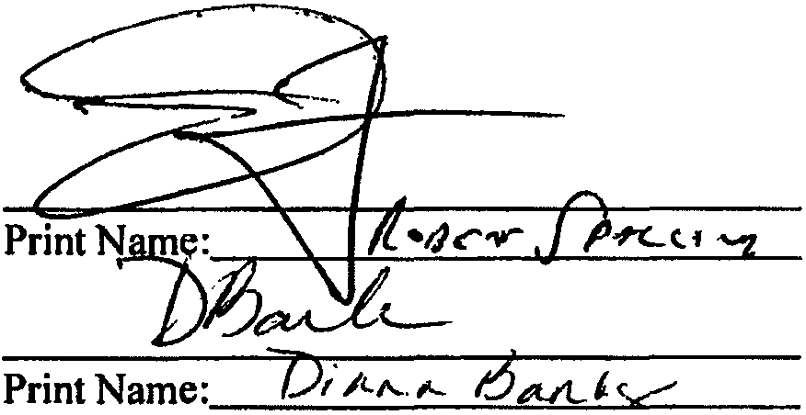By:
SIMQL.ERNSTEIN,Manager

LIMITED PARTNERS:

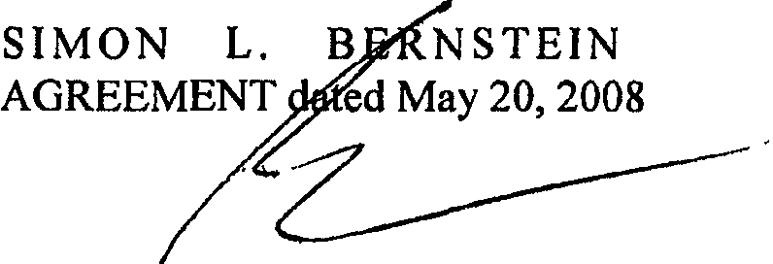
TR U ST
By: __, _
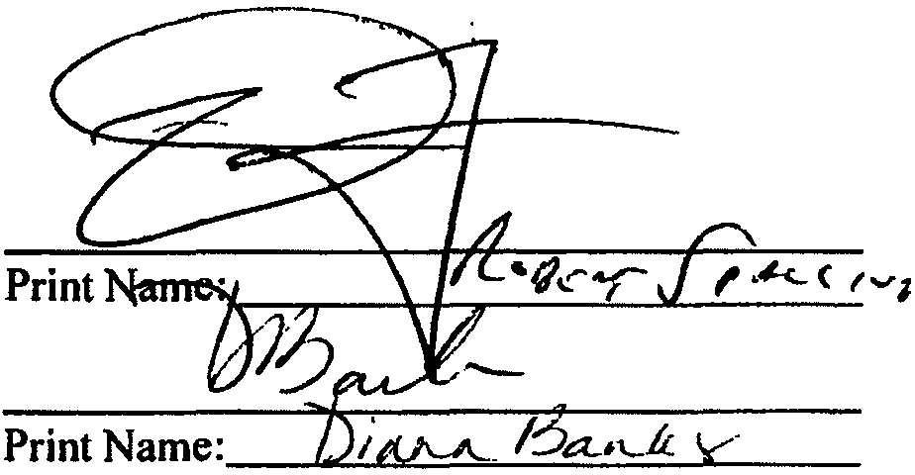\ SIM L. BERNSTEIN, Trustee
J

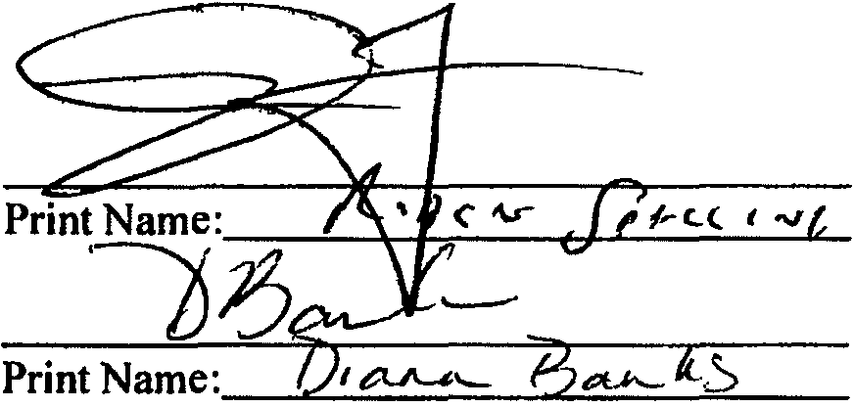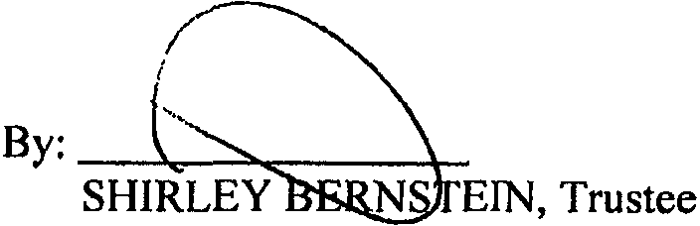SH I R L E Y B E R N S T E I N T R U S T AGREEMENT dated May 20, 2008

) AGREEMENT OF LIMITED PARTNERSHIP OF

STATE OF FLORIDA COUNTY OF PALM BEACH:

: SS.

The foregoing instrument was acknowledged before me this t O day of f\..A ,2008, by SIMON L.BERNSTEIN, Trustee ofthe SIMON L.BERNSTEIN TRUST AGREEM Tdated May 20, 2008, and as Manager of BERNSTEIN HOLDINGS, LLC.
.. UBUC.STATE OF FLOi.'.iA
.:c i1·
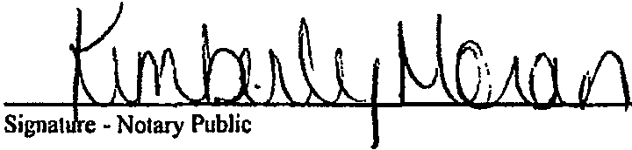P Ki berly Mot·an
.tw eoon 100166470
iEx ire&" APR. 28, 2012
,,,,,.,.,,I' p"" .. CBONDING co.•L. C.
aONDED THRU A:•..,.... •·

[Seal with Commission Expiration Date]

Print, type or s1amp name of Notary Public

Personally Known / or Produced Identification _
Type of Identification Produced -------------------------

)
STATE OF FLORIDA

COUNTY OF PALM BEACH:

: SS.

The foregoing instrument was acknowledged before me this Z.Oday of tv\ 0.. - ,2008, by SHIRLEY BERNSTEIN, Trustee of the SHIRLEY BERNSTEIN TRUST AGREEME Tdated May 20, 2008.
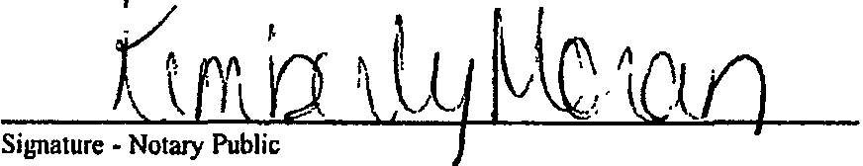;:r:rM;'lpUBLl..STATE OF FLORIDA
,,,.,.,,,,, Kimberly Moran
! Jt.\commission IDD766470
\ l Expires: APR. 28, 2012
[Seal with ComfufiiBWWr ri ifNDejc.

Print, type or slamp name of Nolaiy Public

Personally Known - /,_ or Produced Identification _
Type of Identification Produced -------------------------

F:\WPDATA\drt\Bemstein, Shirley & Simon\Bemstein Family Investments, LLLP\Bernstein Investments, LLLP Partnership Agreement.wpd

) AGREEMENT OF LIMITED PARTNERSHIP OF

SCHEDULE "A"

%
Interest

General Partner:

BERNSTEIN HOLDINGS, LLC _1_% $10.00

Limited Partners:
SIMON L BERNSTEIN, Trustee of the
SIMON L. BERNSTEIN TRUST AGREEMENT
dated May 20, 2008 $495.00

SHIRLEY BERNSTEIN, Trustee of the SHIRLEY BERNSTEIN TRUST AGREEMENT
dated May 20, 2008 $495.00

·,

) NOTE: The foregoing valuations and percentage interests are subject to adjustment based on variations in value of contributed property from the values scheduled here and the actual fair market value of such contributed property on the date of transfer to the Partnership.

) AGREEMENT OF LIMITED PARTNERSHIP OF
BERNSTEIN FAMILY INVESTMENTS. LLLP 33

IN THE CIRCUIT COURT FOR PALM BEACH COUNTY, FL
IN RE: ESTATE OF PROBATE DIVISION

SHIRLEY BERNSTEIN File No. 502011CP000653XXXX SB

Deceased.

INVENTORY

The undersigned personal representative of the estate of SHIRLEY BERNSTEIN, deceased, who died on December 8, 2010, and whose social security number is XXX-XX-9749, submits this inventory of all the property of the estate, that has come into the hands, possession, control, or knowledge of these personal representatives:
REAL ESTATE JN FLORIDA -Exempt (Protected) Homestead: Description
NONE

REAL ESTATE IN FLORIDA -Non-Exempt Homestead:
Description Estimated Fair Market Value

NONE

(Whether homestead property is exemptfrom the claims of creditors, whether it isproperly devised and whether it fs a probate asset may have to he determined by appropriate proceedings.)

OTHER REAL ESTATE IN FLORIDA:
Description Estimated Fair Market Value
NONE $

Total Real Estate in Florida -Except Exempt (Protected) Homestead $

Bar Focm No. P-l.0100
0 Florida Law)'en Suppon Scrvlocs, lni;.
Rtvicwcd Oclobec 1, 1998

- J -
I

Estate of Shirley Bernstein
File No. 50201 1CP000653XXXX SB
INVENTORY

PERSONAL PROPERTY WHEREVER LOCATED:

Description Estimated Fair Market Value

Furniture, furnishings, household goods and personal effects $ 25,000.00 (est.)

TOTAL OF ALL PERSONAL PROPERTY AND FLORIDA REAL ESTATE$ $ 25,000.00

All real estate located outside the State of Florida owned by the decedent of which the personal representative is aware, if any, is described on a schedu le attached hereto. [Ifnone, so ind icate]

NONE

NOTICE: Each residuary beneficiary in a testate estate or heir in an intestate estate has the right to request a written explanation of how the inventory value of any assetwas determined, including whether thepersonal representative obtained an independent appraisalfor that asset andfrom whom the appraisal was obtained. Any other beneficiary may request this information regarding all assets distributed to or proposed to be distributed to that beneficiary.

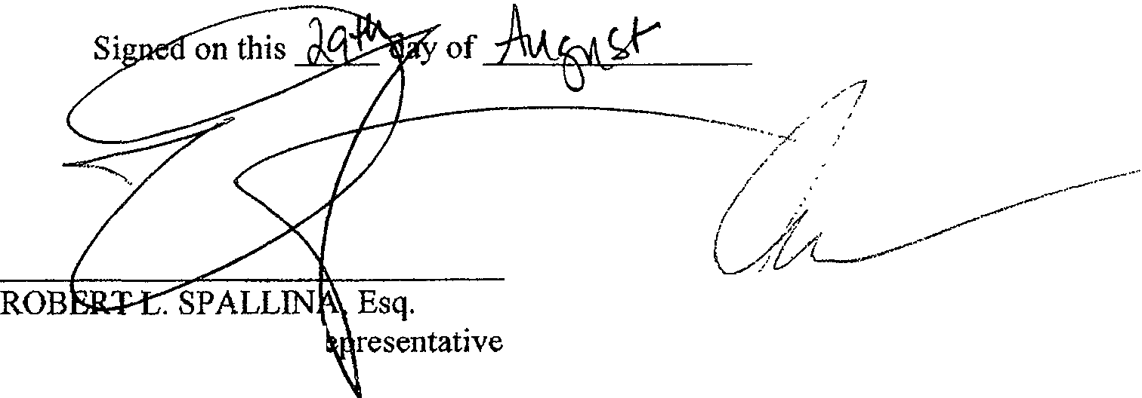Under penalties of perjury, I declare that I have read the foregoing, and the facts alleged are true to the best of my knowledge and belief.

' 2011.

Attorney for Personal R Florida Bar No. 497381 Tescher & Spallina, P.A.
4855 Technology Way, Suite 720 Boca Raton, FL 33431 Telephone: (561) 997-7008

Bar Ponn No. f>.3 0100
C Florida l.t\W)"er1 Support Sctvlw, Ill'; RcmVacdOc1obcr 1, 1998

SJMON BERNSTEIN, Personal Representative

CERTIFICATE OF SERVICE

I HEREBY CERTIFY that a true and correct copy of the foregoing Inventory was furnished by U.S. certified mail to:

Florida Department of Revenue 5050 W. Tennessee St., Bldg. K Tallahassee, FL 32399-0100
on this Cay of J}-(J , 2011.
TESCHER & SPALLINA, P.A.
Attorneys for the Personal Representative of the Estate of Shirley Bernstein
4855 Technolo _Suite 720 Boca Rat_9J1-; lorida 334 Teleph- 61 . 7-700
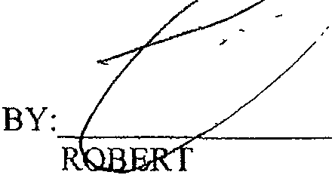/-

L. SPALLINA, ESQ. Florida Bar No. 497381

Dar Ponn No P-:l.1>100
0 Plorida Lll.wyecs Support SeMCCI, Inc Reviewed Oc1obcr I, 1998

LIMITED LIABILITY COMPANY OPERATING AGREEMENT
of

BERNSTEIN HOLDINGS, LLC

a Florida limited liability company

OPERATING AGREEMENT OF BERNSTEIN HOLDINGS, LLC

This Lin bility Company Agreement (the "Agreement") is made and entered into as of
the _U) day of , 2008, by and among BERNSTEIN HOLDINGS, LLC (the "Company"); and SIMON L. BERNS EIN, Trustee of the SIMON L. BERNSTEIN TRUST AGREEMENT datedMay 20, 2008, SHIRLEY BERNSTEIN, Trustee of the SHIRLEY BERNSTEIN TRUST AGREEMENT dated May 20, 2008, SIMON L. BERNSTEIN and SHIRLEY BERNSTEIN, Co-Trustees and ROBERT
- SPALLINA, Independent Trustee of the ELIOT BERNSTEIN FAMILY TRUST dated May 20, 2008, SIMON L. BERNSTEIN and SHIRLEY BERNSTEIN, Co-Trustees, and ROBERT L. SPALLINA, Independent Trustee of the JILL !ANTONI FAMILY TRUST dated May 20, 2008, and SIMON L. BERNSTEIN and SHIRLEY BERNSTEIN, Co-Trustees, and ROBERT L. SPALLINA, Independent Trustee of the LISA S. FRIEDSTEIN FAMILY TRUST dated May 20, 2008, and any subsequent transferee as the Mem bers ("Members"). The Mem bers are herei n sometimes referred to individuall y as a "Member" and collectively as "Members.

WITNESSETH:

WHEREAS, Articles of Organization for BERNSTEIN HOLDINGS, LLC were filed with the Florida Department of State on February 6, 2008.

WHEREAS, the Members desire to reduce their agreements to writing, to set forth the rights and obligations of the Mem bers and the Manager.

NOW, THEREFORE, the Mem bers and the Com pany hereby agree as follows:

ARTICLE I DEFINITIONS
The following terms used in this Agreement shall have the following meanings:

  - "Act" shall mean the Florida Lim ited Liabi l ity Company Act at F.S § 608.401 , et seq and all amendments to the Act.

  - "Articles of Organization" shall mean the A rticles of Organization of BERNSTEIN HOLDINGS, LLC, as fi led with the Department of State of Florida on February 6, 2008, and as may be amended from time to time.

  - "Capital Contribution" shall mean any contribution to the capital of the Company in cash or the fair market value of property by a Mem ber whenever made, net of any liabi lities secured by such contributed property.

LIMITED LIABILITY COMPANY OPERATING AGREEMENT OF BER NSTEIN HOLDINGS, LLC

  - "Capital Account" as of any given date shall mean the Capital Contribution to the Company by a Mem ber as adjusted up to such date pursuant to Article VIII.

  - "Code" shall mean the Internal Revenue Code of 1986 or corresponding provisions of subsequent superseding federal revenue laws.

  - "Company" shall refer to BERNSTEIN HOLDINGS, LLC, a limited liability company formed under the laws of the State of Florida.

  - "Distributable Cash" shall mean all cash, reven ues and funds received by the Company from Company operations, Jess the sum of the following to the extent paid or set aside by the Company:
(i) all principal and interest payments on indebtedness of the Company and all other sums paid to lenders; (i i) all cash expenditures incurred in the normal operation of the Company's business; and (iii) such Reserves as the Managers deem reasonabl y necessary for the proper operation of the Company's busi ness.

  - "Entity" shall mean any genera l partnershi p, lim ited l iabi l ity part nershi p, l imited partnershi p, l im ited l iabi l ity l imited partnershi ps, lim ited l iabi l ity company, corporation, joint venture, trust, business trust, cooperative, association, foreign trust or foreign business organization.

  - "Gifting Member" shall mean any Mem ber who gifts, bequeaths or otherwise transfers for no consideration (by operation oflaw or otherwise, except with respect to bankru ptcy) a ll or any part of its Mem bershi p Interest.

  - "Initial Capital Contribution" shall mean the initial contribution to the capital of the Company pursuant to this Agreement.

  - "Interest" shall mean "Percentage Interest" unless otherwise specifically agreed or in the case of special allocations.

    - "Majority Interest" shall mean the Interests of Mem bers, which in the aggregate exceed 50% of all Interests.

- "Manager" shal l mean one or more managers desi gnated as such pu rsuant to th is Agreement or by subsequent vote of the Members. References to the Manager i n the singular or as him, her, it, itself, or other like references shall also, where the context so req uires, be deemed to include the plu ral or the mascul ine or fem inine reference, as the case may be. Any Person may be named a Manager pursuant to this Agreement

- "Member" shall mean each of the parties who executes a counterpart of th is Agreement as a Mem ber and each of the parties who may hereafter become Mem bers. To the extent a Manager has purchased a Mem bershi p Interest in the Company, he will have all the rights ofa Member with respect to such Mem bershi p Interest, and the term "Member" as used herein shall include a Manager to the extent he has pu rchased such Membershi p Interest i n the Company. Ifa Person is a Mem ber immed iately prior to the purchase or other acquisition by such Person of an Transferee Interest, such Person shall

have all the rights of a Mem ber with respect to such purchased or otherwise acquired Mem bership Interest or Transferee Interest, as the case may be.

- "MembershipInterest" shall mean a Mem ber's entire interest in the Company including such Mem ber's Transferee Interest and, the right to partici pate in the management of the business and affairs of the Company, includ ing the right to vote on, consent to, or otherwise participate in any decision or action of or by the Mem bers granted pursuant to this Agreement and the Act.

- "NetIncome"and "Net Losses" shall mean the income, gain, loss, deductions and credits of the Company i n the aggregate or separately stated, as appropriate, determined in accordance with sound accounting princi ples employed under the cash method of accounting at the close of each fiscal year on the Company's tax return filed for federal income tax purposes.

- "Operating Agreement" (or "Agreement'') shall mean this Operating Agreement of
BERNSTEIN HOLDINGS, LLC, as originally executed and as amended from time to time.

- "Percentage Interest" shall mean, for any Mem ber, the percentage interest that the Capital Account of the Mem ber bears to the total Capital Accounts of all of the Mem bers of the Company, as set forth at Section 9.1 herein, and Exhibit A, as may be changed from time to time by the unan imous vote of the Members.

- "Person" shall mean any ind ividual or Entity, and the heirs, executors, administrators, legal representatives, successors, and assigns of such "Person" where the context so perm its.

- "Reserves" shall mean funds set aside or amounts a llocated to reserves which shall be mainta i ned i n amounts reasonabl y deemed sufficient by the Managers for worki ng capital and to pay taxes, insurance, debt serv ice or other costs or expenses incident to the ownershi p or operation of the Com pany's busi ness.

- "Selling Member" shall mean any Member or Transferee which sells, assigns, pledges, hypothecates or otherwise transfers for consideration all or any portion of its Mem bershi p Interest or Transferee Interest.

- "Transferee" shall be person who has not been admitted by the Company as a Mem ber Partner, but, by virtue of a Transfer of an Interest in the Company to said person, said person is entitled to a pro rata share of one or more of the Company's items of income, losses, credits, and distributions of the Company's assets pursuant to this Agreement and the Act, but said person shall not have, and is not entitled to any right to participate in the management or affairs of the Company, including, the right to vote on, consent to or otherwise participate in any decision of the Mem bers or Manager.

(w)
Member.
"Transferring Memb_er" shall collecti vely mea n a Sell i ng Mem ber and a Gifti n g

(x) "Treasury Regulations" shall i ncl ud e proposed , tem porary and final regu lations prom ulgated under the Code.

ARTICLE II FORMATION OF COMPANY
  - Organization.

BERNSTEIN HOLDINGS, LLC, has been organized as a Florida limited l iabi l ity company by executi ng and del ivering the Articles of Organization to the Florida Department of State in accordance with and pursuant to the Act.

  - Name.

The name of the Company is BERNSTEIN HOLDINGS, LLC, and all business of the Company shall be conducted under that name unless a majority of the Members agree to the filing and use of a fictitious name.

2.3 Principal Place of Business.

The initial princi pal place of business of the Company shall be 950 Peninsula Corporate Circle, Suite 310, Boca Raton, Florida 33487. The Company may locate its places of business and registered office at any other place or places as the Manager may deem advisable.

2.4 Registered Office and Registered Agent.

The Company's i nitial registered office shal l be at the office of its registered agent in Florida, and the name of its i nitial registered agent shal l be Donald R. Tescher, Esq. 2101 Corporate Blvd., Suite 107, Boca Raton, Florida, 33431. The registered office and registered agent may be changed by filing the address of the new registered office and/or the name of the new registered agent with the Florida Department of State pursuant to the Act.

2.5 Term.

The term of the Compan y has fi led Articles of Organization with the Florida Department of State, and shall have perpetual existence, unless the Company is earl ier dissolved in accordance with either the provisions of this Agreement or the Act.

ARTICLE III BUSINESS OF COMPANY
The business of the Company shall be to engage in management of investments, and closely­
held business or real estate ventures, and such lawful activities as are reasonably necessary or useful to the furtherance of the forgoing purpose (the "Business").

ARTICLE IV

NAMES AND ADDRESSES OF MEMBERS

The names of the Members are l isted on Exh ibit A attached hereto and incorporated herein, and the addresses of the mem bers are 950 Peninsula Corporate Circle, Suite 310, Boca Raton, Florida 33487, as amended from time to time.

ARTICLE V

RIGHTS AND DUTIES OF MANAGERS

  - Management.

    - General. The business and affairs of the Company shall be managed by its Managers. The Managers shal l direct, manage, and control the business of the Company. Except for situations i n which the approva l of the Members is expressly requ ired by this Agreement or by nonwaivable provisions of the Act, the Managers shall have exclusive, sole, full and complete authority, power and discretion to manage and control the business, affairs and properties of the Company, to make all decisions regard ing those matters, and to perform any and all other acts or activities customary or incident to the management of the Company's busi ness. At any time when there is more than one Manager, any one Manager may take any action perm itted to be taken by the Managers, unless the approval of more than one of the Managers is expressl y requi red pursuant to this Agreement or the Act. The Managers may create il Board of Directors, and may also appoint individuals with or without titles, includi ng the titles of General Manager, Executive Director, President, Vice President, Treasurer, Secretary, and Assistant Secretary, to act on behalf of the Company with such power and authority as the Managers or Board of Directors may delegate to any such Person.

    - Initial Managers/Designation of Managers/Voting. The Mem bers agree that the initial Manager of the Company is SIMON L. BERNSTEIN. Unless otherwise specifically agreed herein, business decisions of the Company shall be made by said Manager. The Mem bers shall vote their Interests such that only the aforementioned person is Manager of the Company. In all events, an ind ividual shall be a Manager only while she or he is a Mem ber who owns voting Interests (and is not a mere Transferee), either directly or indirectly. After proper notice, in the event of death or mental disability or incompetence of the Manager, the Members shall vote on and elect a new Manager.

  - Certain Powers of Managers.

Without l imiti ng the general ity of Section 5.01 , the Manager (or, if more than one Manager, then the Managers) shall have power and authority, on behalf of the Company to do the following:

- To acqu i re or lease property from any Person as the Managers may determ ine, whether or not such Person is d i rectl y or ind irectly affi l iated or connected with any Manager or Mem ber;

- To borrow money for _the Company from banks, other lend ing institutions, the Man'agers, Mem bers, or affil iates of the Managers or Mem bers on such terms as the Managers deem appropriate, and i n connection therewith, to hypothecate, encum ber and grant security interests in the assets of the Company to secure repayment of the borrowed sums. No debt shall be contracted or l iability incurred
by or on behalf of the Company except by the Managers, or to the extent permitted under the Act, by agents or employees of the Company expressl y authorized to contract such debt or incur such liability by the Managers;

(c) busi ness;

To pu rchase l iabi l ity and other i n surance to protect the Compa ny 's property and

  - To hold and own Company real and personal properties in the name of the Company;

  - To invest Company funds in time deposi ts, short-term govern mental obl igations, commercial paper or other investments;

  - To sell orotherwise dispose ofall or substantially all of the assets of the Company as part of a single transaction or plan as long as such disposition is not in violation of or a cause of a defau lt under any other agreement to which the Company may be bound;

  - To execute on behalf of the Company all instruments and documents, includ ing, without limitation, checks; drafts; notes and other negotiable instruments; mortgages or deeds of trust; security agreements; financing statements; documents providing for the acquisition, mortgage or disposition of the Company's property; assignments, bills of sale; leases; and any other instruments or documents necessary to the business of the Company;

  - To em ploy accountants, legal counsel, managi ng agents or other experts to perform services for the Company;

  - To enter into any and all other agreements on behalf of the Company, in such forms as the Managers may approve; and

U) To do and perform all other acts as may be necessary or appropriate to the conduct of the Company's busi ness.

Unless authorized to do so by this Agreement or by the Manager of the Company, no attorney-in­ fact, employee or other agent of the Company shall have any power or authority to bind the Company in any way, to pledge its cred it or to render it l iable for any purpose. No Member shall have any power or authority to bi nd the Company unless the Mem ber has been authorized by the Manager to act as an agent of the Company in accordance with the previous sentence.

  - Liability for Certain Acts.

Each Manager shall perform his duties as Manager in good faith, in a manner he or she reasonably believes to be in the best interests of the Company, and with such care as an ordinarily prudent person in a like position wou ld use under similar circumstances. A Manager shall not be liable to the Company or to any Mem ber for any loss or damage sustained by the Company or any Mem ber, unless the loss or damage shal l have been the result of fraud, deceit, gross negl igence, wi llful m iscond uct, unlawful acts, or a wrongfu l taki ng by the Manager.

5.4 No Exclusive Duty to Company.

A Mem ber or Manager shall not be requ ired to manage the Company as his or her sole and excl usi ve function and may have other busi ness interests and engage i n activities in add ition to those relati ng to the Company. Neither the Company nor any Mem ber shall have any right, by virtue of this

Agreement, to share or participate in such other investments or activities of a Manager or to the income or proceeds derived therefrom.

  - Bank Accounts.

The Manager may from time to time open bank accounts in, the name of the Company, and the Manager shall be the sole signatory thereon, unless Members owning a Majority Interest determine otherwise.

  - Indemnity of the Managers, Employees and Other Agents.

The Company shall, to the maxi mum extent perm itted u nder the Act, indemnify and make advances for expenses to Managers, its employees, and other agents.

  - Resignation.

Any Manager of the Company may resign at any time by giving written notice to the Members of the Company. The resi gnation of any Manager shall take effect upon recei pt of notice thereof or at such later date specified in such notice; and, unless otherwise specified therein, the acceptance of such resignation shall not be necessary to make it effective. The resignation of a Manager who is also a Mem ber shall not affect the Manager's rights as a Mem ber and shall not constitute a withdrawal of a Member.

  - Removal.

A Manager shall not be subject to removal by vote of the Mem bers except, if at all, pu rsuant to the provisions of this Agreement, as it may be amended by agreement of all of the Mem bers.

  - Vacancies.

To the extent not expressly provided for i n Section 5.1.2 "Voting Agreement of Mem bers," and on ly to said extent, if any: Any vacancy occurring for any reason in the num ber of Managers of the Company may be fi lled by the affirmative vote of Mem bers hold ing a majority of the Percentage Interests present at an election at a meeting of Mem bers called for that purpose or by the Members' unan imous written consent. A Manager elected to fi ll a vacancy shall be elected for the unexpired term of thei r predecessor in office and shall hol d office u nti l the expiration of such term and unti l their successor shall be elected and qual ified or u ntil the Manager's earl ier death, resignation or removal. A Manager chosen to fi ll a position resulting from an increase in the num ber of Managers shall hold office unti l h is successor shal l be elected and qualified, or u ntil h is earl ier death, resignation or removal.

5. I 0 Salaries.

Each Manager shall receive annual compensation (the "Management Fee") if such compensation is agreed to by a majority of the Percentage Interest of the Mem bers in writing, and and shall be entitled to rei mbursement of reasonable and necessary expenses advanced on behalf of the Company.

ARTICLE VI

RIGHTS AND OBLIGATIONS OF MEMBERS

  - Limitation of Liability.

Each Mem ber's l iability to the Company shall be limited as set forth in this Agreement, the Act and other applicable law.

  - Company Liability. A Mem ber will not be personally liable for any debts, obligations, liabi lities or losses of the Company, whether arising in contract, tort, or otherwise, solely by reason of being a Mem ber, beyond his respective Capital Contributions or any obligation of the Member under Sections 8.1 and 8.2 hereu nder, except as provided in Section 6.7 or as otherwise required by law.

  - List of Members.

Upon the written request of any Mem ber, the Managers Shall provide a list showing all of the names, addresses and Mem bership Interests and Transferee Interests in the Company.

  - Approval of Sale of All Assets. The Managers shall have the right, to approve the sale, exchange or other disposition of all, or substantially all, of the Company's assets which is to occur as part of a single transaction or plan.

  - Company Books.

The Managers shall maintai n and preserve, during the term of the Company, the accounts, books, and other relevant Compa ny documents described in Section 9.9. Upon reasonable written request, each Mem ber and Transferee shall have the right, at any time during ord inary business hours, as reasonably determ ined by the Manager, to inspect and copy, at the req uesting Member's or Transferee's expense, the Company documents requ ired to be maintained under Section '608.4101 of the Act, and such other documents which the Managers, in their reasonable discretion, deem appropriate.

  - Priority and Return of Capital.

Except as may be expressly provided in Article IX, no Mem ber or Transferee shall have priority over any other Mem ber or Transferee, either as to the retu rn of Capital Contributions or as to Net Profits, Net Losses or d istributions; provided that this Section shall not apply to loans which a Mem ber has made to the Company.

  - Liability of a Member to the Company.

A Mem ber who recei ves a d istribution or retu rn i n whole or i n part of i ts contribution is l iable to the Com pany only to the extent provided by the Act.

ARTICLE VII

MEETINGS OF MANAGERS AND MEMBERS

7.1 Meetings.

Meetings of the Managers, for any purpose or purposes, may be called by any Manager. Meeti ngs of the Members for any pu rpose or pu rposes, may be called by any Mem bers holdi ng at least 51% of the Percentage Interests of the Mem bers.

  - Place of Meetings.

The Managers may designate any location withi n the U.S., either within or outside the State of Florida, as the place of meeti ng for any meeting of the Mem bers. If no designation is made, or if a special meeting be otherwise called, the place of meeting shall be the principal place of business of the Company.

  - Notice of Meetings.

Except as provided in Section 7.04, written notice stating the place, day and hou r of the meeting and the purpose or purposes for which the meeting is called shall be del ivered not less than five (5) nor more than thirty (30) days before the date of the meeting, either personally or by mail, by or at the direction of the Managers or Mem ber or Mem bers call ing the meeting, to each Mem ber or Manager entitled to vote at such meeti ng. If mai led, such notice shall be deemed to be delivered two (2) calendar days after being deposited in the United States mai l, certified mail return receipt requested, addressed to the Mem ber or to the Manager at its address as it appears on the books of the Company, with postage therei n prepaid. Notice may also be given by telegram, teletype or facsimi le, or other form of electronic communication. Managers and Mem bers may partici pate in and hold meetings whereby all conference telephone or sim i lar communications equ ipment whereby all persons participating i n the meeting can hear each other. Partici pation by commun ications equ ipment shall constitute presence as the meeting, unless a Mem ber or Manager is partici pati ng in the meeti ng for the express pu rpose of objecti ng to the transaction of any busi ness on the ground the meeting is not lawfu lly called or convened.

  - Meeting of All Members and Meetings of All Managers. If all of the Mem bers or al l of the Managers shal l meet at any time and place, and consent to the hol d ing of a meeting at such time and place, such meeti ng shall be valid without call or notice, and at such meeting iawfu l action may be taken.

  - Record Date.

For the purpose of determin ing Mem bers entitled to notice of or to vote at any meeting of Mem bers or any adjournment thereof, or Members entitled to receive payment of any distribution, or i n order to make a determ ination of Mem bers for any other purpose, the date on which notice of the meeti ng is ma i led or the date on which the resolution declared such distri bution is adopted, as the case may be, shall be the record date for such determination of Mem bers. When a determination of Mem bers entitled to vote at any meeti ng of Mem bers has been made as provided i n this Section, such determ ination shall apply to any adjournment thereof.

7.6 Quorum.

Mem bers hold ing at least fifty percent (50%) of a l l Percentage Interests, represented i n person or by proxy, shall constitute a quorum at any meeting of Mem bers, and if there is more than one Manager then serving, then a majority of the num ber of the then-servi ng Managers shall constitute a

quorum at a meeting of the Managers, who shall be represented in person, and shall constitute a quorum at any meeting.

  - Manner of Acting.

Ifa quorum is present, the affirmative vote of a majority of all of the Members represented at the meeting, who must hold a majority Percentage Interest in the Company, shall be the act of the Members, unless the vote of a greater or lesser proportion or num ber is otherwise req u ired by the Act, or by th is Agreement. Unless otherwise expressly provided herei n or req u ired under appl icable law, on ly Mem bers who have a Mem bership Interest may vote or consent upon any matter and thei r vote or consent, as the case may be, shall be counted i n the determ ination of whether the matter was approved by the Mem bers.

  - Proxies.

At all meetings of Mem bers, a Mem ber may vote in person or by proxy executed in writi ng by the Mem ber or by a duly authorized attorney-in-fact. Such proxy shall be filed with the Managers of the Company before or at the time of the meeting. No proxy shall be val id after eleven (11) months from the date of its execution, unless otherwise provided in the proxy. Managers shall not be able to vote by Proxies.

  - Action by Members Without a Meeting.

Action requ ired or permitted to be taken at a meeti ng of Mem bers may be taken without a meeting if the action is evidenced by one or more written consents describing the action taken, signed by each Mem ber entitled to vote and del ivered to the Managers of the Company for inclusion in the m i n utes or for filing with the Company records. Action taken under this Section is effective when all Mem bers ent itled to vote have signed the consent, unless the consent specifies a different effective date.

  - Waiver of Notice.

When any notice is req u i red to be given to any Mem ber, a waiver thereof in writi ng signed by the person entitled to such notice, whether before, at, or after the time stated therein, shall be equ ivalent to the giving of such notice.

ARTICLE VIII

CONTRIBUTIONS TO THE COMPANY AND CAPITAL ACCOUNTS

8.1 Members' Initial Capital Contributions.

Each Mem ber shall contribute such amount as is set forth on the books and records of the Company. No interest shall accrue on any Capital Contribution and the Member shall not have the right to withd raw or be repaid any Capital Contribution except as provided in this Agreement.

8.2 Additional Contributions.

A Member may, but shall not be obl igated to, make such add itional Capital Contributions as shall be determi ned by the Managers. Such additional Capital Contributions shall be reflected in the Account of the Contri buting Mem ber and shall not be a part of any other Member's Capital Account absent written agreement of the Mem bers. After the making of any such determination, the Managers shall give written notice to each Member of the amount ofrequired additional contribution, if any, and each Member may deliver to the Company its pro rata share thereof (in proportion to the respective Percentage Interest of the Member on the date such notice is given) no later than thirty (30) days following the date such notice is given. None of the terms, covenants, obligations or rights contained in this Section 8.2 is or shall be deemed to be for the benefit of any person or entity other than the Mem bers and the Company, and no such third person shall under any circumstances have any right to compel any actions or payments by the Managers and/or the Members.

  - Capital Accounts.

    - A separate Capital Accou nt wi ll be ma intained for each Mem ber. Each Mem ber's Capital Accou nt wi ll be increased by (I ) the amount of money contributed by such Mem ber to the Com pan y; (2) the fair market va lue of property contributed by such Mem ber to the Company (net of
l iabi l ities secured by such contributed property that the Com pany is considered to assume or take subject to u nder Code Section 752); (3) al locations to such Mem ber of Net Profits and Net Losses; and (4) allocations to such Mem ber of income described in Code Section 705(a)(I )(B). Each Mem ber's Capital Accou nt wi ll be decreased by (1) the amount of money distributed to such Mem ber by the Company;
(2) the fair market val ue of property distributed to such Member by the Company (net of liabi lities secured by such d istributed property that such Mem ber is considered to assume or take subject to under Code Section 752); (3) allocations to such Mem ber of expenditures described i n Code Section 705(a)(2)(B); and (4) allocations to the account of such Mem ber of Company loss and deduction as set forth i n such Regulations, taking into account adjustments to reflect book va lue.

    - In the event of a permitted sale or exchange of a Mem bership Interest or a Transferee Interest in the Company, the Capital Accou nt of the transferor shall become the Capital Accou nt of the Transferee to the extent it relates to the transferred Mem bership Interest or Transferee Interest i n accordance with Section 1.704- l (b) (2) (iv) of the Treasury Regulations.

    - The man ner i n wh ich Capital Accounts are to be maintained pursuant to this Section 8.3 is intended to comply with the requ irements of Code Section 704(b) and the Treasury Regu lations prom ulgated thereunder. If the Company determi nes that the man ner in which Capital Accou nts are to be ma intained pursuant to the preced ing provisions of this Section 8.3 should be mod ified i n order to com ply with Code Section 704(b) and the Treasu ry Regu lations, then notwithstand ing anythi ng to the contrary contai ned i n the preced ing prov isions of this Section 8.3, the method in which Capital Accou nts are mai ntai ned shall be so mod ified; provided, however, that any change i n the manner of ma i nta i n ing Capital Accou nts shal l not materi al ly alter the econom ic agreement between or among the Mem bers as set forth i n this Agreement.

    - Except as otherwise requ ired in the Act (and subject to Sections 8.1 and 8.2), no Mem ber or Transferee shall have any liabi l ity to restore a l l or any portion of a deficit balance i n such Mem ber's or Transferee's Capital Accou nt.

  - Withdrawal or Reduction of Members' Contributions to Capital.

    - A Mem ber or Transferee Interest Holder shall not receive out of the Company's property any part of its Capital Contri bution unti l all liabi lities of the Company, except liabil ities to Mem bers on account of their Capital Contributions, have been paid or there remains property of the Company sufficient to pay them.

    - A Mem beror Transferee Interest Holder, irrespective of the nature of its Capital Contribution, has only the right to demand and receive cash in return for its Capital Contri bution.

    - Notwithstand ing anything to the contrary in this Agreement, a Mem ber may withdraw from the Company only at the time or upon the occurrence of an event specified in this Agreement or in the Articles of Organization. No such event is specified i n either the Articles of Organization or in this Agreement at the date hereof. A Member which violates the withdrawal prohi bition in this Section shall be l iable for breach of this Agreement and shall become a Transferee. A withdrawing Mem ber shall not have a right to receive the fair val ue of receive the withdrawing mem ber's Interest in the Company as of the date of the resignation but rather, shall have only such rights as a Transferee would have to receive d istributions as are made by the Company in the discretion of the Managers.

ARTICLE IX

ALLOCATIONS, INCOME TAX, DISTRIBUTIONS, ELECTIONS AND REPORTS

9.1 Allocations of Income and Losses from Operations.

The Net Income and Net Losses of the Company for each fiscal year, and each Member or Transferee's share of Cash Flow, wi ll be allocated in accordance with the Percentage Interests schedule set forth in Exh ibit A attached hereto, and, except as provided therein, the Percentage Interests of Mem bers shall be proportionate to the amount of their Capital Accounts as determined hereinabove.
9.2 Special Tax Provisions As to Extraordinary Allocations, if Any, to Capital
Allocations of Net Income and Net Losses other than those set forth above shall be made based upon the determinations of the tax accountants and attorneys employed by the Company, giving regard to the intention expressed herei nabove and otherwise herei n, with respect to special or priority allocations if any, and with regard to federal partnershi p tax and capital accounti ng princi ples described in Section
8.3 herei nabove.

9.3 Distributions.

With i n the d iscretion of the Managers as to amounts, if any, and as to ti ming, the Managers may d istri bute Cash Flow to the Mem bers, i n accordance with their Percentage Interests .

  - Limitation upon Distributions.

    - No d istributions or return of contributions shall be made and paid if, after the distribution or retu rn of distribution is made either

      - the Company wou ld be insolvent; or

      - the net assets of the Company wou ld be less than zero.

    - The Managers may base a determ i nati on that a d ist ri but i on or ret u rn of contribution may be made under Section 9.4(a) in good faith rel iance upon a balance sheet and profit and loss statement of the Company represented to be correct by the person havi ng charge of its books of account or certified by an independent pu bl ic or certified pu bl ic accountant or firm of accountants to fairly reflect the financial cond ition of the Company.

  - Tax Accounting Principles.

The income and losses of the Company shall be determined i n accordance with sound tax accounti ng pri nciples appl ied on a consistent basis using general ly accepted tax accounting pri nciples as appl ied consistent with the Code.

  - Interest on and Return of Capital Contributions.

No Mem ber shall be entitled to interest on its Capital Contribution or to a retu rn of its Capital Contri bution, except as otherwise provided in this Agreement.

9.7 Loans to Company.

Nothi ng i n this Agreement shall prevent any Mem ber from making secured or unsecu red loans to the Company by agreement with the Company, provided that such loans are arms-length transactions, contai ning terms customary in the lend ing ind ustry at the ti me such loans were made.

  - Accounting Period.

The Company's accounting period shall be the calendar year ("Fiscal Year").

  - Records, Audits and Reports.

At the expense of the Company, the Managers shall maintain records and accounts of the operations and expenditures of the Company. At a minim um, the Company shall keep at its pri ncipa l place of busi ness the following records:

    - A current l ist of the fu ll name and l ast known add ress of each Mem ber and Transferee setting forth the amount of cash each Mem ber and Transferee has contributed, a description and statement of the agreed value of the other property or services, each Mem ber and Transferee has contributed or has agreed to contribute in the future, and the date on which each became a Mem ber or Transferee, and their respective Percentage Interest i n the Company;

    - A copy of the Articles of Organization of the Company and all amend ments thereto together with executed copies of any powers of attorney pursuant to which any amendment has be executed;

    - Copies of the Company's federal, state, and local income tax returns and reports, if any, for the three most recent years;

    - Copies of the Company's currently effective written Agreement, all amendments thereto, and copies of any financial statements of the Company for the three most recent years;

    - Notices of and minutes of every Member and Managers meeti ng,

(f) A ny wri tten consents obtained from Mem bers for actions taken by Mem bers without a meet ing; and

- Unless contained i n the A rticles of Organization or the Agreement, a writing prepared by the Managers setting out the following:

  - The times at which or events on the happening of which any additional contributions agreed to be made by each Member and Transferee are to be made.

- Any right of a Mem ber or Transferee to receive distributions of include a retu rn on all or any part of the Mem ber or Transferee's contributions.

- Any power of a Member or Transferee to grant the right to become an assignee of any part of the Member's or Transferee's interest, and the terms and cond ition of the power.

9.10 Returns and Other Elections.

The Managers shall cause the preparation and timely fi l ing of tax returns requ ired to be filed by the Company pursuant to the Code and all other tax returns deemed necessary and requ ired in each ju risd iction in which the Company does business. Copies of such returns, and pertinent information therefrom, shal l be furn ished to the Mem bers within a reasonable time after the end of the Company's fiscal year upon the Mem bers' written request. A ll elections perm itted to be made by the Company under federal or state laws shal l be made by the Managers i n thei r sole discret ion. It is the i ntention of the Mem bers that the Company shal l be taxed as a "Partnersh ip" for federal, state, and local income tax pu rposes.

9.1 1 Tax Matters Partner.

SIMON L. BERNSTEIN is designated the "Tax Matters Partner" (as defined in Code Section 6231 ), and is authorized and req u ired to represent the Company (at the Company's expense), either d irect ly, or through accounting or tax representatives, i n connection with all examinations for the Company's affairs by tax authorities, includ ing, without limitation admin istrative and jud icial proceed ings, and to expend Company funds for professional services and costs associated therewith. The

Mem bers agree to cooperate with each other and to do or refrain from doing any and all things reasonably required to conduct such proceed ings.

ARTICLE X TRANSFERABILITY
  - General.

    - . Transferees Not Members, Generally. Except as otherwise set forth in Section 10.1.2, or with the consent of all of the Members, neither a Mem ber nor a Transferee shall have the right, as to all or any part of its Mem bership Interest or Transferee Interest to:

      - sell, assign, pledge, hypothecate, transfer, exchange or otherwise transfer for consideration (collectively, "sell" or, as context requ ires "selling"); or

      - gift, beq ueath or otherwise transfer for no consideration (whether or not by operation of law, except in the case of bankruptcy) (collectively, "gift").

A bsent the written consent of all Mem bers to the contrary or otherwise provided by law, the Interest of the Transferee shall be a Non-Voti ng Interest.

  - .2 Transferees Whoare Lineal Descendants of a Member. Any Transferees who are l i neal descendants of both SIMON L. BERNSTEIN and SHIRLEY BERNSTEIN, either d irectly, or ind i rectl y, as beneficiaries ofa Trust, or other entity beneficial ly owned solely for or by that Mem ber (incl ud ing, but not l imited to a revocable trust establ ished by a Mem ber for the sole l ifetime benefit of the Mem ber or the Mem ber's descendants) shall be Mem bers upon thei r written agreement to be bound by the terms of this Agreement and shall be subject to the voting agreements descri bed in Article V, herei na bove.

  - Right of First Refusal.

    - Ifa Selling Member desires to sel l al l or any portion of its Mem bership Interest in the Company to a third party purchaser, the Selling Mem ber shall obtain from such third party purchaser a bona fide written offer to purchase such Interest, stating the terms and cond itions upon which the pu rchase is to be made and the consideration offered; provided, however, the offer shall include a "tag along" or ''take along" provision, pu rsuant to which, all Mem bers have the right to sell a pro-rata portion (determined in accordance with the Percentage Interests of all of the Members) of their Interests to the thi rd party. The Selling Mem ber or Transferee shall give written notification to the remai ning Mem bers, by certified mai l or personal delivery, of its intention to so transfer such Interest, furnishing to the remai ning Mem bers copy of the written offer to purchase such Interest.

    - Each of the remai n ing Mem bers, on a basis pro rata to thei r Percentage Interests or on a basis pro rata to the Percentage Interests of those remai n ing Mem bers exercisi ng their rights of first refusal , shal l have the right to exercise a right of first refusal to purchase a ll (but not less than all) of the Interest proposed to be pu rchased by the thi rd party and sold by the Selling Mem ber and the "tag along Members"upon the same terms and cond itions as stated in the aforesaid written offer to purchase

by giving written notification to the Selling Mem ber and the "tag along Members", by certified mail or personal delivery, of the intention to do so within thirty (30) days after receiving written notice from the Selling Mem ber. Subject to the following paragraph, the fai lure of the remaining Members to so notify the Selling Member and the "tag along Mem bers" of their desire to exercise this right of first refusal within said thirty (30) day period shall result in the termination of the right of the first refusal and the Selling Mem ber and the "tag along Members" shall be entitled to consummate the sale of its Interest in the Company to such third party purchaser, provided that the sale shall be consummated within sixty
- days following the expiration of the aforesaid thirty (30) day period. In the event the remaining Members (or any one or more of the remai ning Mem bers) give written notice to the Selling Mem ber and the "tag along Mem bers" of thei r desire to exercise th is right of first refusal and to purchase all of the Interests of the Sel l ing Mem ber and the "tag along Mem bers" offered upon the same terms and cond itions as are stated in the aforesaid written offer to purchase, the remaini ng Mem bers shall have the right to designate the time, date and place of closing, provided that the date of closing shal l be within sixty (60) days after written notificat ion to the Selling Member of the remaining Member or Members'. election to exercise their right of the first refusal. In the event that two (2) or more Mem bers give written notice of their desire to exercise thei r right of first refusal, absent an agreement between all the Members so exercising such right, each such Member exercising their right of first refusal shall be entitled to pu rchase that percentage of the selling Member's share according to the proportion that thei r Percentage Interests bears to the total Percentage Interests exercising such right of first refusal. The Mem bers shal l communicate with each other during the pendency of any offer made in accordance with the terms of this Section 10.2 in order to effectuate the intent of this Section.

    - As a cond ition to the Company recognizing the effectiveness of either the sale or gift of an Interest in the Company (includi ng, in both cases, a Transferee Interest), the remain ing Members may req ui re the Sell ing Mem ber, Gifting Mem ber and/or the proposed purchaser, donee or successor-i n-interest, as the case may be, to execute, acknowledge and del iver to the remai n ing Mem bers such instruments of transfer, assignment and assumpt ion and such other certificates, representations and documents, and to perform all such other acts which the remai ning Members' may deem necessary or desirable to:

( I ) verify the purchase, gift or transfer, as the case may be;

  - confi rm that the person desiring, to acqu i re an Interest i n the Company, or to be adm itted as a Mem ber, has accepted, assumed and agreed to be subject and bou nd by al l of the terms, obl igations and cond itions of the Agreement (whether such Person is to be admitted as a new Mem ber or as a Transferee);

  - mai ntain the status of the Company as a partnersh ip for federal tax purposes; and

  - assure compl iance with any applicable state and federal laws including securities laws and regulations.

    - Any sale or gift of a Membershi p Interest or Transferee Interest in compl iance with this Article X shall be deemed effective upon the last day of the calendar month in which all the terms and cond itions hereof relating thereto have been satisfied. The admission of a Mem ber in compl iance with this Article X shall be deemed effective as of the last day of the calendar month i n
LIMITED LIABILITY COMPANY OPERATING AGREEMENT OF

.,_.,,-c.. '',¥·,#"1f""i>"'+P,,-< .O;Jci9!J¥fl}/i\*1;;:$1\4..fiJl¥fij;w5,;f;;(J;!lii.i,jki)tg;·S±*i<'. ·'1j¥ i

which the remaining Members' consent thereto was given. The Selling Member hereby indemnifies the Company and the remain ing Mem bers against any and all loss, damage, or expense (including,
. without limitation, tax l iabilities or loss of tax benefits) arising directly or indirectly as a result of any transfer or purported transfer in violation of this Article X.

",,-'.?':

  - Permitted Transfer to Descendants/Mandatory Offer at Death.

10.3. l No Mandatory Offer At Death. Ifa Mem ber's Interest is Transferred to a lineal descendant of the Mem ber, to a Trust or other entity beneficially owned solely for or by that Member or the lineal descendant of that Mem ber, the Transferee shall not be required to sell or offer to sell his or her Interest, shall be el igible to become a Member pursuant to Sections 10.1.l and 10.1.2 above, and shall be subject to the voting agreements described in Article V, above. If Mem bers of the Company are trusts for the lifetime benefit of the lineal descendants of a Mem ber either d irectly or indirectly, then the successors i n interest to the Interests in the Company_ pursuant to the terms of such trusts shall be considered as Mem bers hereof (regard less of ind irect ownership as trust beneficiaries) as long as the beneficial interests are owned by the lineal descendants of the Mem ber, and said persons shall be subject to the voti ng agreements described i n Article V, above.

I 0.3.2 Mandatory Offer At Death . Except wi th transfers described i n 10.3.1 ., above, the death of any Mem ber or Transferee who owns an Interest shall constitute an offer by the Mem ber's Estate, Trust, or other legal successor i n interest, to sel l all of the Mem ber's Interest to the Company (the "Offer") at its fair market val ue (determ ined as of the date of death). The Company shall have one hund red eighty (180) days i n which to accept the Offer at an agreed price, which acceptance shall be made by del ivery of written notice thereof to the legal representative of the estate of the Member or Transferee, by certified mai l or personal delivery, within said one hundred eighty (180) day period. If the Company does not elect to purchase the Interest within said one hundred eighty (180) day period, the remaini ng Mem bers shall have the right, but are not req uired to, purchase the remai ning part, or all, as the case may be, of the Interest at its fair market value (as determined herein) determined as of the date of death, in proportion to their existing Interests. Such right to purchase shall be exercised by delivery of written notice thereof, by certified mail or personal delivery, during the thirty (30) days immed iately after the one hundred eighty (180) day period (the "30 Day Period"). Ifany such Mem ber does not desire to purchase his/her or its full proportionate part of the Interest offered for sale, but the remai n ing Mem bers desire to purchase all of the Interest offered for sale, said Mem bers shall then have the right to pu rchase said Interest proportionally in accordance with thei r respective Interests and the Mem bers shal l comm unicate with each other du ring the 30 Day Period i n order to effectuate the intent of this Section 10.3. Except as provided i n Section I 0.1 .2 and I 0.1 .3, to the extent that any part, or all, of an Interest is not pu rchased under the provisions of th is Section 10.3, the deceased 's Mem ber's Interest shall become a Transferee's Interest, if not owned beneficially or d irectly by another Mem ber hereof. The pu rchase price shall be as agreed by the parties, and, u nless otherwise agreed, shall be paid
i n cash at the closing, wh ich shal l occur no later than th irty (30) days after the end of the 30 Day Period. For pu rposes of th is Agreement, the "fair market va lue" of an Interest is equal to its Percentage Interest mu ltiplied by the va lue of the Company (as agreed by the parties). Ifthe val ue of the Company is not agreed to by the parties, then for purposes of this Agreement "fair market value" of a Mem ber's Interest shal l be determined without red uction for minority, lack of marketabi lity or other entity/Company level discounts, based upon a reasonable appraisal procedure to determi ne the fair market value of the Company's assets. The appraisal procedure shall be agreed upon by the Member and Company. Ifthe

parties cannot agree to an appraisal procedure, then an MAI appraiser shall be selected by the Personal Representati ve of the deceased Mem ber's estate, and if the Company does not agree as to that appraiser, then the Company shall select its own appraiser and each MAI appraiser then shall select a third MAI appraiser and the average of all three (3) appraisals shall be the fair market value of the Interest. As set forth hereinabove, fair market value" ofa Mem ber's Interest shall be determ ined without reduction for minority, lack of marketabi l ity or other entity/Company level discounts.

I 0.4 Transferee Not Member in Absence of Unanimous Consent.

- Except as provided in Section I 0.1.2 and I 0.1.3, ifall of the remain ing Members do not approve by unan imous written consent of the proposed, sale or gift of the Transferring Mem ber's Mem bershi p Interest to a transferee or donee which is not a Member immediately prior to the sale or gift, then the proposed transferee or donee shall have no right to partici pate in the management of the business and .affairs of the Company or to become a Mem ber. The transferee or donee shall be merely a Transferee entitled solely to economic rights to profits, losses and distri butions and shal l have no voting rights under this Agreement or in matters relating to the Company and its business; provided, however, any sale of a Transferee's interest in the Company should be subject to Section 10.2. No transfer of a Member's Interest in the Company (including any transfer of the Transferee Interest or any other transfer which has not been approved by unanimous written consent of the Mem bers) shall be effective unless and unti l written notice (includ ing the name and address of the proposed transferee or donee and the date of such transfer) has been provided to the Company and the nontransferri ng Mem ber(s).

- Upon and contem poraneousl y with any sale or gift of a Transferri ng Mem ber's Interest i n the Com pa ny wh i ch does not at the same time transfer the ba lance of the rights associated with the Transferee Interest transferred by the Transferri ng Mem ber (incl ud ing, without l imitation, the ri ghts of the Transferri ng Mem ber to part icipate in the management of the business and affairs of the Company), a l l remaining rights and interest which were owned by the Transferring Mem ber immediately prior to such sale or gift or which were associated with the transferred Interest shall immediately lapse unti l the remaining Mem bers, by unanimous written consent, reinstate such rights to the Transferee who did not prev iously obtain the unan imous written consent, reinstati ng such rights to a successor or transferee of such Transferee.

ARTICLE XI ADDITIONAL MEMBERS
From the date of the formation of the Company, any Person or Entity acceptable to the Members by thei r unan imous vote thereof may become a Mem ber in this Company for such consideration as the Mem bers by thei r u nanimous votes shall determ ine, subject to the terms and cond itions of this Agreement. No new Mem bers shall be_ entitled to any retroactive allocation of profits losses, income or expense deductions incurred by the Company. The Manager(s) may, at their option, at the time a Mem ber is admitted, close the Company books (as though the Company's tax year has ended) or make pro rata al locations of income, loss, and expense deductions to a new Mem ber for that portion of the Com pany's tax year in which a Mem ber was admitted i n accordance with the provisions of Code Section 706(d) and the Treasu ry Regu lations prom u lgated thereu nder.

ARTICLE XII DISSOLUTION AND TERMINATION
  - Dissolution.

events:
- The Company shall be dissolved upon the occurrence of any of the following

  - by the unani mous written consent of al l Mem bers; or

  - ) the sale, transfer or assignment of substantially all of the assets of the Company; or

  - as otherwise requ ired by law.

  - Winding Up, Liquidation and Distribution of Assets.

    - Upon dissolution, an accounting shall be made by the Company's independent accountant of the accounts of the Company and of the Company's assets, l iabi l ities and operations, from the date of the last previous accounting unti l the date of dissolution. The Managers shall immed iately proceed to wind up the affairs of the Company.

shall:
    - If the Company is dissolved and its affai rs are to be wou nd up, the Managers

      - Sell or otherwise liquidate all of the Company's assets as promptly as practicable (except to the extent the Managers may determine to distribute any assets to the Mem bers i n kind),

- Al locate any profit or loss resu l ting from such sales to the Mem ber's and Transferees' Capital Accou nts in accordance with Article IX hereof.

- Discharge a l l l iabi lities of the Company, includ ing l iabilities to Mem bers and Transferees who are cred itors, to the extent other-wise perm itted by law, other than l iabi l ities to Mem bers and Transferees for Distri butions, and establish such Reserves as may be reasonably necessary to provide for contingent liabilities of the Company (for pu rposes of determin ing the Capital Accou nts of the Members and Transferees, the amounts of such Reserves shall be deemed to be an expense of the Company),

- Distri bute the remaining assets in the following order:

  - - Ifany assets of the Company are to be d istributed in kind, the net fa i r market val ue of such assets as of the date of dissolution shall be determined by
independent appraisal or by agreement of all of the Mem bers. Such assets shall be deemed to have been sold as of the date of dissolution for their fai r market value, and

the Capital Accounts of the Mem bers and Transferees shall be adjusted pursuant to the provisions of Article IX and Section 8.3 of this Agreement to reflect such deemed sale.

  - ) To the Members and Transferees, pro rata, in accordance with the positive balance (if any) of each Member's and Transferee's Capital Account (as determined after taking into account all Capital Account adjustments for the Company's taxable year during, which the liquidation occurs) shall be distributed to the Members and Transferee either in cash or in kind, as determined by the Managers, with any assets distributed in kind being valued for: this purpose at their fair market value as determined pursuant to Section l 2.2(b)(i).

  - i) Thereafter, to the Mem bers and Transferee 's PIQ rata, i n accordance with their respective Percentage Interests.

    - Notwithstand ing anything to the contrary i n this Agreement, upon a l iqu idation with i n the mean ing of Section l.704- l (b)(2)(i i)(g) of the Treasury Regu lations, if any Mem ber has a Deficit Capital Accou nt (after giving effect to a l l contributions, distributions, allocations and other Capital Account adjustments for all taxable years, i ncl ud ing the year during which such liquidation occurs), such Mem ber shall have no obligation to make any Capital Contribution, and the negative balance of such Mem ber's Capital Accou nt shall not be considered a debt owed by such Mem ber to the Company or to any other Person for any pu rpose whatsoever.

    - Upon completion of the wind ing up, l iqu idation and d istribution of the assets, the Com pany shal l be deemed termi nated.

    - The Manager(s) shall comply with al l req uirements of appl icable law pertai ning to the wind ing up of the affairs of the Company and the final d istribution of its assets.

  - Articles of Dissolution.

When all debts, l iabil ities and obligations of the Company have been paid and discharged or adequate provisions have been made therefor and all of the remaining property and assets of the Company have been d istributed among its members in accordance with their respective rights and interests, a Articles of Dissolution of the Company shal l be filed with the Florida Department of State.

  - Effect of Filing Articles of Dissolution.

U pon the fi l i ng of Articles of Dissol ution with the Florida Department of State, and upon issuance of the Certi ficate of Dissol uti on by the Department of the State, the existence of the Compa ny shall cease, except for the pu rpose of suits, of the proceed ings and appropriate action as provided i n the Act. The Managers shall have authority to d istribute any Com pany property d iscovered after dissol ution, convey real estate and take such other action as may be necessary on behalf of and in the name of the Company.

  - Return of Contribution Nonrecourse to Other Members.

·---- ---· ----- ------..---- -------- -

Except as provided by law or as expressly provided in this Agreement, upon dissolution, each Member and Transferee shall look solely to the assets of the Company for the return of its Capital Contribution. If the Company property remaining after the payment or discharge of the debts and liabilities of the Company is insufficient to return the cash contribution of one or more Mem bers or Transferees, such Member(s) or Transferee(s) shall have no recourse against any other Member or Transferee, except as otherwise provided by law.

ARTICLE XIII MISCELLANEOUS PROVISIONS
13.l Notices.

Any notice, demand, or communication required or permitted to be given by any provision of this Agreement shall be deemed to have been sufficiently given or served for all purposes if delivered persona lly or by express mail or courier service (with recei pt acknowledged) to the party or to an executive officer of the party to whom the same is d irected, if telecopied (with receipt acknowledged) to the party or an executive officer of the party to whom the same is directed or, if sent by registered or certified mai l, postage and charges prepaid, addressed to the Mem ber's and/or Company's address, as appropriate, wh ich is set forth in th is Agreement. Except as otherwise provided herei n any such notice shal l be deemed to be given two (2) business days after the date on wh ich the same was deposi ted in the United States mai l , addressed and sent as aforesaid, if sent by mai l or upon confirmation of recei pt if del ivered by telecopier, personal del i very or courier serv ice.

  - Books of Account and Records.

Proper and complete records and books of account shall be kept or shall be caused to be kept by the Managers i n which shall be entered fu l ly and accuratel y a ll transactions relating. to the Company's business in such detai l and completeness as is customary and usual for businesses of the type engaged
i n by the Company. Such books and records shal l be mai ntained as provided in Section 9.9. The books and records shal l at all times be ma intained at the principal place of business of the Company. Add itionally, the Managers shall prom ptly d istribute to all Mem bers, copies of the Company' financial statements on an annual basis.

  - Application of Florida Law.

This Agreement and its interpretation shall be governed exclusively by its terms and by the laws of the State of Florida, and specifically the Act.

  - Waiver of Action for Partition.

Each Mem ber and Transferee frrevocabl y wa ives du ring the term of the Company any right that it may have to ma intain any action for partition with respect to the property of the Company.

  - Amendments.

This Agreement may not be amended except in writing by the affirmative vote of a majority of the Members of the Company which vote must include the affirmative vote of the Manager. Any amendment changing either the Percentage Interests of the Mem bers or any provision within Article V
- req u ires the unanimous vote of the Mem bers.

  - Execution of Additional Instruments.

Each Mem ber hereby agrees to execute such other and further statements of interest and hold ings, designations and other instruments necessary to comply with an laws, rules or regulations.

  - Construction.

Whenever the singu lar num ber is used in this Agreement and when requ ired by the context, the same shall i nclude the pl u ral and vice versa, and the mascu l ine gender shall include the fem inine and neuter genders and vice versa. ·-

  - Headings.

The head ings in this Agreement are inserted for convenience only and are in no way intended to describe, interpret, define, or l im it the scope, extent or intent of this Agreement or any provision thereof

  - Waivers.

The fai lu re of any party to seek redress for default of or to i nsist upon the strict performance of any covenant of cond ition of this Agreement shall not prevent a subseq uent act, which would have ori gina l ly constituted a defau l t, from havi ng the effect of an original default.

13. 10 Rights and Remedies Cumulative.

The rights and remed ies prov ided by this Agreement are cumu lative and the use ofany one right or remedy by any party shall not precl ude or waive the right to use any other remedy. Said rights and remed ies are given in add ition to any other legal rights that parties may have.

  - 1 Severahility.

Ifany provision of this Agreement or the appl ication thereof to any person or circumstance shall be inval id, i l legal or unenforceable to any extent, the remai nder of this Agreement and the appl ication thereof shall not be affected and shall be enforceable to the fullest extent permitted by law.

  - Heirs, Successors and Assigns.

Each and all of the covenants, terms, provisions and agreement herein contained shall be bind ing upon and inure to the benefit of the parties hereto and, to the extent permitted by this Agreement, their respective hei rs, legal representatives, successors and assigns.

  - Creditors.

None of the provisions of this Agreement shall be for the benefit of or enforceable by any creditors of the Company.

  - Counterparts.

This Agreement may be executed in counterparts, each of shall be deemed an original but all of which shall constitute one and the same instrument.

  - Conflict of Interest Waiver. The Mem bers and the Company acknowledge that the law firm of Tescher & Spallina, P.A. has represented the Company in connection with the drafting of this Agreement and the formation and structuring of the Company, and that said law firm also represents one or more of the Members (namely, SIMON L. BERNSTEIN, SHIRLEY BERNSTEIN, SHIRLEY BERNSTEIN FAMILY FOUNDATION, INC., and BERNSTEIN FAMILY INVESTMENTS, LLLP). The Company and its Members acknowledge that they have been advised that there are material income tax consequences and economic ramifications from being a Mem ber in the Company, that they fully understand the tax consequences and economic ramifications ofa Mem ber's investment in the Company, and that they have been encouraged to consult with separate and independent counsel to advise them on Company and Mem ber issues i nclud ing this Agreement and the formation of the Company. The Company and the Mem bers hereby waive any confl icts of interest with respect to the foregoing law firm 's representation of the Compan y and the afore described Members and owners of interests i n entity Mem bers, i n connection with the services set forth in this Section.

======================
IN WITNESS WHEREOF, the parties hereto have caused their signatures, or the signatures of their du ly authorized representatives, to be set forth below on the day and year first above written.

Witnesses: MEMBERS:
AGREET

May 20:2008

SI M ON L. B ERN STE I N TR U ST
dated
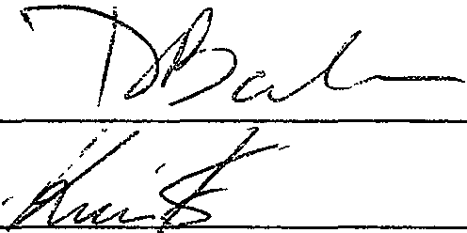By: $---------------
IMON L. BERNSTEIN, Trustee

S H I R L E Y B E R N S T E I N T R U S T
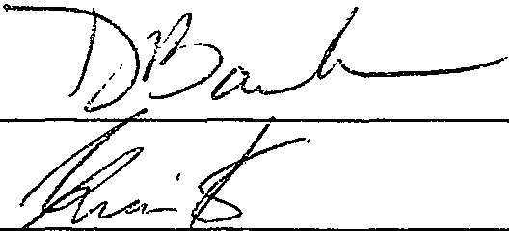AG dated May 20, 2008

By: · -
SHIRLEY BERNSTEIN, Trustee

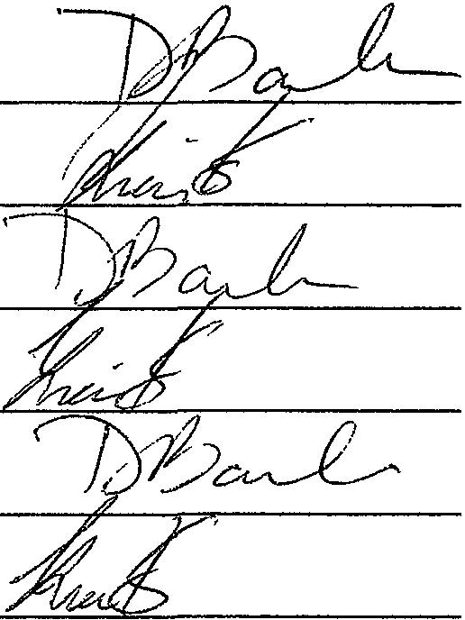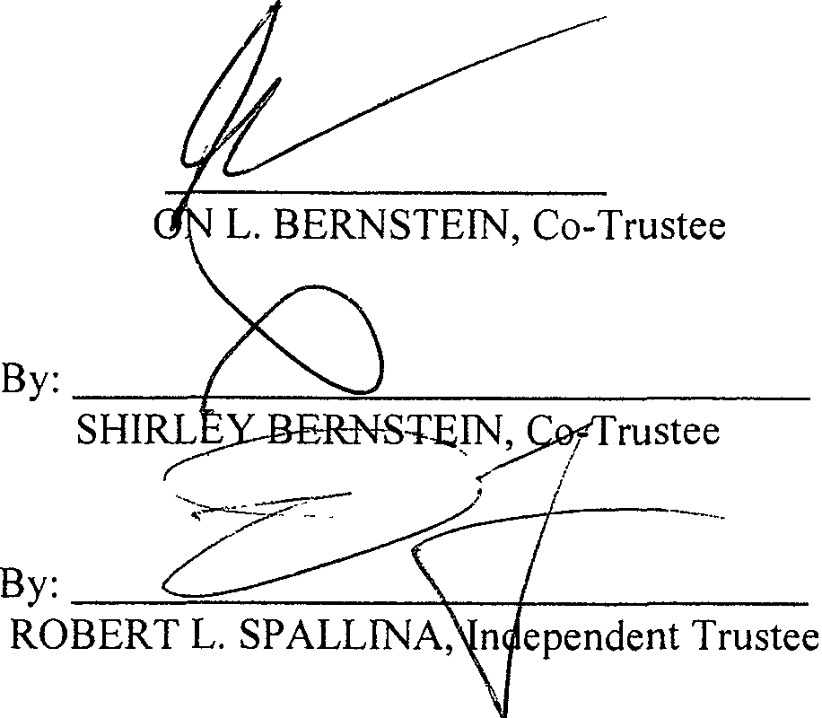ELIOT BERNSTEIN FAMILY TRUST dated May 20, 2008

By: --.f-- ­
SIM

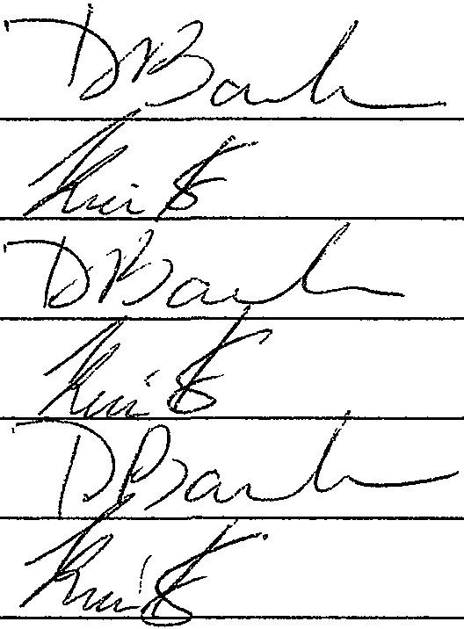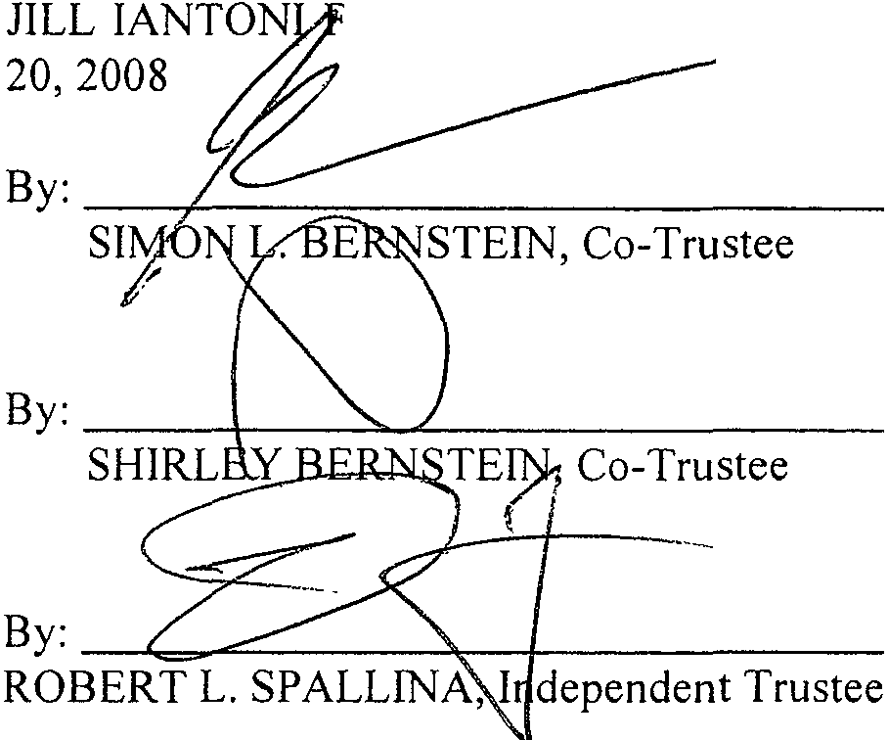
AMILY TRUST da-te-d--May

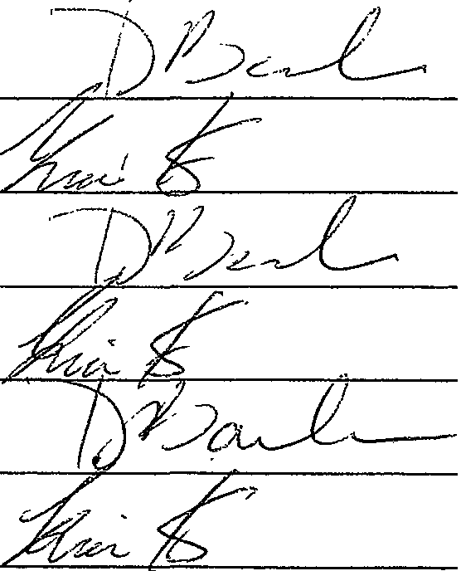LISA S, FRIEDSTE FAMILY TRUST dated May 20, 2008 ---
By: -=-
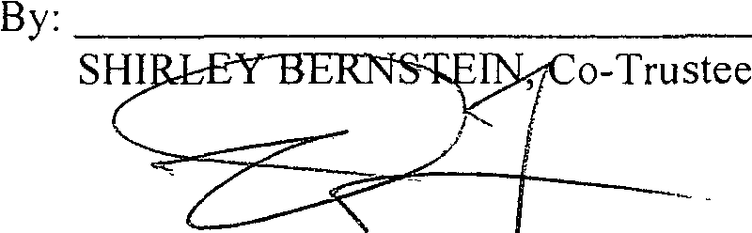SIM L. EIN, Co-Trustee

By: ----.: -+-
ROBERT L. SPALL ependent Trustee

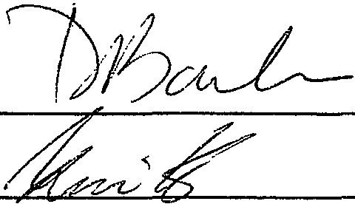BE:RitNedSITiEIN HOLDINGS, LLC, _a F/lorida
COMPANY:

SIMO,,.RNSTEIN,Manager

F \WPDATA\drt\Bernstem, Shirley & Simon\Bernstem Family Investments, LLLP\Bernstem Holdings, LLC\Bernsrem Holdings, LLC Operating Agreement wpd

BERNSTEIN HOLDINGS, LLC LIMITED LIABILITY COMPANY OPERATING AGREEMENT

EXHIBIT A

Percentage Capital
Mem ber(s) Interest* Contri butions

SIMON L. BERNSTEIN, Trustee
of the SIMON L. BERNSTEIN TRUST
AGREEMENT u/t/d May 20, 2008 48.5% $48.50

SHIRLEY BERNSTEIN, Trustee
of the SHIRLEY BERNSTEIN TRUST
AGREEMENT u/t/d May 20, 2008 48.5% $48.50

SIMON L. BERNSTEIN and SHIRLEY BERNSTEIN,
Co-Trustees
ROBERT L. SPALLINA, Independent Trustee of the ELIOT BERNSTEIN Family Trust
dated May 20, 2008 | 1% | $1.00

SIMON L. BERNSTEIN and SHIRLEY BERNSTEIN,
Co-Trustees  ROBERT L. SPALLINA, Independent Trustee of the JILL!ANTONI Family Trust  dated May 20, 2008 | 1% | $1.00

SIMON L. BERNSTEIN and SHIRLEY BERNSTEIN,
Co-Trustees
ROBERT L. SPALLINA, Independent Trustee of the LISA S. FRIEDSTEIN Fam i ly Trust  dated May 20, 2008 | 1% | $1 .00

*proportionate to capital accounts of Mem bers

