Case 3:15-cv-07118-AET-LHG Document 9 Filed 10/01/15 Page 1of 22 PagelD: 143
- Case 3:15-cv-07118-AET-LHG Document 7 Filed 09/28/15 Page 1of 14 PagelD: 104

UNrrBD STATES DISTRICT COT DISTRICT OF NEW JERSEY
)

C.A.·No._._

SBCURITIES AND EXCHANGE COMMISSION,
- Plainti

v.
.... .
DONAW R. TBSCHBR. et al.,
. '

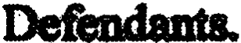

·CONS O:FDD'ENDANT DONALD.R. TE
  - 1. Defendant Donald.R. Tescber ("Defendant") waives service of a summons aild
the compJaint in . action. enteri a general appearance, a1icl adinita the s urisdiction over

herein inparaaraph ·12and..except as to PerDu.l and subjectmatter ction, which
. Defendant adm.. its), Defendant here.by eonsents to the entry of the fin.ral Judgmcat inthe fomi
• • 4 • • • •

attached he!eto (tho "Fmal Jmit") and incoJporated reference herein, which, among other
tbjnp:

' .
IO(b) and 14(e) ofthe Securities change Act of t934 ("Rxchange Act? ··
[lSU.S.C.§§ 78j(b) and 78n{e)) and Rules lOb-S ind 14&-3 thereunder [17 C.F.R.·*§240.lOb-S and.240. 14e-3);
(b) · orders DefeDdapt tO disgorgement inthe amount of $9,'!J7,plus · prejudgment interest thereon intheamount of $690;and

1.

Case 3:15-cv-07118-AET-LHG Document 9 Filed 10/01/15 Page 2 of 22 PagelD: 144
- Case 3:15-cv-07118-AET-LHG Document 7 Filed 09/28/15 Page 2 of 14 PagelD: 105

. ,
- orders Deto pay a civil penalty in1heamount of $9,937 under ·
. .
Section 21A of tbe Exchange Act [ISU.S.C.§ 78u-1].
. "
- Defendant agrees that he shall not se.ek or accept, dii'ectly or indirectly,
reimbqrsemmt or jndernnJfic.atioo from. any source, includilig but not limitedto payment made pursuant to any insurance policy,withregardto any civil penalty amounts that Defemlant pays pursuant to the Final Judgment. regardless ofwhether suchpenalty amounts or any part tbereo
are added to a distributi0a fund or otherwise used for the benefit of investon. ·DefeDdant fbrther
agrees that be shall not claim, assert, or apply for atax deduction or tax ciedit with regard to .,.y
·federal, stale, or local tax for any penalty .amothat Defendant pays pursuant.to the Final
, <

·.Judplent. ess of wbetlm·sUchpenalty amOUDts any part thereof are addedto a
diStribldi fund or otherwise used for.the benefit of investors..
- Defendant tectP that the Court is not imposinga ciyil penalty in excess
·of$9,937 based on DefeQdant'scooperation ina Commi•on inwsdptio.n and/ormated
. .; _, • •· ·. ' •· • ·'""-• ;,,,. a • ; •"· .._ '. ·•· .. ; • • ' • • ' ' • • • • • ' ,., • • , ... • ·• ,. • • ..; ,;, ;,- ; _, .; ' ,.,, -,.-.-, ; •• ; .-. •

action.
eonsents that ifat an1time followin& the eJl1rJ otthe rrma1
(•
.

Judgment Commiaion obtains infomuttion incticatins that Defendant lmowinalY pm,videcl
materially false or mislead infonnation or materials to the Commission or inarelated
. . .
iJroceedin& the Commission may, at its sole OD am without prior notice to the Defendant;.
petitionthe ·for an order requiring Defendant·topay an additional civilpenalty. In
. ·connection with the Commission' smotion for civilpenal1ies, and at any hcmin1held on such a motion: (a) Defendant Will be preCtuded from arguing that hedid not viol8te the federal securities laws as alleged in the Complamt; (b) Defendant may not challenge the validity ofthe Judgment, this Consent, or any related Undertakings; (c) the of the cOmp solely for purposes of' motion, shall beaccepted as and deemed 1rueby the Court; and (d) the

. 2

Case 3:15-cv-07118-AET-LHG Document 9 Filed 10/01/15 Page 3 of 22 PagelD: 145
- Case 3:15-cv-07118-AET-Lf:iG Document 7 Filed 09/28/15 Page 3 of 14 PagefD: 106

CoUl'.lmay deterlnine the issuos raised inthe motionon the basis of affidavits, declarations, excapCB of sworn deposi or investigative testimony, anddocumentary evidence without reprdto the standards for SUIDID8I)' judsment CODtaiDecl inRule S6(c) ofthe Federal Rules of
Civil Procedme. Under these cireumstances, theparties may tab discovery,including disc.overy
·-
  - S. Defendant waives die Ol1tlJ of ftnclinp of fact and conclusiom of lawpursuant to

Rule 52 ofthe Federal Rules of Civil Procedme.
6. Defendant waives the right, ifany, to ajury 11'.:ial and to appeat iom the 011t1J of.
the FinalJudgment.
,7. Defendant enters into thia CODSeDt volmdarily and 1epieaerd8 that DO tbieats,
o1l\n, promises, or inducementa of any kind haw been made by. the Conmrission or any .,. " member.ofticer,employee, apnt, or representative of the Cc>mmissiou to incluce Dcfendaul to enter into this C.onsent.

- Defendant lllW that tbia Consent shall be incorpomtecl into the Final Judpent
withthe same foJCe and effect as if 1blly set forththerein.

- · Defendant willnot oppose the enforcement of the Final Judgment on the ground,
,.
if any exists, that itfails to comply with Rule 6S(d) ofthe Fedeml Rules of Civil Proceclme. and
hereby waives any objection basedthereon. "

- Defendant waives aonrice of the Fm' al Judgment andaglees that entry of the Pinal Judgment by the Court and filina with the Cleit of the Court wiD constitute notice to Defendant . of its terms and conditions. Defendant fbrtber aarees to provide counsel for the Commission, within thirty days after the Final Judgment is filed widl the Clerk of die Court, with an aftidavit

or declaration stating dud Defendant bu received and read acopy of the Fm'
al Judgment.

3

Case 3:15-cv-07118-AET-LHG Document 9 Filed 10/01/15 Page 4 of 22 PagelD: 146
- Case 3:15-cv-07118-AET-LHG Document 7· Filed 09/28/15 Page 4 of 14 PagelD: 107 ·

' .
11.· Consistent with 17 C.P.R. §202.S(f), tbis.ConsCnt reso.lves only the Claims
issertedaPmst Defendnt inthis.civil Ing ldatotbalt nopromise or
. .
. · 1ep1esmtation has beenmade by the Cnmnrission or any. 'otlicer,Cmployee, agent, 0r
w f the·C!ommissic>n with regmd to any al li8bility that may have arisen or
may arise JiOm the faclB underlyina this aidon or immuDitJ tiom any criniinal liabilitJ.
. Defendant waives any.claim of DoubleJeopardy uponthe eat.of tbia .... including the imposition of miy relnedy or civil penalty berebi. Defmctant fiD1h'4' ·
that the Court'sentry of apermanent on may have collateral UDder federal
. .,. .
or state law and the rutes and ieguJatiOns of self-regulatory orpnimions, 1icensina boards, and
other regulatoJy organiZa.tions. Suchcollateral consequences but are·n limitedto, a
.statuto!Y with:iespect to or participation in,0r on widi a ·
. .
.... . .. . .. · .. . .. . ,. .. ·. :· . · .
mmnb:r o( a.Seit -nibsbdutol)'. 1118 COJ1soquencea1hat
.;::· :
·are seParate ·&om any sandion imposed inin administrBtive ins ..In addition, inany.
• :, ..- " ; ;n..- .;.c ;.;.<.4..... · ' ll ·'; .,: . . " ..,. ._ ;..,.'. . · ·· .,, _;··';";,:.,:;..'. . - ;;...:·::.:· ./ . .;-..- ;,oo.- •·:•· f . .. .. :.) · ·fp ,·>: .. ,-•; • 1:,.'•-'.,;i'::·.." Ol.>··· ·i·• :_-y·o;._:·,.;: :.. . :·.;,: - : · "":'' · ·-•·• ,: . =-·.c ··: ·".
·disciplinary procttdin1bcfme thoCommission based 0n the.eatry of the inJuDction inthis
-
' ' ..

action. Defendant understands that he shall not be pcumitmd to contest factual allegations. of the cOmplaint inthis actiOn. ,.
12 · Defendant understands and agrees to comply with the of 17 CJl.R.
•.
§202.S(e), which provides inpaaUbat it is fhe·Cmmnission'spolicy "not to permit a cle&mcJarit
' .
o.r respondent to consent to ajudgm. ent or order that imposes a sanction wbUe denying th.e
.
·allegati inthe complaint or Older for poceerlinp,"and "'aietbsal to admit the allegations is equivalent to a denial, unless the defendant or JeSpODdent stama that heneither admits nor denies the alleptiona." A:s part of Pefendaut'a agreeineDt to comj>ly wid;i the terms of Section 202.S(e),
. Defendant: (i) will 'not ..any on ormah or permit to bemade any public stalemmt

4

Case 3:15-cv-07118-AET-LHG Document 9 Filed 10/01/15 Pa_ae 5 of 22 Page1Il: 147 .
- Case 3:15-cv-07118-AET-LHG Document 7. Filed 09/28/15 Page s-of 14 Page1.D. 1oa

; | .
denyin& directly or | y, y allegation inthe | taint ot | the | that the
coiswithoqt.factual basis;(b)willnot nlake plrmit to be made anypublic"statemeat
.
' . . .. . ..· .. : .. . . . . ' •. . . . ;. ''· , -
to the eJfect that Derem1aat does not 8dmit the allegations of the orM ·Consent.
aliO-.that
- contains no admission of the a119aons, without Defendant does not deny the
I" "( . .. •

,: ' •. . " ii :;.

(th)upon.·tbe filing of thii Consent, DefCDdant bmeby withdraw.s IDJpapen. filed' bi

tbi8 actioa tc> the.
that they clCnJ 811)' allegation inthe Coniplaint; 8nd (iv) stipulates solely
. ' ,
.

for purpo•i,of ex.ceptiona to discbarp set forth inSection S23 of,tbe Bankruptcy Code, 11 .·
. us. .§523,that the anepdons in the complaint aretrue, and .that .ii,debt tor .
·disgorgement, prejudsment iutmeaa, civil penahy or other amoUnt8 by Defendant under the. \ :
..
Final Jndlment or otherj utgment, order,consent order, decree or:settleme.n,t agaeema¢ . . ·
- in connoctkm th :pioeeedm,. isadebt fbrtbe violatlmbJ of the .
securities Jaws or any ieauJation.or Order issUed suCh lawl, as set forth in Section ·
S23(a)(19Jof tho Banlauptcy Code, 11U.S.C. §S23(aj{19). If DcfendaaUnachesthis
.,,., ....;- . ,,..,,:.., ; •·-"?·• 1 "·· • -' ·'........,•.;.,; . .. ................ . ....-:.· ..,. : ""'/ .. .• ·. .• .•· •. . : :: •.-.. .., ,. . . .,.,,, ,...., .. ... ;.. . .. ,; . •' •;:* . ........ ·... . :·· .: · ......_ ., : - " · " -;
agreemA the Commission fDliJ }letition the Court to vacate die Pinal Jlutgmeot and restore this ·
.. > • • • ' ... • •
acdoD to m activo docbt. N in.this ,..agrapli aftecta 'a: (i) testimonial
. .
m
·obligations; or (d) right to take legal or filctua1positions litigation or other legal·proceedings· ·
' .. ..

13. Defendant 1-ebywaives any rights under the Accesa to Justice Act, dJe Small B•'Sinns Regulatory Enforcement Fairness.Act of 1996, or any other pmvisionof law to seek fi:Om the United States, 0r any agency, any ot1i ofthe United States acting hia or ·
- her official capacity, directly or indirectly of attomey'i fees or other tees.
- eXpmses, or costs eX.,ended by to defend apinst this action. For thes8 pmposes, .

s

Case 3:15-cv-07118-AET-LHG Document 9 Filed 10/01/15 Page 6 of 22 PagelD: 148
  - . Case 3:15-cv-07118-AET-LHG Doc;ument 7 Filed 09/28115 Page s·of 14 PagelD: 109
·. -> " ' •

: ' I' I • <, . ' •
" ;· .
. Defendant agree.a tbat Defendant isnot the prevailing'party inthis action smce tho panicshave
< · 1 > ' , • • • .; • • ;,

. ; •&004•. ·

14. ln :tllia· lllYreJateil oi

places.as the staft utioreasOnable notice; (n)will by.man or e
.
.
. . . ,.
tnmsmiuion .of D01icea or subpoenas issued by the Commission.for 1ta ot testimony .at
depositions, hearings, r or connection th Oyre on by Commission
" . '·
-
. . .
. statl;.(W. appoints Defendant's undenipecl attomey •agent to receive selvice of suchnotices
i ' •
and subpoenia; (IV) with respect to such'. notices subpoenas, waives thO territorial limits OD
, . . , '

· .. . .
. rules.pmvided that1be pariy the onyreimbmaes ·UIMI,. --
at.,
. subsislmce U.S.Govenmimt per dieauataa; and (v) CODSeDta to .
• ".;.' '' ,..,.• .,.•:"'< " ''" ,('"'-·n •:• ·-• .-:. •-.. :• •·•• ·• 11·-" ;.. .•' •<i"·•·:;:.·•.;.·,•.,;.o. i.;•. o< ,...; , ,,,, ;,,.;111; .., ( • • .,,. . •. ,..... ..v.:..,, ,...., , ./.,-• , ; ' .. ... .,,,. ;.'·'" ·' · ······· •• " • • •• . ,,. .,.·,.H , ,., : ., ..... . , ,,
personal jurisdiction ovs· ant inany U States DiitridCourt for purposes of
enfOJdn& any such subpoena. .
    - · IS. Defendant ap.that the Commission inay present the Final Judimem to the
. Coult for sipah.ue and en1ry without 1brther notice.·

:

6

Case 3:15-cv-071 8-AET-LHG Document 9 Filed 10/01/15 Page 7 of 22 PagelD: 149
Case 3:15-cv-07118-AET LHG Document 7 Filed 09/28/15 Page 7 of 14 PagelD: 110
.. . . . .

. :· ..

: : ::PllfPOs.:of forcing;_tlt - -of the•Fin:.Ju<l8#111······•
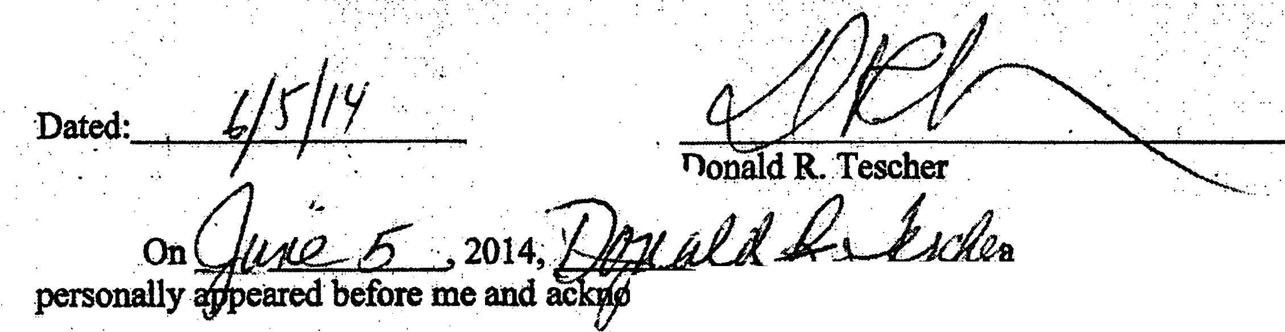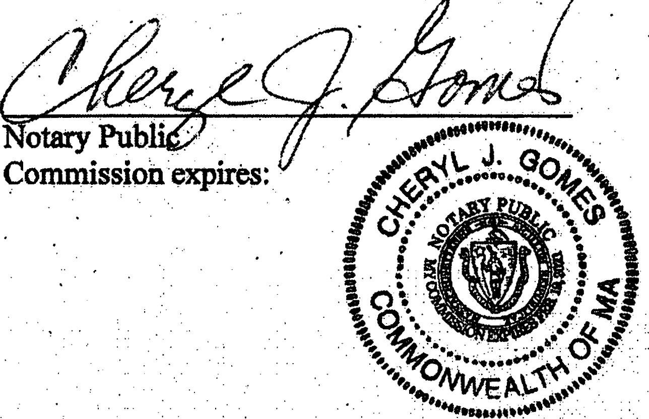..... ·._:..

{ . .

. . . . person known to me, ·
wledg&l executing the.foregoing ;co· · t.· ·

. Approved asto form: ·
.. ·.·

. . . . .
·..·· dt,41/{(}r
.N,900@ A. .;'g$q, .....• " .. .
Moscowitz & MoseowitZ,P.A
  - Sabadell Financial Center. ·
lll lBrickell Ave.,. Suite 2050
Miami, FL 33131

. ,,........-· .... ..
... . .

7

Case 3:15-cv-07118-AET-LHG Document 9 Filed 10/01/15 Page 8 of 22 PagelD: 150 Case 3:15-cv-07118-AET-LHG Document 1· Filed 09/28/15 Page 8 of 14 PagelD: 11

. . . . .
UNJtBo: STA'fES DIS'fRICT COURT
. DISTIUCT OF W•l'ERSEY . .

. .
. .
,
.
. .•
SBCURITIEs AND EXCHANGE coMMiss19N, .
. Plain .
.,. . . v.
- DONALD R. TESCHBR et al.,
.Defendants.
C.A.No._-_

·' . FINAL JUDGMENT AS DEFENDANT DONALD R.
TO TESCllER .
. f . .. .,, • , . • ,. ._ .• - .. . . . . . . . : . . . .

. . .· . . . . !" . . . .
    - · Donald R. TeSc:her ("Defendant") havfug-entered a general appearance;,consented to the Court's
juriSdiction over Defendant.and tl1e subject matter of this &®on; consented to entry ·of this Fh)at
. .. . . l . . .. . . . . .· . ' . .·· ·. .. . . ·.
Jucigulent With(, ·:ftdtt.itdns. or.dC11Yful ibe'.ailiegations of tlie_ Complaint (except _a8..t0'.
jmisdiction and except as otherwise provided herein in paragraph VI);waived findings of fact
and·conclusiot,JS of law; and waived any right to appCal from this Final JU:<fgment:

I.

IT IS-HEREBY ORDERED, ADJUDGED, AND DECREED that Defendant an4.
Defendant's agents, ··employees, attomeys, and all persons _ in active concert or

      - participation with them who receive actual notice oftbis Final Judgment by personal service·or otherwise are pennanently restrained andenjoined fl:om violating, directly or y, Section
10) ofthe Securities Exchange Act of 134 (the "Excb&nge Actj [15 {!.S.C. §78j(b)] and
. . . . . . . .
. Rule lOb-5 promul thereunder [17 cF.R. § 240 l0b-S],by using any means or :'

. ..
Case :3:15-cv-:07118-AET-LHG Document 9 Filed 10/01115 Page 9 of 22 PagelD: 151
Case 3:15.-cv-07118-AET-LHG Document 7 Filed 09/28/15 Page of 14 PagelD:112 ;

secUrities ee in·eotio wtttidle <>t .le (>f •i ti:: · :· · ···
. . ..
... .. ·-. . .;. ' . • . • ,: . ' < ··, . .·: : : :,·•. ·.....
(al· · 19 ploy ally deVi Ii l"attifi to defr'llUd; :

.· :: : -- · . . . . . . . . . ·- ,· .: ·; _, . .- : .- . . · ·, . . . . . ..
. .. .
an or

... :<bl
,. ,. ·:1. ..
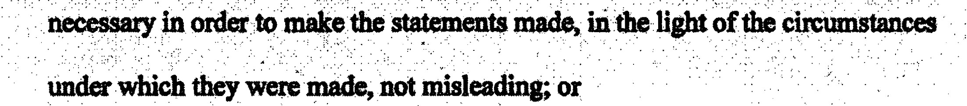. · · .m. ·a·.·b· · ..Y u. nt.·rue··· · ·· · ·· · e·· .n· t..o.f... ..a..'..l.ri.a.ter·.i"1·.· fa.. ct. . . t.O. .om. . . i.t tO.....s....td. .,. .a.m. . .l.te. r.i·alfact .
• · ; · .. ·.·
. .:..;
< .,
·,
.·•
statem

.. . .

. . .
(c) . . to engage iany act.practice, or·c6urse of business which or Woutd

... . .
FtJRrimR''.oiu>EREo,:AJ;>JUDGED,:AND I>ECRElm thatI>efelldant .

·• IL
. · . \.

.. .• . •. . .. ITJSHEREBY
. :'' • .. ., · . .·. ' . . . ··, .. .. ..· .·· ·... . '·'·. . .- . . .. '; ·. . . .. ·.' . :· ..<.. .' . : . ..·. .. .· . . ._., .. ' .. . .. . : ·- . . . . . ..
. .
- and Deteiidant'sagents, 'etnplbyees, attOrneys, and allpersons inactive eoneert t>r · · ·
·participatio with them who n=ive adualnotl"of.this Final Judgment by petsODal service ot
,, :o ;n y lfuDi vtot- 14(e> ot• ··
. . . . . . . ' . . .
.Act [lSU.S. § 78n(e)) and Rule 13 [11C.F.R. §240.13] ,in
. /
OOnnection th any offer ot request o invitation. for tenders, from enpging in any fraudulent, deceptive, or. pulative act ,or practice,by:
 | , ' | .
(a) | pm,chasing or sellliig or causg to | purchased or sol the securities

. . . .

sought or to be sought insuch tendet offer, securities convertible into or­
. exchangeable ·for any such'securitie$ or 1my option or right to.obtain or dispose of any of the foregoiq securitieswbile inpossessfon of material infonnation lating to such tender offer that Defendant knows or has. . , .
:; . . . ' . . . . · ,
. . ' : . . : . . .· . . . .

2

Case 3:15-cv-07118-AET-LHG Document 9 Filed 10/01/15 Page 10 of 22 PagelD: 152
Case 3:15-cv-07118-AET-LHG Document.7 Filed 09/28/15 Page 10 of 14 PagelD: 113

:· . . . . .
. <'.. . , lai.- tJy o,r. tuly fo11fthl' ot.T. g .,me isof ·· . .

. ·.·· ... .,.:·_):··..' <••·•:··:•·<>:·:.·......>:. \:: ,·. '• .- ·..: . . ."·:.< .. .:: -
tti·
.by
; ._:..:.·' · ·

· . !) ·i:· .•· .
,., .. -. > ' ·::.. ,- . . ,, ··-:. . . ....,' ' .. .:·:--:-:-- · ·.·,··:

:;·
·..:::;·:;
{·:·.-.:·.·

  - n or sueh·iSSUer. utll•.within a reaSonBble.titne··pntir i0·any such-.,.

. . .
. .. . . . . .
'.•
. ·- . - . .
.. .-

.. ····.•··purchase Or sale rmationand ltiJ S01lrClC are pllblicly disclosed by
press releaSe or otherwise; or ·.
  - communicating material, nonpublic information relating to a tender offer,

. . ...
.•'. · . .
. . . ' . . .

.·· ' which Defendant knows or has reason to know is nonpublic and kliows or '
.
. ·..
· · .· has_reason to kriow has hemacquired directly or indirectly.&om tho

' '
    - · offering n;. eis.sUer ·o(the securities sought_·or to : ua.fu :by siich:
'. '.- . "., .:. :. . . < ·::.:i ·:-:. : ' . .. ·
' >··' &;r c,wet; oi any.om'*, ,- ,empfoy IUlViSOr,:<>r other < < ·.· ·.·
person acting on behalf of the offering person of such issuer, to any person
1.U1der eircumDnces inwf:Uch it is reasonably foreseeable that such. .

.·· :·: ·<··: : :: · : . . . .. .... . ......._ ..........._. ,,,,._ ..,...._ ._.,... ,.,. .. .. -.., :< "? .. ··: ··· ·- ·.·":•:"f ":···.·:. ·'..··· · ··· ;··· : .. ....,;.,_ ..;;:· ; ··.···-·.-.;•:• --. ······- --:: ·· ·-· · ·:, , . •
. . comm\Ulicmon , is likely to resu)t inthe purchase_ 0r,Sale of Curities.inthe
. . er described insubparagr8ph (a) above;, excCpt that this f'aragraph
shall not apply to a communication made in good faith . ·

- to the officers, directors. or employees of the offering perso to its advisors or to other persons, involved inthe planning, financing, preparation or execution of such
tender offer;
- to the issuer whose securities are sought or to be sought by
such tender offer, to its officers, directors, partners,
.. employees or.adviSC>rs or to,other persons·involved in the

Case 3:15-cv-07l18-AET-LHG . Document 9 Filed 10/01/15 . Page 1 of 22 Pa gelD: 153 · · Case 3:15-cv-07118-AET-LHG Document 7 File 09/28/15 Page 11of 14 PagelD: 114 · . ,
..
. > . . . . . .

. . . .

. . plan. ri.m.&··· finm.
c.,in&·.·. · .· ·· aratio. n·.·.· o···r·
x.ecliti.on. o. f th. e. ·

. . ·· ·.. ·: :. _. ...;. ....·; ..·:.. ·. .. .. . .......· . . · • ·. .·... .: -·· , ,· . ..<i :··: : .=- : ·: , :·; · · · · ·... ,,, .
·• aditi«,a q(lssuer witll re8 fu-sueli. otrer; or .
. :-':.··>.\·:_,· ·: ,.:··::·.. ·.,. . _ ·......·. ·.. .....:,·. ·.. . '
(iii) · to aby, n purs,uant tb. a 1ili'ente. f tstafute or

.· .·.· o.rea1ion
.. .

' •

tODluigated :tllcWr.:
;· · ·• :·: ·<·
. .. . .
' '

. ' . . . .
.. . m..

' . . .
IT IS FtJR1HER ORDERED.ADJUI>GEJ;>, AND_DECREBD tblt r>efendands liable'
. for disgorgemen( f $9,937 reinsennn& poftts gedas a result of the ndUct alleged inthe ·
··Complaint, k>Mtier·withprejudgment blst thereon in amowrt of $690,·and a ciVil penaltj ·.
:· .. ;,. ·. ..-· . .:· .

. in the amounto.f:$.- .9.,...93·7 pu. i".$. Uant t. o
()IJ. 2·1Aof tbe E
•
. ' . . , . . . . .
.
xclumge Act .[lSU.S
.
. . . . . . :· ·' . .

. . .
.
§78\l-U
. . . •

:?.·· :>- - .:.··:;: . . . : . . . . .. . :. •' :... ' :. :·" . ' . . . . . -- . :,···.,::· .' . ,
. ' . .
·I>reijciani:•iitli•· ··$fY.•.ilil&:ob1i.PtiP.ti•·J,y•P.• $.20,s.tt1.. ·stle8·. ·· :::•-••·:
::-: _. :.= - •• , . , • :- :• : ·,· , ·.-· • : ···r .'· • . , ' . '. = :• • ·'··•.• :•• : ·:-::;.:- :: ;...

-. co : ihi1fl4 clalys -entii:: rthls'.Fi1u'1 eiit · · ·· . .
. . .·. ·. DefendlDt 111ay payment _electroniy to the Commission, ch Will provide .
·•·····&taU•rAattra: Wlrts m 'PYiiiebt Y.· ·IQalfe'clli&tt1·· ·····'·..-..-;.... ···"·"'-'
.·. fro a acco\llll.. Pay.g<>V thrOujli tl1C SBC websi4' at . • .
hitp://\VWW.$tcgov/a}>out/offi ofut.btm. Defendattf ri.ay also pay by cemfied check; bank cashier' cheek, or United States postal money or<Jer payable to the Securities and Exchange CommiiOn, which shall be deliverec:l or edto
Enterprise Services Center Accounti Receivable Branch .· · 6500 South MacArthur Boulevard
OklahomaCity,OK.73169.· . ..·..
: ·,; . and shall aeco.nJ>811Jtd b.y altter idetltifyiDg, .,· ·title,·civil action 'n1JJnl>or,. ·nmn of
. . :·
    - thiS c() &@a:k.Te8cher as a defendan.Hn'.;tllis action; aml sHYinl·tbatJ•ymenfis mad·

" 4 ' '

Cas 3:15-cv-07118-AET-LHG Document,9 Filed 10/01/15 Page 12 of 22 PagelO: 154
. .
      - Case 3:15-cv-07118-AET-LHG Document·7 Filed 09/28/15 Page 12 of 14 PagelD:115

Defendant shall simultaneously transmit photocopies of eviden o(payment and case
identifyin,g infon to the Coullnimon'scounselin tbiS action. By.making -payment,
. . . .. . ,_ . . . .
Defendant relinquishes ·all legal and equitable right, title,and·interest in such (Unds and·no part
. . of to 11ie ()on send_ the paid
the funds shallbe Defendant. s ds puiSu.ant .
; . . ·_,··_ : . . .. . ; . ·. .•··. ·.·: ." .·· ·. . .. . ; . . . .. -. · . . . . . •, . .· . .
' .
to this FiiJal J t to.the Uiiited SU!tea TieasUfi."
Th OJion may enforce the ci'sjudgllient for disgorgemeDt and udgment
interest by moving for civil contempt (and/or .through ocollection procedures Wihorized by -
:· .. . . . ( .
law) at any tinie after 14 following ent;ry of this Final Judgment. Defendant shall pay post
judgment .interest on. any delinquent amounts pursuant to 28U.S.C. § 1961.:

IV• .
. . .
IT IS HEREBYFUR 1HER ORDERED,ADJUDGED,AND DBcR.EED that based on
,, Defendant'scooperation ina Commission investigation and/or related enforcement action, the
· '.co\lrt. snofoideriiii'Deti0'pay·,1c1-Yii J>eDlliY ili-exss-·01s§ 37:;rr aDY ;tlme' · following the- entiy of tho:Fini.t_ Judgment meCommiUion obtains ormation indicating that . Defendant knowingly .provided materially false ·or misleading information or materials to the
Commission or m·a related proceeding, the <;ommission may, at its sole discretion without
. prior notke to the Defendant, petition the Court for an order requiJinl Defendant to pay an
additional civil penalt.y: In connection with any such petition and at any hearin. g held on sUch a
' . . ; ' ·-
. . .
·motion: (a) Defendant will be precluded ftom arguing that he did not violate the federal
securitiei laws alleged iii the _Complaint;_ (b) fendant may not challenge the validity of the JUdgment, ibis Consent, or any. lated Undertaking&; (c) the allegations of eComplaint, solely
for the purposes of such motion, shall be accepted as and deemed true by the urt; and (d) the

s

, .
Case 3:15-cv-07118-AET-LHG Document 9 Filed 10/01/15 Page 13 of 22 PaaeJo· 155
Case 3:15-cv-07118-AET-LHG Document 7 . Filed 09128/15 Page 13 of 14 Paget o.: 6l
. .
;

. Curt may determine the issues nUsed inthe motion on tho basis of affidaVits, declarations,
- excerpts of sWom. sition or inv.estiptive testimo!ly,an documen .evidence without
.. .
- regard to the standards foi' summary jud8ment containCd in Rulo 6(c) of the Federal Rules of' Civil Pr. Under th circumstar1ces, t1te parties Y take diseovery,hicluding discovery . from ippro}>riate non-parties. · . .
v. .
IT IS FUR'IHER ORDERED,ADJUDGED,AND DECREED that the Consent is
. . . . .
incorporated herein with the sameforce and effect as iffully set forth h and that Defendant
shall comply;with all of the undertakinp and agreements set fot;tli therein.

VI.

ITIS 'IHER ORDERED,ADJUOOBp, AND DECREED that, solely for purpoSes of
.. . ..;... •. ..exns to.diScharge set forth Section s of.the.Bantauptcy ."code,..11u.s.c.:..f 523 the.. ..
. . .
allegations inthe Complaint are true admitted by Defendant, and er,any debt for
·diSgorgement, prejgmen interest, ciVn penalty or other amowits due by endant under this Final Judgment or any otherjudgment, order, consent order,decree or settlement agreement
entered inconnection with, this proceeding, is a.debt for the violation by Defam,nt of the federal
l .
securities Jaws or any regulation or order issued under such laws, a;S set forth in Section 523(a)(l9) of the BanlQuptey Code, 11 U.S.C.§ 523(aXl9)..

VIL
IT IS FURTHER. ORDERED, ADJUDGED,AND DECREED that this Court shall·retain
- jurisdiction of this m8tter for the purpo&es of enforcing the tenns of this Final Judgment.

6

Case 3:15-cv-07118-AET-LHG Doument 9 Filed 10/01/15 Page 14 of 22 PagelD: 156
Case 3:15-cv07118-AET-LHG Document 7 Filed 09/28/15 · Page 14 of 14 PagelD: 117

Vlll.

There being nojust reason for delay, pursuant to Rule 54(b) of the Federal .Rules of Cvil
,. ' <
cedure, the .Clerk isordered to.enter this Final Judgment forthwith and without further n0tice.··

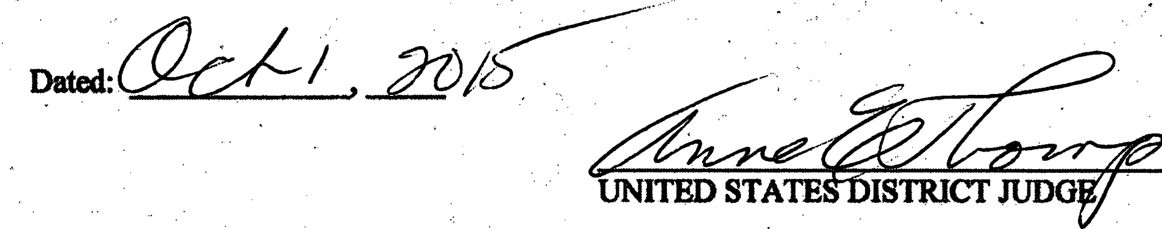

7 ·

Case 3:15-cv-07118-AET·LHG · Document 9 · Filed 10/01/15 ·Page 15 of 22 P@elD: 157
Case 3:15;.cv-07118-AET-LHG Document 7-1 .Filed 09/28/15 Page 1 of 7 PagelD: 118 _.

. .
.
.
;

UNJ'fBD:STATES DISTRICT COURT
·. p1snUeroP w·J$Suv .·.

. . .

...

-------·-. ---•-'
-----------' ---.--' ------

SBCURITlES AND EXCHANOE COMMISSON, . ·

. . . v.

DONALD R. TESCHER et al.,
Plajn .
C.A. No.-•-

.Defendants.;

.· FINAL roooMENTAS To.DEFENDANT DONALD0 R. TESCBE1t·

• • • ' ' " o ,,·' •• • ., • " ._ • " • • ,, ' • r I ' : ' ' , ,.' : , • • I '

' • • ' :• • • • •

Donald riTeseher ('Defendant") havirig entered · general appearan;·consen to the Coul"t's .·
···..
... . . . .. . :· . . . . . . . · _ . . · ·· . · . · · ·' . . . . .
jurisdicti n over .Defendant and die subjectinatter of tms adion; consented to entJy of this Final .
. · ·· / . ' ... .. .·· . . . . ..· ·. ·. . . ·· . . . ·.
.· · , ' .
iehi;It.hUi-admiUilii" ··· Yful.ihe.a11ePtioDl··c,riil ;·com1'l ··cex.a1·•i0-·-···.·.:··
jurisdicti and exas otherwise provided herein ·inparagraph VI);waived findings of fact
. .
llnd·conclusions of law; and waived any right to appCal from this Final 11l;dgment:

I.
IT IS HEREBY ORDERED, ADJUDGED, AND DECREED that Defendant an
Defendant' s agents, servants,.elDJ>loyees, attorneys, and allpersons.in active concert or

- participation with them who receive tual notice of'this Final Judgment by personal Service or
. ,
otherwise are pennanently restrained and.enjoined m violating, ·directly or indhectly,.Section
l) of the Securities Exchange A of 1934 (the."Excb8nge Act") [IS v.s.c.§78j(b)] and
·.. . ·.
Rule lOJ>..S promul thereunder (17cF.R. §240.101>-5],by using any means or ,.·

Case 3:15-cv-07118-AET-LHG Document 9 Filed 10/01/15 Page. 16 of 22 PagelD: 158
Case 3:15-cv-07118-AET-LHG Document 7-1 Filed 09/28/15 Pag 2 of 7 PagelD: 119 ...

• it· .·
securities cha,Jtge,·m..eonno11."th tb.C ttas,e otsa}e of iu.tY securlty ·. . . : :.·:
- to ei,llploy any dCvic, 1ien1e, r:artliice to detraud; .
, ' . : . '. . . .. ... . " .. . . ... : . . .. : . . . '. . .. ; ... . .. . . . .. .
fact
: (b) . .··.t<.. mab•anyuninie stiUcmlent of a'maierial of to oJDit .to•.•·1n&ieria1·fid·
. .. . '. ·;·:·.:·-..·.·
. , :-.
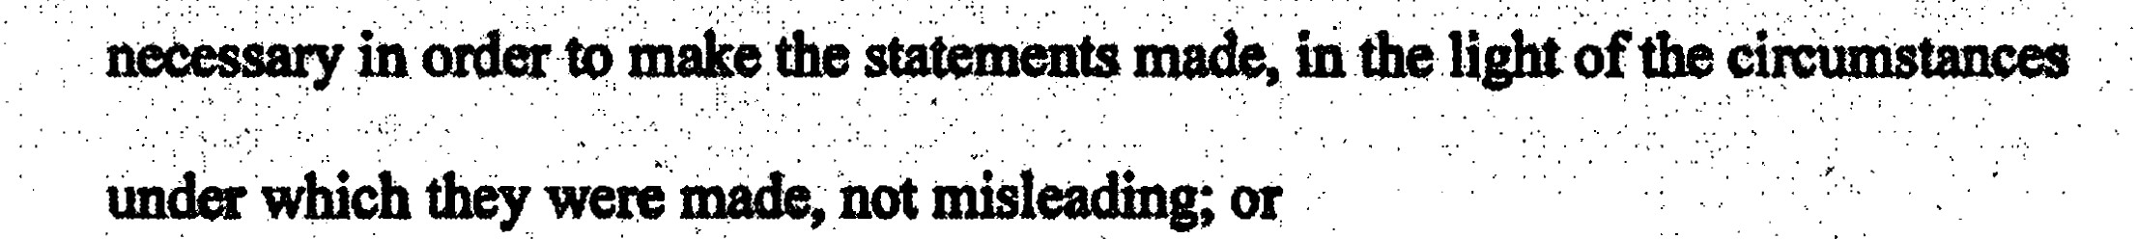

(c) to engage iany practice, on ourse of business which openies or would

. . .
.
. . .. . . .. . . . . . .

f.- ...:.
operate as a fraud ·or deceit upon ally person.
\.
. . : .·;-. . ·: II..
  - , ··... :.·: ·: ·: < ·1T 1s:i1BREBv FURtHElt oRDERED,AJ)JUDoED,AND DBcREED tbtu befeiidant . • .
... . . ' . . . .. ,· . ,. . . . . .. . . . ' . . . · . .·. ·. . ... · . .. . . . . . . ·- .
,· .; ' '

. . . . . ·. . . . . . .
participation with them who receive actual notl o(this F Judgment by penOnaJ service ot
. • . . ! • : ·• . .

.·····.;-:--.:·.·:.. <>tiise.'.&rc.petDimrtJ1·r;st11 · ,feiiJ<>tnea·b·vtotltiil&::se>a'I4(e>'or'·&cb8Dae·.
Act (IS U.S.C.§ 78ii(e)] and .Rule 14e 3.[17C.F. §240.14e-3]promulgated thereunder,in
-<: • •

nnection with any tender offer or request o invitation. for tenders, .from engaging in.any fraudulent, deceptive or. pulative act_or practice, by:
- purchasing or selliDg or causing to be purchased or sold the securities
'> . • . • + ., , . · •

sought or 19be sought in such tendet offer, securities convertibe into .or. exchange11ble for·any'such ,securitie$ or any opuon or right to .obtain or dispose of any.of the foregoing securities while ·inpossessian ofmaterial
, . . . .· . . . . . . . . . .
information latingto such.tender offer that Pefendant .knows orhas . · ·. ' .
: ···

. ... . ... ...
. reason to know is nonpublic and kno\Vs or h.as reason to w bas ber1
. ' . ..

2

Case 3:15-cv-07118-AET-LHG Document 9 Filed 10/01/15 Page 17 of 22 Pq_qelD: 159
Case 3:15-cv-07118-AET-LHG Document 7-1 Filed 09/28/15 Page 3 of 7 Pagel 120 ·

. .. .. -- . - r . Y::fffilJl · t?ff - i ot
·:
••• • i."
·················...t;f: Jz o!i l;;;o;!:
iuuer,
' ' ' .• person or sucll tm1e.·within atCasonablejJme Prior to any sucb ' .
.PurcJiase or sale sUch <>:nnatiori andlts sourcC are publicly.disclosed by. ..
' .. . ·. . .· . . . .·
- press
release ·or otherwiSe; or

- communicating material, nonpublic information relating to a tender offer,
:' .. · . . . :' : .
' . -.. . . ' ' . .
bows
which Defendant knows or has reason to know is nonpublic a,iJ.d or ·

  - . ·. ' ' . ' has reason to know bubeenacquired directly or indirectly fromthe
/>>··· ·offerins tltcl ott& u liOugbtot tA> besouibt bf sllch · ·
"tCticlc=r otterf of anY ftiectt,<,patMet.,·CDiplC>:ad .or other · ·:_: . · ·. ..
person acting on behalf of the offering person of such issuer,· any person
    - under circumstances inwb,ich it is reasonably foreseeable that such
:: ''·: :· •, •, - ' 'o ' , '' • ' "• ":, ' ' ' ' : ., !'+•:•'• ·: ;' '''- ' ·: •" '(·,•.: '•• ' ,.. •,' : - '','- '. '• ' ._. ' '' ' "'• _. ·: ;' ,..,,• . • ; :', ; • • '• :,_ ' 'o, '' • ,. .,; d •• • ;>' ::;;• • :• /• A • ., ,. ' • 0 • :"'• .: ,. •:'• •o :;
. . . .
Ubication,is likely to result inthe pmchase, m;.Sale of es inth
- • . m dtSribed in subJ>&m8raph (a) above;eXcept that this·ParaaraPh ·
shall not apply to a communication made in gQOd faith ,

(i) to the officers, directors, or employees of the

offering person, to its advisors or to other persons, involved
I ··.,:
inthe planning, . financing, preparation or execution of such tender offer;
- to the.issuer whose securities are sought or to be sought by
. . . . '
such tender offer,to its ofticen,directors, partners,
employees or.advisors or to.other persons•involved in the
3 '

Case 3:15-cv-071)8'."AET-LHG Document 9 . Filed 10/01/15 Page 18 .of 22 PagelD: 160
Case 3:15-cv-07.118-AET-LHG Document 7-1· Filed 09/28/15 Page 4 of 7 PagelD: 121

. .

. . . . . '
. :. .PJ0n.i :fim.ng, PQJ.l.<>J ei.<>tt..9f tl\f> ..
. .• Q( tQ SQCh Qil'Cr; Qr• . ..
: ·.: ";/ ·..· . :.,
- to;'°>'prlpursuant to.a requitellleri_t C),r Y statute or ·
. . " .
th ····.
. . ' ·, .· . : ... ..-. . . . :- _ .. · .
. .
nil .<>t teation promulpted

' . ...

.· . . ':
IT IS FURiHER ORDERED,ADJU00ED,AND DECREED dult Defendantis liable,
. for disgorgemein,'6r$9,937 representing pi-Ofits gam as a result of the condUct alleged in the
. .
. . .... . .. -· .. . . . ' . .
- · Complaint, together with prejudgment illthereon in ·amount of $690, amd .ciVilpenatty, ·. .
• in. §.
. '.. . .
the amount ()f $9,937 pursuant to n 21Aof•·Exchatlge [,s U.S.C. 181] . ·
. . . : . . . .. ... .' - .- .. . . . '.· . ;· . ... . . . . -.. . •... ; ' . . .' : .. . . . . . .. . : . . . .. . .:-. , .. . - . . . . .. . . . '
.- ..: . ;...,., ...... .. : .. . : . - . , ... .. . :, ·•...
. · b1i .,;;p. StO s : ' · .
·>.(.._.:" ;' . .·
::·.: -.· . <.: :, .::.'

- · Defendant 1nay | Ont "ltucallY to the Commission, | Wlll pi1>vide;· · .
········defallACH | - ··pa•mafa&: | ·htJy·····

htt,P: //www.SeQ,gov/aJ>oµt/oftices/ofm. htgl. Defendant 'may also pay by cel'tified check, bank

cashier' check,. or Uted States postal money or4ef payable to the Securities and Exchange
Commi.on, which shall be delivered or mailed
l . ., > •

Enterprise Services Center AccOwtts Receivable Branch
6500 South MacArthur Boulevai'd
Okllhoma City, OK 73169 ·. :.· . .
- nd shllll be l)CCQtnPmned by a Je..identifying tl}e aR tide, ci'Vil action nwnber, 8nd Jlame of
. .. .. . . . . . . . . .. ..· . . . .
'
;.::.-:·...: ·:. '
··.. · tllis Court; fj()tU.la. Tesch.er.as a dei dm,fiJl..thiS action;llll(f • SJ>eoifying ·that·•J;aYlJlentds made .· . . . · · ·
. ' ·-·

·pursuant to this Final Judgment. · ·· ·
4

Case 3:15-cv-07118-AET-LHG Document 9 Filed 10/01/15 Page 19 of 22 PagelD: 161·
;- · Case 3:15-cv-07118-AET-LHG Document·-7-1 Filed 09/28/15 Page 5 of 7 PagelD: 122

Defendant shall simultaneously transmit photocopies of evidence opayment and case identifying infol'1D8tion to the Commission•s counselin this action.· By mang · payment, Defen- retitlquishes 'ml legal aDd equitable right. title and intetat in such (imds. andno part .·
. of tlie funds sh.llbe J:Ctllmedto Defe. The oon sluill sCnd the fund$ paid pufsuam
t0 this Final Juct8me.fit tothe United StatesTmdUrY.. :
. . . - . ·,· . :. .. ' ,. . . . : . . . .
' ' ': . . : ' . . ·. -;
. .. ;.,
1 The coniMb.sion may enforee the Com1'sjudg[nent for disgorgement and prejudgment
interest by moving far clvil·contempt (arul/or through ocollection procedmes aUihorl7.ed by
< •
law) at any time after 14days following entfy of this Final JUdgment. Defendant shall pay post .
judgment cinterest on any delinquent am01D1ts·pursuant to 28·u.sc.§ 1961..:·

  - IV.·
IT IS HEREBY FURTHER ORDERED,ADJUDGED,AND DECREED that based on
, · Defendant'scooperation ina on investigation and/or related enforcement action.the
. . . .
coUrtis n0t 1>et tt0 p.ya'cmiPemltf lii exCeU ot$9" J7:' rrat &.iitune·
following the·entry of the .Fm81 Judgment thC Commission obtains nnation indican. that Defendant knowingly proVidedmaterially false or misleading infonnation or material$ to the Commission or in are proceeding..the <;OlllDliuion may,at its sole discretion without
. prior notice to the Defendant. petition the Court for an order requirinl Defendant to pay an
additional . civil ·penal In connection with any such petition and at any hearig held o such a .
·motion: (a) Defendant will be precluded ftom arguing that he did not violate the federal secwitiei laws alleged hi the Complaint;.(b) fendant may not challenge the validity of the · JUdgment, this Consent, or any. lated Undertakings; (c) the allegations of tl,te .Complaint, solely for the purposes of such motion, shall be·accepted as Ind deemed true by ·the Court;•and (d) the

s

Case 3:15-cv-07118-AET-LHG Document 9 Filed 10/01/15 Page 20 of 22 PagelD: 162
Case 3:15-cv-07118-AET-LHG Document 7._1 Filed 09128/15 Page 6 of 7 PagelD: 12

Court may dthe issuCs..msed inthe motion on tb"basis of llffidav.its, dlarations,
excerpts of swom deposition or ingative testimoy, arul documentary .evidence ·witho . \.
' ·
.' . .. . .
?6(
·regard to the .standards for summaryjudgment contaiD.ed in Rule c)·of the Federal Rules of_ · ·
. . .
Civil Proeedure.. Under these·circwnstances, .the parties Y take disCovery,iticluding discovery

. ttolll ·appro non-parties. ·

v. .
IT IS FURTHER ORDERED, ADJUDGED, AND DECREED that the Consent is
incorporated herein with the same force an4 effect as iffully set forth here and that Defendant .
shall comply·with all of the undertakings and qreements set foi:th therein.

VI.
\

IT IS THER. ORDER.SD, ADJUDGEµ, AND DECREED that, solely for purpoSe& of
..ex•to .diSchatge set forthinSectionS3 of !MJJankruptcy,.Code.1lU.S.C.§.:523,..the.. . allegations inthe:Complaint are e aind admitted by Defendant, and fWther,.&DY debt for
disgorgem.,prejugmen int.erest, ciVn penalty or other amounts due by Defendant under this Final Judgment or an other judgment, order, consent order, decree or settlement agreement
·entered in connection wi this proceeding, is adebt for the violation by Defenda.nt of the federal secwities laws or any regulation or order issued under such laws, set forth in Section 523(a)(19) of the Bmdquptcy Code, l 1U.S.C7 § 523(a)(19).
VII.

- IT IS FUR'lllER. ORDERED, ADJUDGED,AND DECREED that this Court shall retain

jurisdiction of this matter for the purpoies of enforcing the terms of this Final Judgment

6

Case 3:15-cv.-07118-AET-LHG Document 9 Filed 10/01/15 ·Page 21 of 22 Pa_qelD: 163 · Case 3:15-cv;..07118-AET-LHG Document 7-1 Filed 09/28/1-5 Page 7 of 7 PagelD: 124 ·

. -., ·, vm.
There being nojust reason for delay, pursuant to Rule S4(b) of the Federal _Rules of Civil

  - 'the Clerk is ordered to entei- this Final Judgment forthWith and without further n0tice.

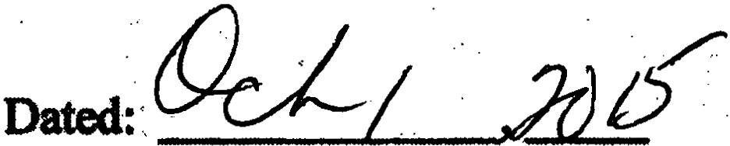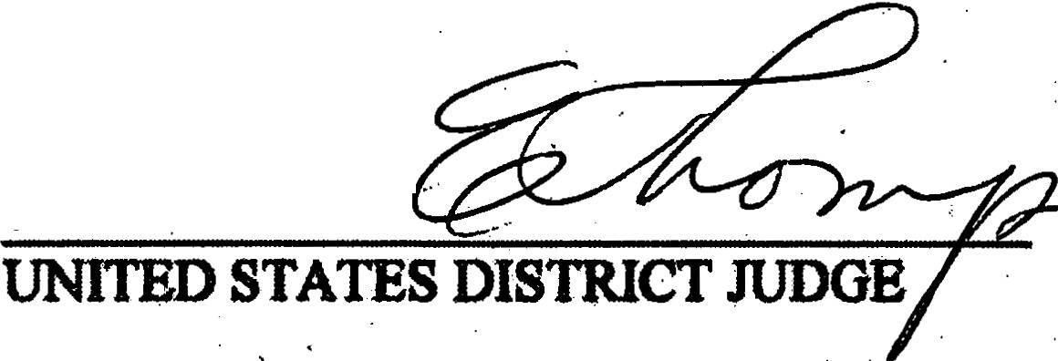
·
····

7 ·

Case 3:15-cv-07118-AET-LHG Document 9 Filed 10/01/15 Page 22 of 22 PagelD: 164

