IN nm VNITBD STATBS DISTRICT COURT POR. THB DJSTRICI' OPNEW JBRSBY

,

SECUJUTIBS AND BXCHANGB COMMISSION,

Plaintiff;
v.
BER.TL.SPALLINA. et al.,

CONSENT OF DBF.ENDANT ROBERT L.SPALLINA
J. Dofendant ·llobort L Spallina ("Defoadant") waivol service of a summona mid tho complaU;at mthis action, eaten a paeral appearance, and admits tbo Court,•juriadiction over Defendant IDCIover tbe subject matter of this action.
- Dofendant 1111 aaned to plead guilty to criminal conduct re1atfn& to certain
} mattors al1epd illthe eomplaint in this action andacknowledges that his conduct violated die
. federal securitiea law& Specjficaly,Defendant bas aareed to plead guilty to a one count information which charges himwith committing securidos find involving insidor trading Jn tho aocmidca of Phannasset, Inc. ina matter to befiled inthe United States District Court tol tho District ofNew Jeney.(tbe ''CrimJnal Action").
- Defendant hereby cots to the entry of the Final Judgment Jn the form attached
hereto (the "Pinal Judgment') and incorporated by retercmco herein, which, among other things:
  - Permanently restrains and eqjoina Deteodant Jiom violation of Sections
·lO(b) mid 14(o) of the Securities Bxchinp Aat ·o,1934 (''Bxchango Act")

Case 3:15-cv-07118-AET-LHG Document 12 Filed 10/01/15 Page 2 of 18 PagelD: 206
Case 3:15-cv-07118-AET-LHG Document 3 Filed 09/28/15 Page 2 of 12 PagelD: 30

[15U.S. .§I 78j(b) and 7,n(e)] and Rules JOb-S and 14o-l thereunder (17 C.P.R. f l 240.tOb-S and 240.14e-3];
  - order8 Defendant to pay disgorgement inthe amount of$39,156, plus
prejudplCllt interest tlJoreon in the amount of Sl,794;provided, however,
- that 139,1545 shallbe doc:med sadafted inlight of Defendanra comont to the entry of a fbrfeiture moneyjudgment in the amount of $39,1S6 in conneotkm with tho Criminal Aationt and
  - m:dtrs Dofmdaat to pay a ctvD penalty in tho amount of $39,156 under Seodon 21A ofdlo BxchanpAct [1.S U.S.C. f 78u-1].
4. Defondant agrees that ho ahall not seek or accept, or indirectly,
.
reimbunemeDt or indoamrification &om any sourc:o. includina but not limited to payment made
pumamt to my hlsunmQe policy,with reprd to my civil penally amounts that Defendant paya panwmt to the Pinal 1uclpient, teprdle88 of whether such penaky arnounta or aay patt thereof are added to a diatn1nltion fbDd or otlaerwise uaed for the benefit of investora. Defendant .tbrther agrees that he shall not claim, asaert, or apply for atax cleductlon or tax credit with regard to .IDY federal, state, or local tax fbr any penalty amounts that Defendant P8J1 pmauant to the Final Judgment, reprdtea of whether such penalty amounfl or anypart thereof aro added to a distribution ftmcl or octi.wiao used for tbo benefit of inveaton.
$. Defendant waives the en1ry of ftndinpof llct and concluaiona of Jaw panwmt to
.Rule 52 of the Pederal Rules of Civil Pn>cedure.
6. Defendant waivoa the right. if any,to ajury trial and to appeal fiom the entry of

the PJnal Judgment.

2

Case 3:15-cv-07118-AET-LHG Document 12 . Filed 10101115 Pa.ae 3 oL18 Paae.1.p: 207
case 3:15-cv-07118-AET-LHG Document 3 Flied 09/281/15 Page 3' o11z P-age 1tr. '3

. .
7. Defendant enters into this Consent voluntarily andrepresents that no an.ts,
..
often, pzomiae1.ot inducomadl of any kind have been made by fJio Commillion or any member,offioar,employ-. .orrepresentative of theCommfaaion to induce Defendant to ents lato thia Consent.
8. Defendant agrees that this Consent shall bo incorporat.ed into the F J'vdgment
with·the same fim:e and ctToct aa if1Wlyset forth thereJn.
9. Delendant will notoppoao tho enforcement of tho Pinal Judament on tho ground,
·ifany existl, that ft fails to comply with llu1o 6S(d) of the Federal lt.ules of CivilProcedure, and .
hereby waives any objection buod thereon.
10. Dofondant waives service of the Pinal Judgment and asrees that entry of the Pinal
1udgment by dlo Court and fililJgwith the Clerk of the·Comt will oonstitu1e notice to Defendant of illtmaa and conditions. Dofendant iUrther ....to provide counael for 1ho Commiuion. within thilty clays after 1hePinal Judsmont la filed with the Clerk of the Court, with an afttdavit
or declaration 8tatina tbat Defendant bas recoived rad a copy of the PinalJudament.
11. Conaistmt with 17 c.F.R. 202..5(1),thJI Consent resolves only the claims 8SICl1ed against Defendant inthis civil pmcrdtng, Defendant acknowledges that no promise or representation has been made by the Commilaion or any momber,ooer,employee. agent, or repraeucadve of the_ Commiaaion with rvgard to any oriminal Habillty that may have arisen or may arJae ftom. the facta underlying tbf;I action or immunity &om any sucb criminal liability.
Defendant waives any claim of Double Jeopanly based upo the settlement of this pmradin&
including tho imposition of any remedy or cfvii penalty herein. Defendant 1brtb.er aclm.owledges
that tho Court'sentry of a ent bQunction may have collatoral conaequencos under fedenJ ,
I
or state law and the rules and regulations of self..regu1atory organizations, licensing boards, and
t
i
l
f
i

Case 3:15-cv-07118-AET-LHG Document 12 Filed 10/01/15 Page 4 of 18 PagelD: 208
Case 3:15-cv-07118-AET-LHG Document 3 Filed 09/28/15 Page 4 of 12 PagelD: 32

other regulatory organizations. Such collateral consequences include, but aro not limited to, a
.slatGtory disquali8c:adon with respect to membership orparticipation in,or associationwida a
member of; a orpnizatioD. 11da atatutory disqualiftcation bas consequencea that are separate from any aanc:don imposedinID proceeding. Jn addition, iDay disciplfnlry pmceoding before the Comrmuion baaed on 1bomtiy of the injunction in this action, Defendant undontanc.fa that hoabal1not bopmmittecl to contest the factual allejadons of the complaint iathia action.
- Defendant underabmdl and apeea to comply with tho terms of 17 C.F.R.
f 202.S(e).whlcb provides inpart that it iitho Commission•a policy •'nqt to pamit a dofendaat
or respolideM to consent to ajudgment or older that imposes a llDCtionwhllo denying the
.
'

allepdona inthecomplaint or Older for prooeedinp." Aa part of DelendaDt'a
agreemant to

comply with tho tcims of Section 2015(0), Defendant acknowledges that be bua8ft*1 to plead guilty tor rolatec1 conduct as deacribcd inpamaraph 2 above. and: (i) will not tabany acdon or make orpermit 10be made any publio statement denying directly or indirectly,any allegation in
compJafnt or creatin& the impieulon that the complaint la without W basis;(If) will not maborpermit to bomade my public statement to tho etfeot tbat Defendant doel not admit tho alleptlona ofthe complaint., or that dlla Consent eonlahw no admission ofthe alleptiou; (iH) upon the filing oftbia Conaeat. Defendant hereby withdraws any papers filed in this action to tbe extent that they dmy•Y aDepdon IDthe complaint; ad(iv) sdpul"'8 for purpoauof aceptiona to discbarp sot forth inSection 523 of the Bantruptcy Code, 11U.S.C. §523.that the allegations Jn the complablt m true, and fbrthor,that any dobt tor dilgorgement. prejudgplcnt interest, civil penalty or other amounts due by Defendant under the Pinal Judpient or any other
judgment. Older consent order,decreo or sottleaDeat agreement entered in connection with this

4

Case 3:15-cv-07118-AET-LHG Document 12 Filed 10/01/15 Page 5 of 18 Pa.q. eJD: 209 Case 3:15-cv-07118-AET-LHG Document 3 Filed 09/28/15 Page 5 of 12 Page1u:33

proceeding, ia a debt tbt the violation by Defendant of tho fedeml socurities laws or any
regulation or onfcr issued under such laws, u sol forth inSection 523(a)(l 9) of the Bankruptcy Code, 11u.s.c.tS23(aXt9). If Defendant breachol 1hilaaroemant, the Commission may petidon the Court to vacate tho PinalJudgmeat andrutarethis action to 111active cfock.ot.

Nothing hitbia PM181'8Ph affocti Dofcmdant'a: (i) tmtimonia1 oblptlona; or (H)rightto take
lept or factual positions inlltipdon or adsleplproceodlnp in wMohthe Commission lanot
a party.
. i
- . Dofendant hereby ·wafvea any rigbta und• tbe EqualAccoaa to Justice Act, tho !
SmaD Buinesa R.egulatory BDforoement Faimeaa Act of 1996, or anyother pmvilfon Of Jaw to aeak from the United Stafel, or·aay agency, or any ofBoial oftho United States acting Inbia or
- her official capacity,direcdy or indirectly,reimburaenaent orattoJnof •feel or other foes,
expema, or coatl expended by Defendant to detend lpinst thfa acdon. For tbeae pt1lp08ea, . Do.ftmdant agrees that Ddmdaat iinot the prevailing party ID this action sinco thepartiahave reached a good faith settlement,
- Jnconnectionwith thia action and any related judicial or administrative proceeding 0t Jnvestipdon oommonced by the Commluion or to which tho Commlulon is a party,Defendant (i)apeea to appear and be illterYiewed by Commlaicm ata1f at such dme8 and
pllooa u tho ltd'requeata upon reasonable noticoi (11) will accept service by mail or Acsimilo 11'1D81Diasion of noticee or subpoeaaa iaaued bythe Commiaaion for documeata or toadmony at depoaitlona, hearinp, or trials. or In connoadon witb any related Investigation by Coinmi'Y'ion (iH) appointl Dotendant'a undersigned attorney as.qent to receive service of such notices
and subpoonu; (iv) with respect to such nodces and subpoow, waives the terri limits on
service contained in Rule 4S of the Federal Rules of Civil P •nd any aPIJlicable 10caa . !
I
I
s
I

Case 3:15-cv-07118-AET-LHG Document 12 Filed 10/01/15 Page 6 of 18 PagelD: 210
Case 3:15-cv-07118-AET-LHG Document 3 Filed 09/28/15 Page 6 of 12 PagelD: 34

rules. j>rovidcd chat die party requesdng the testimony reimburses Defendant'stravel. lodgbl& and
subsistencO spmsoa attbo then-pnmliling U.S.Oovemment per elem rates;·and (v) conscmtl to ·
penonaljurisdiction over DofeD.cflllt ia aayUnited States Diatrict Com for'purpoaea of

·enforolng my auch
- Defendant agrooa that tho Commission may present thePinal Judgment·to the Comt for aipatum ancl entzy without tbrtber notice.

Defendant asreea chat this Court aball rotain Jurisdiction ovs tbia matter for tho
I

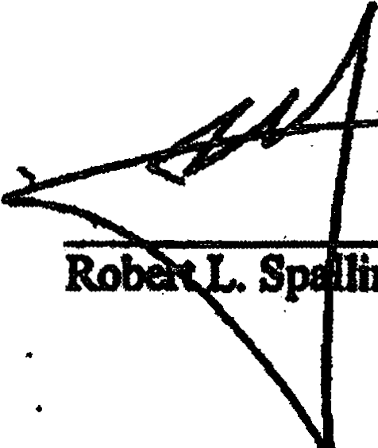purpose of enforcing the terms of the Pinal Judgment.

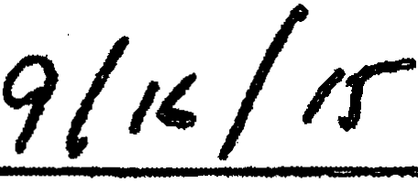

Notary PubHo .
  - Commiaion expUes:

ApptQved 11to form:

Gibbobs " I
One Oateway Center Newal'flt NJ 07102-5310
Counsel for R.obert L. Spallina

i
I
. i
6 I

Case 3:15-cv-07118-AET-LHG Document 12 Filed 10/01/15 Page 7 of 18 PagelD: 211
Case 3:15-cv.;.07118-AET-LHG Document 3 Filed 09/28/15 Page 7 of 12 PagelD: 35

IN THE UNITED STATES DISTRICT COURT FOR THE DISTRICT OF NEW JERSEY

SECURITIES AND EXCHANGE COrvlMISSION,

Plaintiff,

v.
ROBERT L. SPALLINA, et al.,

Defendants.

FINAL JUDGMENT AS TO DEFENDANT ROBERT L. SPALLINA

The Securities and Exchange Commission having filed a Complaint and Defendant Robert L. Spallina having entered a general appearance; consented to the Court's jurisdiction over Defendant and the subject matter of this action; consented to entry of this Final Judgment; waived findings of fact and conclusions of law; waived any right to appeal from this Final
Judgment; and Defendant having admitted the facts set forth in the Consent of Robert L. Spallina and acknowledged that his conduct violated the federal securities laws:

I.

IT IS HEREBY ORDERED, ADJUDGED, AND DECREED that Defendant and

Defendant's agents, servants, employees, attorneys, and all persons in active concert or participation with them who receive actual notice of this Final Judgment by personal service or otherwise are permanently restrained and enjoined from violating, directly or indirectly, Section IO(b) of the Securities Exchange Act of 1934 (the "Exchange Act") [15 U.S.C. § 78j(b)] and Rule IOb-5 promulgated thereunder [17 C.F.R. § 240. lOb-5], by using any means or

Case 3:15-cv-07118-AET-LHG Document 12 Filed 10/01/15 Page 8 of 18 PagelD: 212
Case 3:15-cv-07118-AET-LHG Document 3 Filed 09/28/15 Page 8 of 12 PagelD: 36

instrumentality of interstate commerce, or of the mails, or of any facility of any national securities exchange, in connection with the purchase or sale of any security:
(a) to employ any device, scheme, or artifice to defraud;

- to make any untrue statement of a material fact or to omit to state a material fact necessary in order to make the statements made, in the light of the circumstances under which they were made, not misleading; or
- to engage inany act, practice, or course of business which operates or would operate as a fraud or deceit upon any person.

II.

IT IS HEREBY FURTHER ORDERED, ADJUDGED, AND DECREED that Defendant

and Defendant's agents, servants, employees, attorneys, and all persons inactive concert or participation with them who receive actual notice of this Final Judgment by personal service or otherwise are permanently restrained and enjoined from violating Section 14(e) of the Exchange Act (15 U.S.C. § 78n(e)] and Rule 14e-3 [17 C.F.R. § 240.14e-3] promulgated thereunder, in connection with any tender offer or request or invitation for tenders, from engaging inany fraudulent, deceptive, or manipulative act or practice, by:
  - purchasing or selling or causing to be purchased or sold the securities sought or to be sought in such tender offer, securities convertible into or exchangeable for any such securities or any option or right to obtain or dispose of any of the foregoing securities while inpossession of material information relating to such tender offer that Defendant knows or has reason to know is nonpublic and knows or has reason to know has been

2

Case 3:15-cv-07118-AET-LHG Document 12 Filed 10/01/15 Page 9 of 18 Pa_qelD: 213
Case 3:15-cv-07118-AET-LHG Document 3 Filed 09/28/15 Page 9 of 12 PagelD: 37

acquired directly or indirectly from the offering person; the issuer of the securities sought or to be sought by such tender offer; or any officer, director, partner, employee or other person acting on behalf of the offering person or such issuer, unless within a reasonable time prior to any such purchase or sale such information and its source are publicly disclosed by press release or otherwise; or
- comniunicating material, nonpublic information relating to a tender offer, which Defendant knows or has reason to know is nonpublic and knows or has reason to know has been acquired directly or indirectly from the offering person; the issuer of the securities sought or to be sought by such tender offer; or any officer, director, partner, employee, advisor, or other person acting on behalf of the offering person ofsuch issuer, to any person under circumstances in which it is reasonably foreseeable that such communication is likely to result in the purchase or sale of securities in the manner described in subparagraph (a) above, except that this paragraph shall not apply to a communication made in good faith
  - to the officers, directors, partners or employees of the offering person, to its advisors or to other persons, involved in the planning, financing, preparation or execution of such tender offer;
  - to the issuer whose securities are sought or to be sought by such tender offer, to its officers, directors, partners, employees or advisors or to other persons involved inthe
3

Case 3:15-cv-07118-AET-LHG Document 12 Filed 10/01/15 Page 10 of 18 PagelD: 214
Case 3:.15-cv-07118-AET-LHG Document 3 Filed 09/28/15 Page 10 of 12 PagelD: 38

planning, fm'
ancing, preparation or execution of the

activities of the issuer with respect to such tender offer; or

  - to any person pursuant to a requirement of any statute or rule or regulation promulgated thereunder.

III.

IT IS FURTHER ORDERED, ADJUDGED, AND DECREED that Defendant is liable for disgorgement of $39,156, representing profits gained as a result of the conduct alleged inthe Complaint, together with _prejudgment interest thereon inthe amount of $1,794; provided, however, that $39,156 shall be deemed satisfied in light of Defendant's consent to the entry of a forfeiture money judgment inthe amount of $39,156 in connection with the resolution of a parallel criminal action instituted inthis Court; and a civil penalty in the amount of $39,156 pursuant to Section 21A of the Exchange Act [15 U.S.C. § 78u-1]. Defendant shall satisfy this obligation by paying $40,950 to the Securities and Exchange Commission within 14 days after
entry of this Final Judgment.

Defendant may transmit payment electronically to the Commission, which will provide detailed ACH transfer/Fedwire instructions upon request. Payment may also be made directly from a bank account via Pay.gov through the SEC website at http://www.sec.gov/about/offices/ofm.htm. Defendant may also pay by certified check, bank cashier's check, or United States postal money order payable to the Securities and Exchange Commission, which shall be delivered or mailed to
Enterprise Setvices Center Accounts Receivable Branch
6500 South MacArthur Boulevard Oklahoma City, OK 73169

4

Case 3:15-cv-07118-AET-LHG Document 12 Filed 10/01/15 Page 11of 18 PagelD: 215
Case 3:15-cv-07118-AET-LHG Document 3 Filed 09/28/15 Page 11of 12 PagelD: 39

and shall be accompanied by a letter identifying the case title, civil action number, and name of this Court; Robert L. Spallina as a defendant in this action; and specifying that payment is made pursuant to this Final Judgment.
Defendant shall simultaneously transmit photocopies of evidence of payment and case identifying information to the Commission's counsel in this action. By making this payment, Defendant relinquishes all legal and equitable right, title, and interest in such funds and no part of the funds shall be returned to Defendant. The Commission shall send the funds paid pursuant to this Final Judgment to the United States Treasury.
The Commission may enforce the Court's judgment for disgorgement and prejudgment interest by moving for civil contempt (and/or through other collection procedures authorized by law) at any time after 14 days following entry of this Final Judgment. Defendant shall pay post judgment interest on any delinquent amounts pursuant to 28 U.S.C. § 1961.

N .

IT IS FURTHER ORDERED, ADJUDGED, AND DECREED that the Consent is

incorporated herein with the saine force and effect as if fully set forth herein, and that Defendant shall comply with all of the undertakings and agreements set forth therein.

v.

IT IS FURTHER ORDERED, ADJUDGED, AND DECREED that, for purposes of exceptions to discharge set forth in Section 523 of the Bankruptcy Code, 11 U.S.C. § 523, the allegations in the Complaint are true and admitted by Defendant, and further, any debt for disgorgement, prejudgment interest, civil penalty or other amounts due by Defendant under this
5

Case 3:15-cv-07118-AET-LHG Document 12 Filed 10/01/15 Page 12 of 18 PagelD: 216
Case 3:15-cv-07118-AET-LHG Document 3 Filed 09/28/15 Page 12 of 12 PagelD: 40

Final Judgment or any otherjudgment, order, consent order, decree or settlement agreement entered in connection with this proceeding, is a debt for the violation by Defendant of the federal securities laws or any regulation or order issued under such laws, as set forth in Section 523(a)(l9) of the Bankruptcy Code, 11 U.S.C. § 523(a)(l9).

VI.

IT IS FURTHER ORDERED, ADJUDGED, AND DECREED that this Court shall retain jurisdiction of this matter for the purposes of enforcing the terms of this Final Judgment.

VII.

There being no just reason for delay, pursuant to Rule 54(b) of the Federal Rules of Civil Procedure, the Clerk is ordered to enter this Final Judgment forthwith and without further notice.

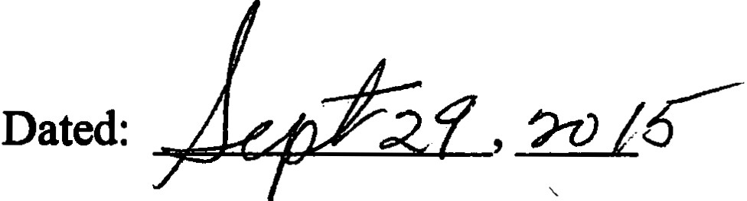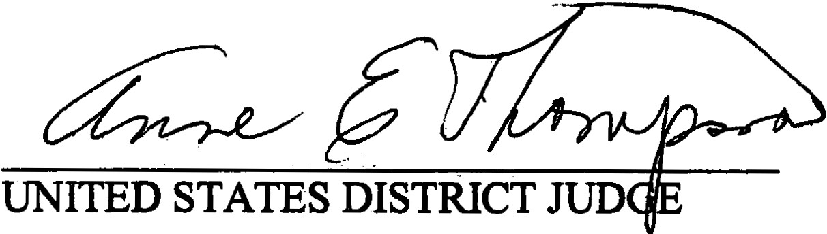

6

Case 3:15-cv-07118-AET-LHG Document 12 Filed 10/01/15 Page 13 of 18 PaelD: 217
Case 3:15-cv-07118-AET-LHG Document 3-1 Filed 09/28/15 Page 1 of 6 PagelD: 41

IN THE UNITED STATES DISTRICT COURT FOR THE DISTRICT OF NEW JERSEY

SECURITIES AND EXCHANGE COMMISSION,

Plaintiff,

v.
ROBERT L. SPALLINA, et al.,

Defendants.

FINAL JUDGMENT AS TO DEFENDANT ROBERT L.SPALLINA

The Securities and Exchange Commission having filed a Complaint and Defendant Robert L. Spallina having entered a general appearance; consented to the Court's jurisdiction over Defendant and the subject matter of this action; consented to entry of this Final Judgment; waived findings of fact and conclusions of law; waived any right to appeal from this Final
Judgment; and Defendant having admitted the facts set forth in the Consent of Robert L. Spallina and acknowledged that his conduct violated the federal securities laws:

I.

IT IS HEREBY ORDERED, ADJUDGED, AND DECREED that Defendant and

Defendant's agents, servants, employees, attorneys, and all persons in active concert or participation with them who receive actual notice of this Final Judgment by personal service or otherwise are pennanently restrained and eajoined from violating, directly or indirectly, Section IO(b) of the Securities Exchange Act of 1934 (the "Exchange Act") [15 U.S.C. § 78j(b)] and Rule 1Ob-5 promtilgated thereunder [17 C.F.R. § 240.1Ob-5], by using any means or

Case 3:15-cv-07118-AET-LHG Document 12 Filed 10/01/15 Page 14 of 18 PagelD: 218
Case 3:15-cv-07118-AET-LHG Document 3-1 Filed 09/28/15 Page 2 of 6 PagelD: 42

instrumentality of interstate commerce, or of the mails, or of any facility of any national securities exchange, in connection with the purchase or sale of any security:
(a) to employ any device, scheme, or artifice to defraud;

(b) to make any untrue statement of a material fact or to omit to state a material fact necessary in order to make the statements made, in the light of the circumstances under which they were made, not misleading; or
- to engage in any act, practice, or course of business which operates or would operate as a fraud or deceit upon any person.

II.

IT IS HEREBY FURTHER ORDERED, ADJUDGED, AND DECREED that Defendant

and Defendant's agents, servants, employees, attorneys, and all persons in active concert .or participation with them who receive actual notice of this Final Judgment by personal service or otherwise are permanently restrained and enjoined from violating Section 14(e) of the Exchange Act [15 U.S.C. § 78n(e)] and Rule 14e..J [l7 C.F..R. § 240.14e-3] promulgated thereunder, in connection with any tender offer or request or invitation for tenders, from engaging in any fraudulent, deceptive, or manipulative act or practice, by:
  - purchasing or selling or cal!sing to be purchased or sold the securities sought or to be sought in such tender offer, securities convertible into or exchangeable for any such securities or any option or right to obtain or dispose of any of the foregoing securities while in possession of material information relating to such tender offer that Defendant knows or has reason to know is nonpublic and knows or has reason to know has been

2

/

Case 3:15-cv-07118-AET-LHG Document 12 Filed 10/01/15 Page 15 of 18 Pa_gelD: 219
Case 3:15-cv-07118-AET-LHG Document 3-1 Filed 09/28/15 Page 3 of 6 PagelD: 43

acquired directly or indirectly from the offering person; the issuer of the securities sought or to be sought by such tender offer; or any officer, director, partner, employee or other person acting on behalf of the offering person or such issuer, unless within a reasonable time prior to any such purchase or sale such information and its source are publicly disclosed by press release or otherwise; or
- communicating material, nonpublic information relating to a tender offer, which Defendant knows or has reason to know is nonpublic and knows or has reason to know has been acquired directly or indirectly from the offering person; the issuer of the securities sought or to be sought by such tender offer; or any officer, director, partner, employee, advisor, or other person acting on behalf of the offering person of such issuer, to any person under circumstances in which it is reasonably foreseeable that such communication is likely to result in the purchase or sale of securities in the manner described in subparagraph (a) above, except that this paragraph shall not apply to a communication made in good faith
  - to the officers, directors, partners or employees of the offering person, to its advisors or to other persons, involved inthe planning, financing, preparation or execution of such tender offer;
(ii) to the issuer whose securities are sought or to be sought by such tender offer, to its officers, directors, partners, employees or advisors or to other persons involved in the
3

Case 3:15-cv-07118-AET-LHG Document 12 Filed 10/01/15 Page 16 of 18 PagelD: 220
Case 3:15-cv-07118-AET-LHG Document 3-1 Filed 09/28/15 Page 4 of 6 PagelD: 44

planning, financing, preparation or execution of the activities of the issuer with respect to such tender offer; or
(iii) to any person pursuant to a requirement of any statute or rule or regulation promulgated thereunder.

III.

IT IS FURTHER ORDERED, ADJUDGED, AND DECREED that Defendant is liable for disgorgement of $39,156, representing profits gained as a result of the conduct alleged inthe Complaint, together with prejudgment interest thereon inthe amount of $1,794; provided, however, that $39,156 shall be deemed satisfied in light of Defendant's consent to the entry of a forfeiture money judgment iilthe amount of $39,156 in connection with the resolution of a parallel criminal action instituted in this Court; and a civil penalty iilthe amount of $39,156 pursuant to Section 21A of the Exchange Act [15 U.S.C. § 78u-l]. Defendant shall satisfy this obligation by paying $40,950 to the Securities a.nd Exchange Commission within 14 days after entry of this Final Judgment.
Defendant may transmit payment electronically to the Commission, which will provide detailed ACH ttansfer/Fedwire instructions upon request. Payment may also be made directly from a bank account via Pay.gov through the SEC website at http://www.sec.gov/about/offices/ofm.htm. Defendant may also pay by certified check, bank cashier's check, or United States postal money order payable to the Securities and Exchange CoJ.llillission, which shall be delivered or mailed to
Enterprise Services Center Accounts Receivable Branch
6500 South MacArthur Boulevard Oklahoma City, OK 73169

4

Case 3:15-cv-07118-AET-LHG Document 12 Filed 10/01/15 Page 17 of 18 Pa_g elD: 221 Case 3:15-cv-07118-AET-LHG Document 3-1 Filed 09/28/15 Page 5 of 6 PagelD: 45

and shall be accompanied by a letter identifying the case title, civil action number, and name of this Court; Robert L. Spallina as a defendant in this action; and specifying that payment. is made pursuant to this Final Judgment.
Defendant shall simultaneously transmit photocopies of evidence of payment and case identifying information to the Commission's counsel in this action. By making this payment, Defendant relinquishes all legal and equitable right, title, and interest in such funds and no part of the funds shall be returned to Defendant. The Commission shall send the funds paid pursuant to this Final Judgment to the United States Treasury.
The Commission tnay enforce the Court's judgment for disgorgement and prejudgment interest by moving for civil contempt (and/or through other collection procedures authorized by law) at any time after 14 days following entry of this Final Judgment. Defendant shall pay post judgment interest on any delinquent amounts pursuant to 28 U.S.C. § 1961.

IV.

IT IS FURTHER ORDERED, ADJUDGED, AND DECREED that the Consent is

incorporated herein with the same force and effect as if fully set forth herein, and that Defendant shall comply with all of the undertakings and agreements set forth therein.

v.

IT IS FURTHER ORDERED, ADJUDGED, AND DECREED that, for purposes of exceptions to discharge set forth in Section 523 of the Bankruptcy Code, 11 U.S.C. § 523, the allegations in the Complaint are true and admitted by Defendant, and funher, any debt for disgorgement, prejudgment interest, civil penalty ot other amounts due by Defendant under this
5

Case 3:15-cv-07118-AET-LHG Document 12 Filed 10/01/15 Page 18 of 18 PagelD: 222
Case 3:15-cv-07118-AET-LHG Document 3-1 Filed 09/28/15 Page 6 of 6 PagelD: 46

Final Judgment or any otherjudgment, order, consent order, decree or settlement agreement entered in connection with this proceeding, is a debt for the violation by Defendant of the federal securities laws or any regulation or order isSl.Jed under such laws, as set forth in Section 523(a)(19) of the Bankruptcy Code, 11 U.S.C. § 523(a)(l9).

VI.

IT IS FURTHER ORDERED, ADJUDGED, AND DECREED that this Court shall retain jurisdiction of this matter for the purposes of enforcing the tenns of this Final Judgment.

VII.

There being no just reason for delay, pursuant to Rule 54(b) of the Federal Rules of Civil Procedure, the Clerk is ordered to enter this Final Judgment forthwith and without further notice.

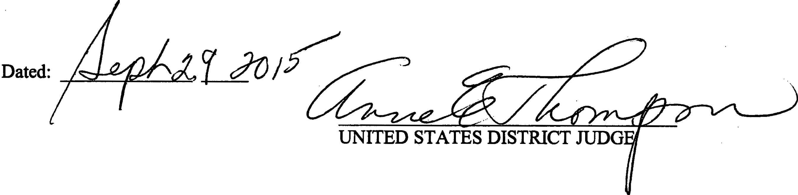

6

