“Surf with Vision”

Eliot I. Bernstein
Founder & Inventor
Direct Dial: (561) 245-8588 (o)
(561) 886-7628 (c)
Sent: Hand Delivered to Chambers

Monday, September 23, 2013

The Honorable Martin H. Colin
CIRCUIT COURT OF THE FIFTEEN JUDICIAL
CIRCUIT IN AND FOR PALM BEACH COUNTY, FLORIDA
South County Courthouse
Second Floor, Courtroom 8
200 West Atlantic Ave.,
Delray Beach, FL 33444

Re: Shirley Bernstein Estate case no. 50 2011CP000653 - ORDERS
Dear Honorable Judge Martin H. Colin,
I hand delivered on Friday, September 20, 2013, a copy of the attached herein letter but believe that some of the exhibited correspondences regarding the Orders between opposing counsel and myself was left out inadvertently and therefore I have enclosed them all herein for your review in drafting your Orders from the hearing.
I will submit this letter to opposing counsel.

Respectfully Yours,
- 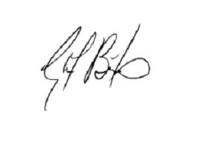
______________________
Eliot I. Bernstein
Founder & Inventor
Iviewit Holdings, Inc. – DL
Iviewit Holdings, Inc. – DL
Iviewit Holdings, Inc. – FL
Iviewit Technologies, Inc. – DL
Uview.com, Inc. – DL
Iviewit.com, Inc. – FL
Iviewit.com, Inc. – DL
I.C., Inc. – FL
Iviewit.com LLC – DL
Iviewit LLC – DL
Iviewit Corporation – FL
Iviewit, Inc. – FL
Iviewit, Inc. – DL
Iviewit Corporation
cc/ec:
Enclosure(s)/Attachment(s)/URL’s

