Report : CZREZDK Instance : JISPROD
CLERK OF THE CIRCUIT COURT PALM BEACH COUNTY
Docket Print from Easyview
Date : Time :
1O-Jan-2013
4:29:11PM

Case ID : 2011CP000653 - SHIRLEY BERNSTEIN

UCN : 502011CP000653XXXXSB
Page 1 of 6

Case Filed : 10-Feb-2011 Status : DJ - DISPOSED BY JUDGE

Case Type
FO - FORMAL ADMINISTRATION
Court CP
Location SB
Division Jury
IY

Type
Party Name
Represented by

JUDGE COLIN, JUDGE MARTIN H.

A , ROBERT L.
ERNSTEI
N , SHIRLEY
DECEDENT B ----------'-"--  PERSONAL REPRESENT. BERNSTEIN , SIMON L. |  | ---  SPALLIN
Filing Date Docket No Pages Docket Description Docket Code
10-Feb-2011 | ADDITIONAL COMMENTS |  | 00000

Docket Text
Book No Page No

1O-Feb-2011
1O-Feb-2011
- ---- --F/FO-PP-PR-GA
PENDING
CPF
ILL
500FF PE

---

ADMINISTRATION
-2011
-2011
1O-Feb-2011 |  |  |  |  | RECEIPT FOR PAYMENT |  | RCPT |  | A Payment of -$419.00 was made on receipt SBCV76959.
10-Feb-2011 |  |  |  | 2 | PETITION FOR |  | PADM
 |  |  |  |  | ADMINISTRATION
1O-Feb-2011 |  | 2 |  | 1 | DEATH CERT PROBATE |  | DCPD
 |  |  |  |  | DECEDENT
1O-Feb-2011 |  | 3 |  | 9 | W |  | WILL |  |  |  |  | 024364 | 00792
1O-Feb-2011 |  | 4 |  |  | NOTICE OF TRUST |  | NOTR
10-Feb-2011 |  | 5 |  |  | ORDER ADMITIING WILL |  | OAWP |  | AND APPT PR
10-Feb |  | 6 |  | 2 | OATH |  | OATH |  | OF PR
10-Feb |  | 7 |  | ----- | LETIERS OF ADMINISTRATION |  | LADM |  |  |  |  | 024364 | 00776
06-Apr-2011 |  | 8 |  | 3 | NOTICE OF FILING |  | NOF |  | PROOF OF CREDITORS | PUBLICATION OF NOTICE | TO
06-Apr-2011 |  | 9 |  | 3 | NOTICE OF FILING |  | NOF |  | PROOF OF | PUBLICATION OF NOTICE | OF

Case Filed : 1(}-Feb-2011 Status : DJ - DISPOSED BY JUDGE

Filing Date Docket No Pages Docket Description
Docket Code Docket Text
Book No Page No

25-Apr-2011 10 3 PROOF OF SRV NOT TO
PNCR
UPON THE AGENCY FOR HEALTH CARE ADMIN . &

---
CREDITORS
.
-

PNAD
NOTICE OF FILING

01-Aug-2011 11 6 PROOF OF SERV NOTICE OF

---
ADMIN

09-Sep-2011 12 3 INVENTORY - ESTATE
06-0ct-2011 13 2 PROOF OF SERVICE
24-0ct-2012 14 AFFIDAVIT/STMNT RE:
INV
POS OF INVENTORY ASNA

---
15
CREDITORS

24-0ct-2012
--- -- 3 PETITION FOR DIS-CHARGE
POCH

24-0ct-2012 16 WAIVER
WAIV WAIVER OF ACCOUNTI NG AND PORTIONS OF
PETITION
FOR DISCHARGE; WAIVER OF SERVICE OF PETITION FOR
DISCHARGE; AND RECEIPT OF BENEFICIARY AND
CON
RG
E

--- SENT TO DIS
CH
24-0ct-2012 | 17 | WAIVER | WAIV | WA IVER OF ACCOUNTI NG AND PETITION |  | PORTIONS | OF
 |  |  |  | FOR DISCHARGE; WAIVER OF PETITION FOR DISCHARGE ; AND BENEFICIARY AND |  | SERVICE RECEIPT | OF OF
CONSENT TO DISCHARGE BY TED S. BERNSTEIN
24-0ct-2012 | 18 | WAIVER | WAIV | WAIVER OF ACCOUNTING PETITION  FOR DISCHARGE ; WA1VER PETITION FOR | AND PORTIONSOF OF SERVICE OF
 |  |  |  | DISCHARGE ; AND RECEIPT AND | OF BENEFIC1ARY

-A - - -----

--------
CONSENT TO 01SCHARGE BY PAMELA B. SIMON

EIN
----

Filing Date | Docket No | Pages | Docket Description | Docket Code |  | Docket Text |  | Book No | Page No
24-0ct-2012 | 19 |  | WAIVER | WAIV |  | WAIVER OF ACCOUNTING AND PORTIONS OF PETITION  FOR DISCHARGE; WAIVER OF SERVICE OF
PETITION FOR
DISCHARGE; AND RECEIPT OF BENEFICIARY AND
 |  |  |  |  |  | CONSENT TO DISCHARGE BY ELIOT BERNST
24-0ct-2012 | 20 |  | WAIVER | WAIV |  | WA1VER OF ACCOUNT1NG AND PORT10NS OF PET1TION
 |  |  |  |  |  | FOR D1SCHARGE; WA1VER OF SERVLCE OF PETIT10N FOR
 |  |  |  |  |  | DISCHARGE;AND RECEIPT OF BENEFLCIARYAND CONSENT TO D1SCHARGE BY JILL !ANTONI
24-0ct-2012 | 21 |  | WAIVER | WAIV |  | WAIVER OF ACCOUNTING AND PORTIONS OF PETIT1ON FOR DISCHARGE; WAIVER OF SERVICE
OF PETITION FOR
DISCHARGE ; AND RECEIPT OF BENEFICIARY AND CONSENT TO DISCHARGE BY LISA S. FRIEDSTEIN
24-0ct-2012 | 22 |  | NON-TAX | NTCT
CERT/RCPT/AFFIDAVIT
24-0ct-2012 | 23 | 2 | PROBATE CHECKLIST | PBCK
06-Nov-2012 | 24 |  | EXPARTE CLERKS MEMO | EXPM
19-Nov-2012 | 25 |  | WAIVER | WAIV |  | OF ACCOUNTING AND PORTIONS OF PETITION FOR DISCHARGE ;
WAIVER OF SERVICE OF PETITION FOR
DISCHARGE; AND
RECEIPT OF BENEFICIARY AND CONSENT TO DISCHARGE

Filing Date | Docket No | Pages | Docket Description | Docket Code |  | Docket Text |  | Book No | Page No
19-Nov-2012 | 26 |  | WAIVER | WAIV |  | OF ACCOUNTING AND PORTIONS OF PETITION FOR DISCHARGE;

19-Nov-2012

19-Nov-2012

27 WAIVER WAIV

28 WAIVER WAIV
WAIVER OF SERVICE OF PETITION FOR
DISCHARGE; AND
RECEIPT OF BENEFICIARY AND CONSENT TO DISCHARGE
BY TED S. BERNSTEIN
OF ACCOUNTING AND PORTIONS OF PETITION FOR DISCHARGE;
WAIVER OF SERVICE OF PETITION FOR DISCHARGE; AND
RECEIPT OF BENEFICIARY AND CONSENT TO DISCHARGE
BY PAMELA SIMON
OF ACCOUNTING AND PORTIONS OF PETITION FOR DISCHARGE ;
WAIVER OF SERVICE OF PETITION FOR DISCHARGE; AND
RECEIPT OF BENEFICIARY AND CONSENT TO DISCHARGE
BY ELIOT BERNSTEIN

- Nov-2012 29
PETITION FOR DISCHARGE POCH
OF ACCOUNTING AND PORTIONS OF PETITION FOR DISCHARGE;
WAIVER OF SERVICE OF PETITION FOR DISCHARGE; AND
RECEIPT OF BENEFICIARY AND CONSENT TO DISCHARGE
JILL IANTONI

Case Filed : 10-Feb-2011 Status : DJ - DISPOSED BY JU OGE

Filing Date | Docket No | Pages | Docket Description | Docket Code |  | Docket Text |  | Book No | Page No
19-Nov-2012 | 30 |  | WAIVER | WAIV |  | OF ACCOUNTING AND PORTIONS OF PETITION FOR DISCHARGE;

03-Jan-2013

31 -1 --
FINAL

DISPOSITION SHEET
WAIVER OF SERVICE OF PETITION FOR
DISCHARGE ; AND
RECEIPT OF BENEFICIARY AND CONSENT TO DISCHARGE
 | --------------------
S ---------- | -------------

LISA S. FRIEDSTEIN
- |  | - | FD

03-Jan-2013 | 32 | ORDER OF DISCHARGE | ODCH |  | 025696 | 00720
03-Jan-2013 | Atch - 32 - | DISPOSED BY JUDGE | DJ

Report : CZREZDK Instance : JISPROD
CLERK OF THE CIRCUIT COURT PALM BEACH COUNTY
Docket Print from Easyview
Date : Time :
1O-Jan-2013
4:29:11PM

Case ID : 2011CP000653 - SHIRLEY BERNSTEIN

Docket Entries : 37 Last Activity :

*** end of report czezdk ***

(czrezdk) Revised : 28-Jul-2003

UCN : 502011CP000653XXXXSB
Case Filed : 10-Feb-2011
Page 6 of 6

Status : DJ - DISPOSED BY JUDGE

SlAf( OF FLORIOA • PALM BEAC COUNTY
1 ner by certify th11t tne foregoing 11 •
true copy o! the record In my olllce with
: redaction . II anU!J.eQulred by law
.-HIS lQ_ DA OF C )A f,j .2013.
  - SHARON R BOCK
B u;u

y -

DATE: Novem ber 5, 2012
MEMORANDUM

TO: Robert L. Spallina, Esq.

FROM: Astride Limouzin Case Manager, on behalf of - This orfice does not provide legal advice
For proced ural inq uiries Tel. #561-274-1424
I XIJUDGE MA RTIN H. COLIN [ [JUDGE JAMES L. M A RTZ
I ]JUDGE ROSEM ARI E SCHER
Division - JY Division - I Z Division - IX

CASE NUMBER: 50 2011CP000653XXXXSB Estate of Shirley Bernstein MATTER: Docu ments being returned Order of discha rge
Death certificate (CERTI FIED COPY) not su bmitted. F.S. §731.103, Probate Rule 5.205 & Probate Rule 5.171 Receipted bill for fu neral ex penses req uired (Must be paid infull).
Proof of will or codicil is req uired; it is not self-proved. Please review F.S. §732.502; 733.201; P.R. 5.210 & P.R. 5.230.

Order adm itting will/ codicil/ and or appointing persona l representative is eit her missing or incorrect. FS§733.20t,
R.5.210 &5.235

Petition and order designating a rest ricted depository, and accepta nce is req uired FS §69.031 &JS §7441(6).
o N
Oat h of Persona l Representative, of Gua rd ia n or Ad minist rator Ad Litem and designation of r ag1111t was not
su bmitted or incorrect. Resident agent m ust sign the accepta nce. (Rule 5.110, 5.120 and 5.320 c...o...,mr,,'l-ii.ittet!otes)•
-< J>. I
°'
("') •
Proof of publication not sub m itted. Ru le 5.241. :i:
no l:D
Statement rega rding cred itors not subm itted. Probate Rule 5.241 (d). r,g?' :Ii:

7n

Inventory not su bmitted. Proba te Rule 5.340.
:;;-::Tl 9

All claims m ust be satisfied, st ruck, or dismissed. or-:x CD
Final certificate of estate tax or affidavit of non-tax is not su bmitted. FS §198.26 & 193.28

All Beneficia ries m ust join in the petition or t hey must receive formal notice on the petition. FS §735.203 & Probate Rule S.530(b).

XX Receipts for assets from ·a11 of the specific beneficia ries were not nota rized.

Receipt of fina l accou nting, service of petition for discha rge and/or waiver from all resid uary beneficiaries or
q ualified t rust beneficia ries are req uired. See. R. 5.400. Attorney fees see FS §733.6171(6), 731.302, 731.303(1)(b) and Probate Rule 5.180(b). Committee notes (one person serving in two (2) fid uciary ca pacities may not wa ive or consent to the persons acts without the a pproval of those who the person represents).

Proof of service of t he Objection to the Claims. FS §733.705(2), Proba te Ru le. 5.496 & Proba te Rule. 5.040.

Proof of Service of the Notice to Creditors to the Agency for Hea lth Ca re Ad ministration. FS §733.2121(d) & Proba te Ru le 5.241 (a).

For Lost/Destroyed Wills/Codicils please com ply with FS § 733.207, 733.201(2) & Probate Rule 5.510

An 8:45 a.m. motion calendar hearing (limited to 5 mins) with notice to all interested parties is req uired.
Notice must be a t least five (5) business days (Tue, Wed and Thurs). Please verify suspension dates. Files m ust be order via the internet at http://15thcircuit. co.palm-beach. fl.us/web/guesUcad min.

OTHER:

PLEASE RETURN A COPY OF THIS MEMORANDUM AND PROPOSE ORDERS WHEN REPLYING; ADDRESS TO THE CLERK AND COMPTROLLER. 200 W ATLANTIC A VENUE.DELRAY BEACH. f L 33444

IN THE CIRCU IT COU RT FOR PA LM BEACH COUNTY, FL

IN RE: ESTATE OF SHIRLEY BERNSTEIN,
Fi le No . 50201 I CP000653XXXXSB
Probate Division

Deceased. Division1

WAIYER OF ACCOUNTING AND PORTIONS OF PETITION FOR DISCHARGE; WAIVER OF SERVICE OF PETITION FOR DISCHARGE; AND RECElPT OF BENEFICIARY AND CONSENT TO DISCHARGE

The 1.1ndersigned, Ted S. Bernstein, whose address is 880 Berkeley Street, Boca Raton. Florida 33487, and who has an interest i n the above estate as beneficiary of the estate:
- Expressly acknowledges that the u ndersigned is aware of the right to have a final accou nti ng; (b) Waives the filing and service of a final or other accounting by the personal representative ;
- Waives the inclusion in the Petition for Discharge of t he amount of com pensation paid or to be paid to the personal, representative, attorneys, accountants, a ppraisers, or other agents employed by the personal representat i ve, and the manner of determ in ing that com pensation;

- Expressl y aciknowledges that the undersigned has actual knowledge of the amou nt and man ner of detennin ing the compensation of the personal representat ive, attorneys, accountants, appraisers, or ot her agents; has agreed to t he amount and manner of determin ing such compensation; and waives any objections to the payment of such compensation;

- Waives the i ncl usion i n the Pet ition for Discharge of a plan of distribution;

- Waives service of the Petition for Discharge of the personal representative and alll notice thereof u pon the u ndersigned;

- Acknowledges recei pt of complete distri bution of the share of the estate to which the undersigned was entitled; and

- Consents to the entry of an order d ischarging the personal representative without notice, hearing or waiti ng period a d "thout further accou nting.
Signed on _?J, , 2012.

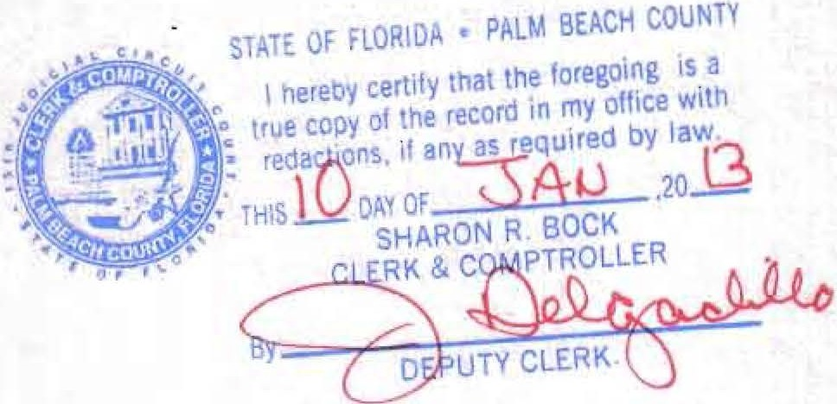D BERNSTEIN
;

.,:.... / . . ' - ;·· ..·· ·: ...-., :If'.- ..... ....'T .... 1·:.:. - · '.
·.·/ .
... . :!-
. .· ·- .":" . -.

JN THE CIRCUIT COURT FOR PALM BEACH COUNTY, FL

JN RE: ESTATE OF SHIRLEY BERNSTEIN,
Deceased.
File No. 50201 I CP000653XXXXSB
Probate Divisiqn Division
·rnnNOV \,9 PM 2:29
. OCK CLERK
SHf:\.RON R . B roUNiY. f l
sPo.AuLl:H'HBC fjiRAHCIH ILEO
I ' v

WAIVER OF ACCOUNTING AND PORTIONS OF PETITION FOR DISCHARGE; WAIYER OF SERVICE OF PETITION FOR DISCHARGE; AND REC.EIPT OF BENEFICIARY AND
CONSENT TO DISCHARGE

The undersigned, Ted S. Bernstein, whose address is 880 Berkeley Street, Boca Raton, Florida 33487, and who has an interest in the above estate as beneficiary of the estate:
- Expressly acknowledges that the undersigned is aware of the right to have a final accounting;

- Waives the filing and service of a final or other accounting by the personal representative;

(c) Waives the inclusion in the Petition for Discharge of the amount of compensation paid or to be paid to the personal representativ , attorneys, accountants, .appraisers, or other agents employed by the personal represeritative , and the manner of determining that compensation;

- Expressly acknowledges •hat the undersigned has actual knowledge of the amount and manner of determining the compensatiO'n of the personal representative, attorneys, accountants, appraisers; or other agents; has agreed to the amoµnt and manner of determining such compensation; and waives any objections to the payment of such compensation; ·

- Waives the inclusion in the Petition for Discharge of aplan of distribution;

(f) Waives service of the Petition for Discharge of the personal representative and all notice thereof upon the undersigned;

- Acknowledges receipt pf complete distribution of the share of the estate to which the undersign·ed was entitled; and

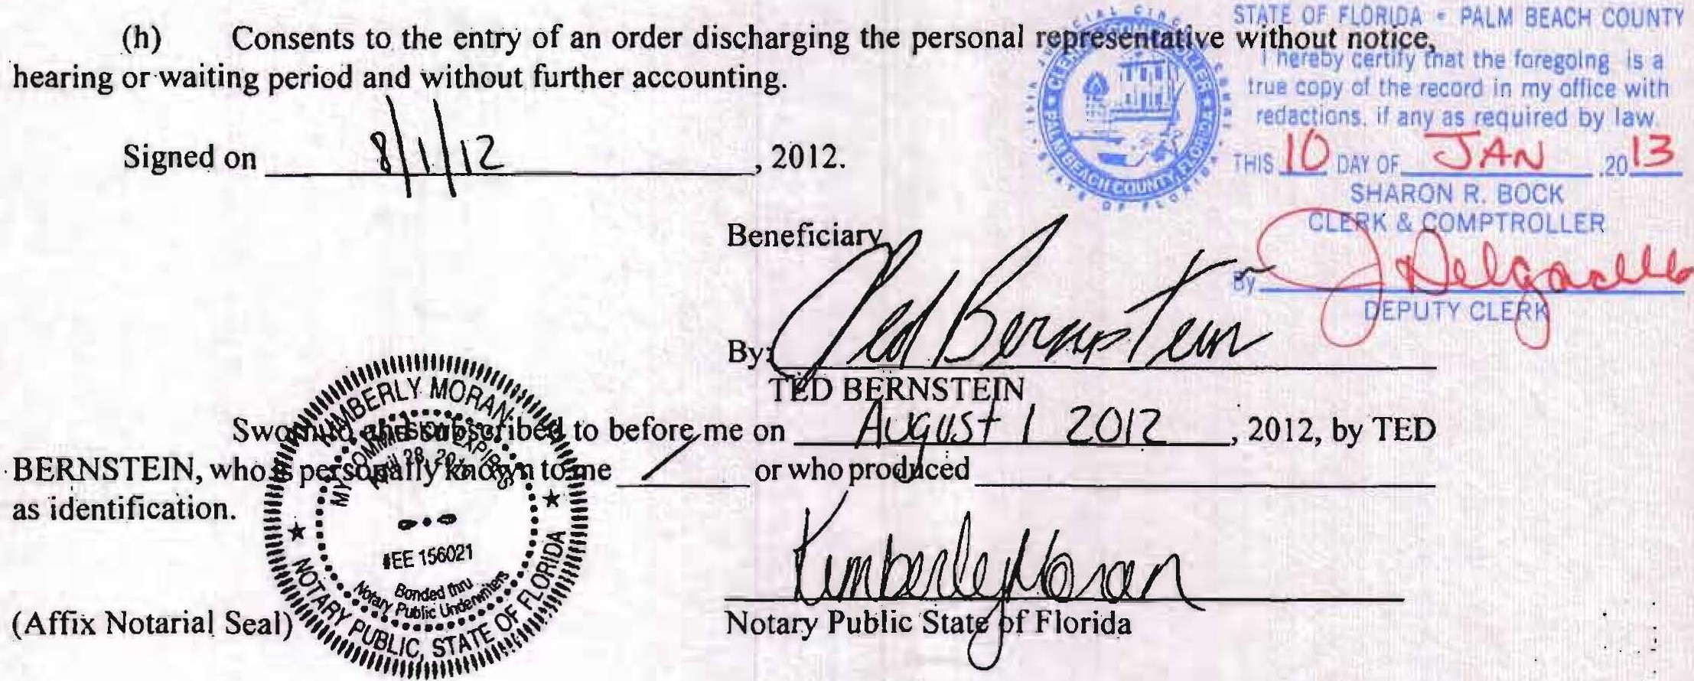., ·· .

.- . - -. ... ..=. • • . ,

IN THE CIRCUIT COURT FOR PALM BEACH COUNTY, FL

IN RE: ESTATE OF
,)
File No.50201 I CP000653XXXXSB :ZOl'2NOV .h9..... PM 2:29

SHIRLEY BERNSTEIN,
Probate Division
SHA.ROH R. SOCK. CLERK

PAtH BEiiCii COUMTY. FL

Deceased. Division

WAIVER OFACCOUNTING AND PORTIONS OF PETITION . FOR DISCHARGE; WAIVER OF SERVICE OF f ETITION FOR DISCHARGE; AND RECEIPT OF BENEFICIARY AND CONSENT TO DISCHARGE

SOUTH CT Y BtlANCH·FILEO

The undersigned, Jili lantoni, whose address is 2101 Magnolia Lane, Highland Park, fL 60035, and who h_as an inter:est in the above estate as beneficiary of the estate:
  - Expressly acknowlledges that the undersigned is aware of the right to have a final accounting;

  - Waives the filing and service of a final or other accounting by the personal representative;

  - Waives the inclusion in the Petition for Discharge of the amount of compensation paid or to be paid to the personal represi;ntative, attorneys, accountants, appraisers, cir other agents employed by the personal representative, and the manner of determining that compensation ;

  - Expressly acknowledges tha.t the u ndersigned has actual knowledge of the amount and manner of detennining the compensation of the personal representative, attorneys, accountants; appraisers, or other agents; has agreed to the amount and manner of determining such compensation; and waives any objections to the payment of such compensation;

  - Waives the in.clusion in the Petition for Discharge of a plan of distribution;

(t) Waives service of the Petition for Discharge of the personal representative and all notice thereof upon the undersigned;

- 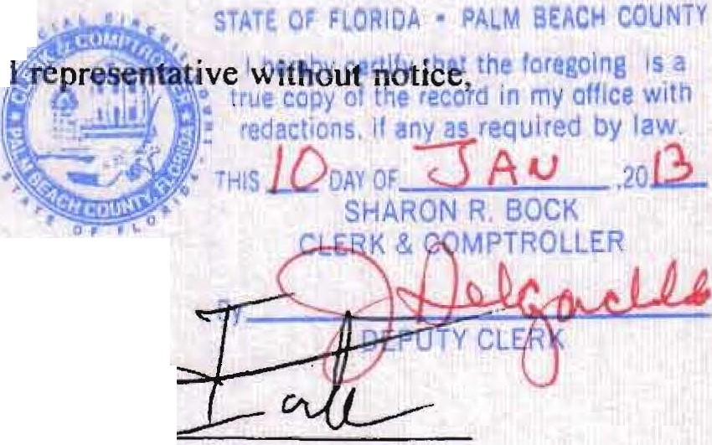Acknowledges receipt of complete distri bution of the share of the estate to which the undersigned was.entitled; and
'
- Consents to the entry of an order d ischarging the persona
hearing or waiting period and without further accou nting. : Signed on Q_(' frJbif ' - - - ' 2012.

.•\\\lill1Ufl11i, JILL IANTOll11
Beneficiary | J
By: | QJ1. | --

EfllY,,,,, ,,, ,_.. I
\. I•'
Swo o before me on {)l-fotf/ , 2012, by JILL
lANTONI, who is pe{So .met./ or who produced __ ____

as 1.denll.fi1cat1. on.
-* :· - c1> :-:

I' ··•

.·-: .
. : a.•.., =*=
. 9,.':. : ;:
-· .
· IEE 156021
·-z • • -
·
!' · . ·
·. -!'?- ttlN · ···§!
(Affix Notarial Seal) ,,,,"vc STAit-a' ::-;
' !11/111mlll\''

lN THE CIRCU IT COU RT FOR PALM BEACH COUNTY, FL

I N R E: ESTATE OF SHIR LEY BERNSTEIN,
File No. 50201 ICP000653XXXXSB
Probate Division

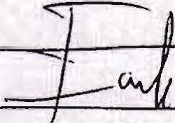Deceased. Division

WAIVER OF ACCOUNTING AND PORTIONS OF PETITION FOR DISCHARGE; WAIVER OF SERVICE OF PETITION FOR DISCHARGE; AND RECElPT OF BENEFICIARY AND CONSENT TO DISCHARGE

The u ndersigned, J ill lantoni, whose address is 210 I Magnol ia Lane, Highland Park, IL 60035, and who has an interest in the above estate as beneficiary of the estate:
- Expressly acknowledges that the undersigned isawareof the right to have a final accounting;

- Waives the filing and service of a final or other accounting by the personal representati ve;

- Waives the inc.l usion in the Petition for Discharge of the amount of com pensation paid or to be paid to the personal representative, anomeys, accountants, a ppraisers, or other agents employed by t he personal representative, and the manner of determining t hat compensation;

- Expressly acknowledges that the undersigned has actual knowledge of the amount and manner of determining the compensation of the personal representative, attorneys, accountants, appraisers, or other agents; has agreed to the amount and manner of dctennining such compensation; and waives any objections to the payment of such compensation;

- Waives the inclusion in the Petition for Discharge of a plan of distri bution;

(f) Waives service of the Petition for Discharge of the personal representative and all notice thereof upon the undersigned;

- Acknowledges recei pt of complete distribution of the share of the estate to which the undersigned was entitled; and

- Consents to the entry of an order discharging the personal representative without notice , hearing or waiting period and without funher account ing.
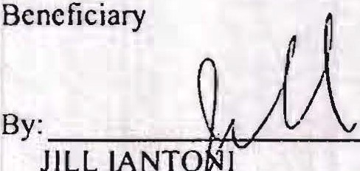Signed on (}l7D /.st- ' 201 2.

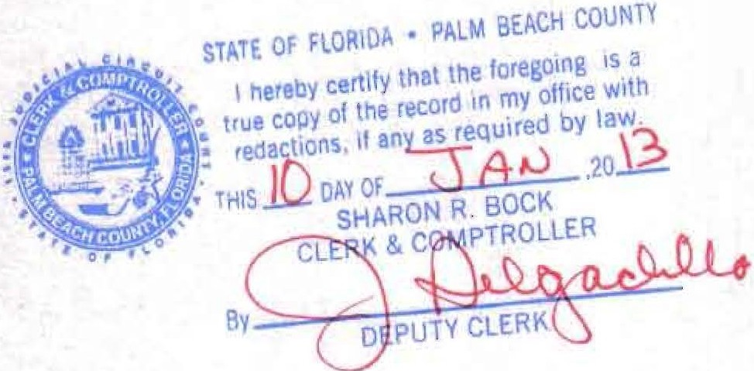

IN THE CIRCUIT COURT FOR PALM BEACH COUNTY, FL IN RE : ESTATE OF Fi le No. 50201 l' CP000653XXXXSB
SHIRLEY BERNSTEIN, Probate Division
Deceased. Division

WAIVER OF ACCOUNTI NG AND PORTIONS OF PETITION FOR DISCHARGE; WAI VER OF SERVICE OF PETITION FOR DISCHARGE; AND RECEIPT OF BENEFICIARY AND CONSENT TO DISCHARGE

The undersigned, Pamela B. Simon, whose address is 950 North Michigan Avenue, Suite 2603, Chicago, IL 60606, and who has an interest in the above estate as beneficiary of the estate:
- Expressly acknowledges that the undersigned is aware of the right to have a final accounting;

- Waives the filing and service of a final or other accounting by the personal representati ve;

- Waives the inclusion in the Petition for Discharge of the amount of compensation paid or 10 be paid to the personal representative, attorneys, accountants, appraisers, or other agents employed by the personal representative, and the manner of determining that compensation;

- Expressly acknowledges that the undersigned has actual knowledge of the amount and manner of determining lhe compensation of lhe personal represen1a1ive, atlomeys, accountants, appraisers, or other agents; has agreed to the amount and manner of determining such compensation; and waives any objections to the payment of such compensation;

- Waives the inclusion in the Petition for Discharge of a plan of distribution ;

(f) Waives service of the Petition for Discharge of the personal representative and all notice thereof upon the undersigned ;

- Acknowledges receipt of complete distribution of the share of the estate to which the undersigned was entitled; and

- Consents to the entry of an order discharging lhe personal representative without notice, hearing or waiting period and without further accounting .
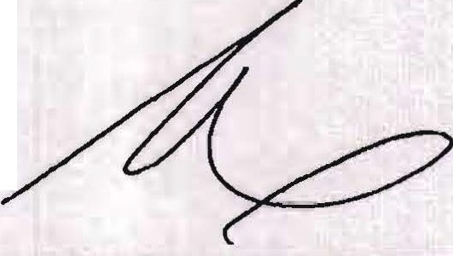Signed on q(r ,2012.
Beneficiary

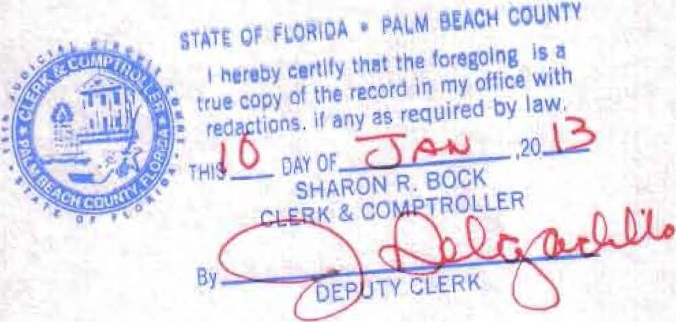By: _ PAMELA B. SIMON

•• • -. \ 'I • • •/• . ''' '. ..... .·.

1 • T,,'.• • ' •
·

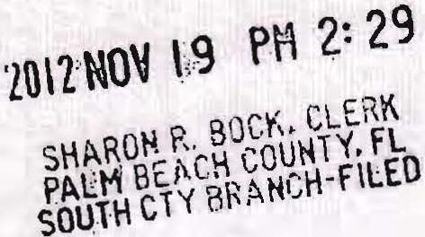IN THE CIRCUIT COURT FOR PALM BEACH COUNTY, FL

IN RE: ESTATE OF SHIRLEY BERNSTEIN,
File No . 50201 I CP000653XXXXSB
Probate Division

Deceased. Division

WAIYER OF ACCOUNTING AND PORTIONS OF PETITION FOR DISCHARGE; WAIVER OF SERVICE OF PETITION FOR DISCHARGE; AND RECEIPT OF BENEFICIARY AND CONSENT TO DISCHARGE

The undersigned, Pamela B. Srinon, whose address is 950 North Michigan Avenue, Suite 2603, Chicago, IL 60606, and who has an interest in the above estate as beneficiary of the estate:
- Expressly acknowledges that the undersigned is aware of the right to have a final accounting;

- Waives the fil ing and service of a final or other accounting by the personal representative;

- Waives.the inclusion in the Petition .for Discharge of the amount of compensation paid ,or to be paid tothe personal representative , attorneys, accountants, appraisers, or other agents employed by the personal representative, and the manner of determining that compensation;

- Expressly acknowledges that the undersigned has actual knowledge of the amount and manner of detennining the compensation of the personal representative, attorneys, accountants, appraisers, or other agents; has agreed to the amount and manner of detennining such compensation; and waives any objections to. the payment of such compensatiOn;

- Waives the inclusion in the Petit ion for Discharge of a plan of distribution ;

- Waives service of the Petition for Discharge of the personal representative and all notice thereof upon the undersigned ;

- Acknowledges receipt of complete distribution of the share of the estate to which the undersigned was entitled; and

'\.'<"MOAAA"/11.
PAM% B. SIMyON .

11111
By:_

_-""""=------+--r-="--=--'--'--=='

Swor , J.oo before me on US 1
PAM ELA B. SI& ';;·.ponaUy known to e _
' 2012, by
or wh o produced

-------o=;;;
,..;:ir--- :_·:-=-= as id¢fi@cation.
CPe4ilt :25:
:
,.. cf'. ,..P,\ :{$:

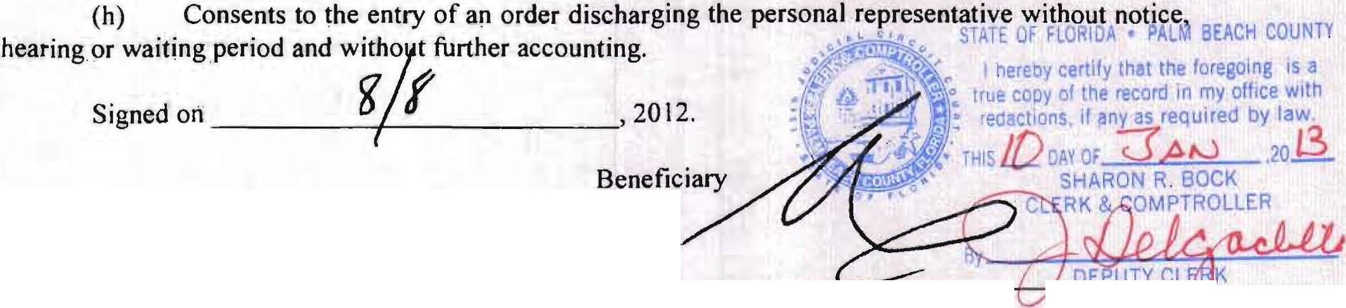:=. • •t;.. :o
·· BororA.;••
(Affix Notari al Seal) \,,_:;;,ti/! .{
"11,.1/,,'U,,B,,i,.1,.c,"'''"'',,

IN THE CIRCUIT COURT FOR PALM BEACH COUNTY, FL

IN RE: ESTA TE OF SHIRLEY BERNSTEIN,
Deceased.
File No. 50201 I CP000653XXXXSB
Probate Division Division

WAIVER OF ACCOUNTING AND PORTIONS OF PETITION FOR DISCHARGE; WAIYER OF SERVICE OF PETITION FOR DISCHARGE; AND RECEIPT OF BENEFICIARY AND CONSENT TO DISCHARGE

The u ndersi gned, Simon L. Bernstein, whose address is 7020 Lions Head Lane, Boca Raton, Florida 33496, and who has an interest i n the above estate as beneficiary of t he estate:
  - Expressl y acknowledges t hat t he undersigned is aware of the ri ght to have a final accounti ng;

  - Waives the fil i ng and service of a final or other accounti ng by the personal representative;

  - Waives the inclusion in the Petition for Discharge of t he amount of compensation paid or to be paid to the personal, representative, attorneys, accountants, appraisers, or other agents employed by the personal representative, and the man ner of determin i ng that com pensation;

  - Expressly acknowledges that the u ndersigned has actual knowledge of the amount and manner of determ i ning the com pensation of the personal representati ve, anomeys, accou ntants, appraisers, or other agents; has agreed to the amou nt and man ner of determ i ning such compensation; and waives any objections to the payment of such compensation;

  - Waives the i ndusion i n the Petition for Di.scharge of a plan of distri bution;

  - Waives service of the Petition for Discharge of the persona l representative and all notice thereof u pon the u ndersigned;

  - Acknowledges receipt of com plete d istri bution of the share of t he estate to which the undersigned was entit led; and

  - Consents to the entry of an order d ischarging the personal representative without notice,
7
hearing or waiting period and without further accounting. ·

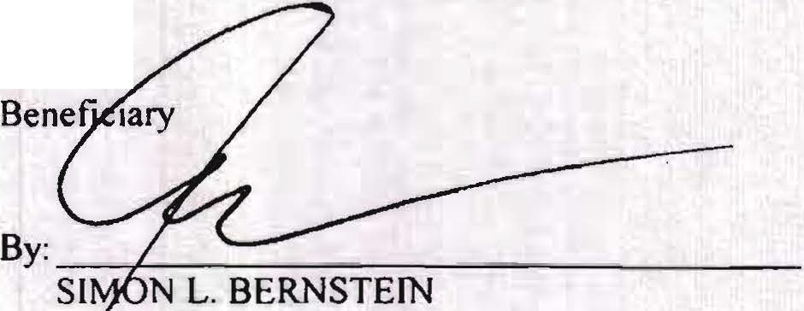Signed on
l-{
{_tl,__._{/ :l--
, 2012.

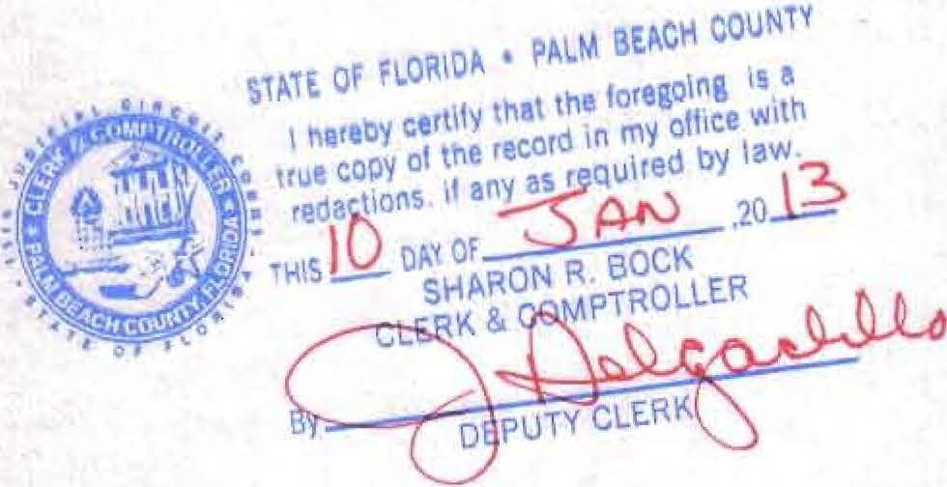

.... .. •" l .. .. 1 ·.. • • :-.,..•.-- -,_-.,--;· _ .;:.._.----=.-;,,...,.,.... ----,.---

IN THE ClRCUIT COURT FOR PALM BEACH COUNTY, FL

IN RE: ESTATE OF
SHIRLEY BERNSTEIN,
Deceased.
File No. 50201 I CP000653XXXXSB
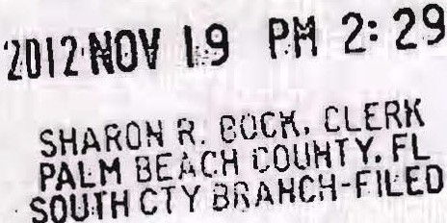Probate Division Division

....;.

F E Ek lo :T; I R DISCHARGE; AND RECEIPT OF BENEFICIARY AND CONSENT TO DISCHARGE

The undersigned, Simon L. Bernstein, whose address is 7020 Lions Head Lane, Boca Raton, Florida 33496, and who has an interest in the above estate as beneficiary of the estate:
- Expressly acknowledges that the undersigned is aware of the right to have a final accounting;

- Waives the fi,lirtg and service of a final or at.her accounting by the personal representative;

- Waives the inclusion in the Petition for Discharge of the amount of compensatfon paid or lo be paid to the personal representative,- attorneys, accountants,appraisers, or other agents employed by the personal representative, and the manner of determining that compensation;

- Expressly acknowledges that the undersigned has actual knowledge of the amount and manner of determining the compensation of the personal representative, attorneys, accountants, appraisers, or other agents; has agreed to the amount and manner of determining such compensation; and waives any objections to the payment of such compensation;

- Waives the inclusion in the Petition for Discharge of a plan of distribution;

- Waives service of the Petition for Disharge of the personal representative and al l notice · thereof u pon the undersigned;

- 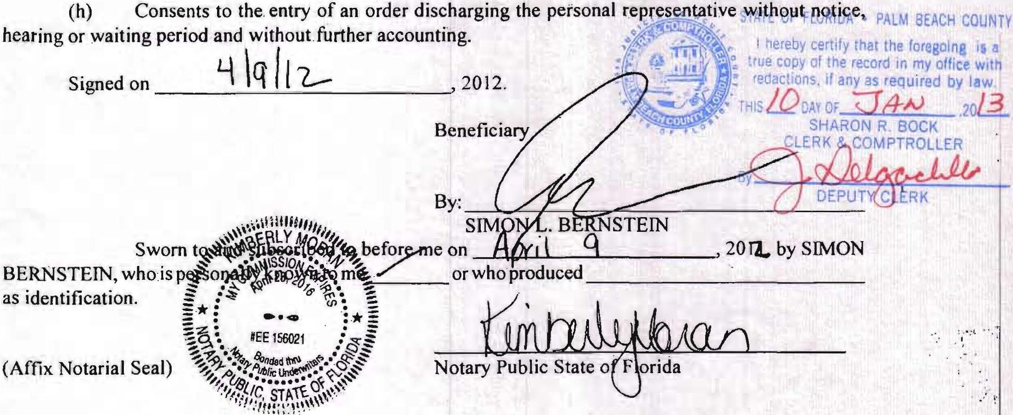Acknowledges receipt of complete distribution of the share of the estate to which the undersigned was entitled; and

_, ·• ''' ;·-.- -I,•• . - ·- ' ··'-)' . .. . - . . ,,...

JN THE CIRCUIT COURT FOR PALM BEACH COUNTY, FL

IN .RE: ESTATE OF SHIRLEY BERNSTEIN,
Fi le No. 50201 J CP000653XXXXSB
.Probate Division
2012 NOV 1-9 . PM 2: 29
SHAROH fL e.OClt CLERK

Deceased. Division

WAIVER OF ACCOUNTG AND PORTIONS OF PETITION
.Foa DISCHARGE; WAIVER OF SERVICE OF PETITION FOR DISCHARGE; AND RECEIPT OF BENEFICIARY AND CONSENT TO DISCHARGE
PALM BE fCtl COUNTY. FL
:SQUlH CTY BR t..HCH-FILEO

The undersigned, Lisa S.Friedstein, whose address is 2142Churchill Lane, Highland Park, IL60035, and who has an interest in the above estate as beneficiary of the estate:
(a:) Expressly acknowledges that the undersigned is aware of the right to have a final accounting;

  - Waives the filing and service of a final or other accounting by the personal representative;

  - Waive.s the inclusion in the Petition for Discharge of the amount of compensation paid or to be paid to the personal representativ , attorneys, accountants, appraisers, or other agents employed by the personal representative, and the mannr of determining-that compensation;

  - Expressly acknowledges that the undersigned has actual knowledge of the amount and man.ner of detennining the compensation of the personal representative, attorneys, accountants, appraisers, or other agents; has agreed to the amount and manner of determining such compensation; and waives any objections to the payineiit ·of such compensation ;

  - Waives the inclusion 'in the Petition for Discharge of a plan of distribution;

(f) Waives service of the Petition for Discharge of the personal representative and all notice thereof upon the undersigned ;

- 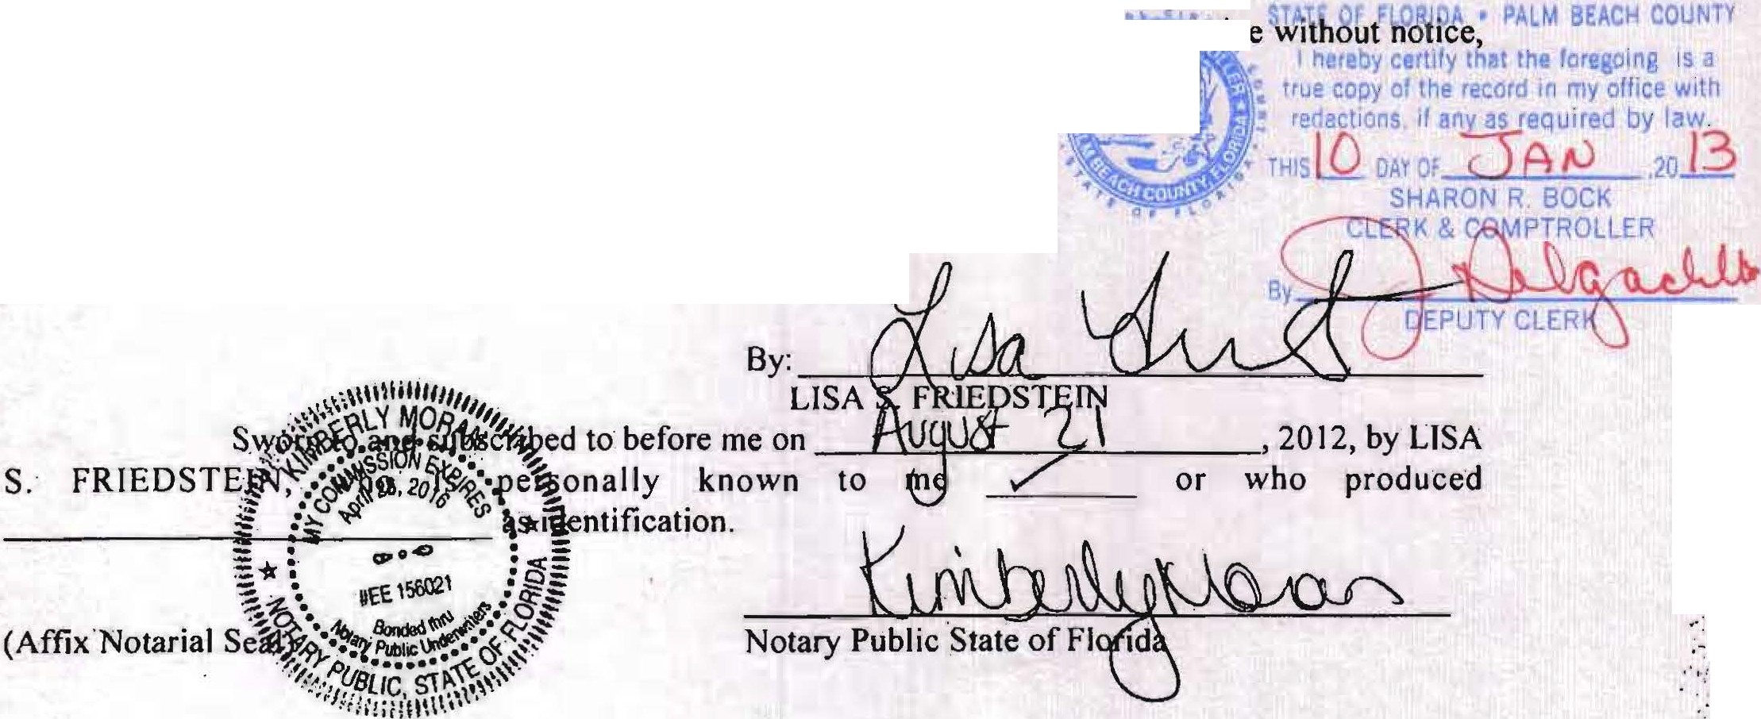Acknowledges receipt of complete distri bution of the share of the estate to which the undersigned was entitled; and

- Cons.ents to the entry of an order discharging the personal r MS011W1 Y hearing or waiting period and without forther accounting. :: · :f,ii1
Signed On alADl .;( I .2012. ' . ·· rn!lliif(-
Beneficiary

,.
' ·;.'
...
..'\
·-:·

' . ... -·. -.. . • ·. . •,' , ., •.•_ '•.. -. - · " ·• ...' ••·,.._ ,, ;- •. . ··•· . . ·- ' -···- . '• .. '· ·. ·-··· ··-····-.... ·-· '"-"·-,,_-:._,._:,_.,._ .·· =· =·.'..;,.,.,._·..-:;":;_·· ··
..

iN THE CIRCUIT COURT FOR PALM BEACH COUNTY, FL IN RE: ESTATE OF File No. 50201 ICP000653XXXXSB
SlllRLEY BERNSTEIN, Probate Division
Deceased . Division

WAIYER OF ACCOUNTING AND PORTIONS OF PETITION FOR DISCHARGE; WAIYER OF SERVICE OF PETITION FOR DISCHARGE; AND RECEIPT OF BENEFICIARY AND CONSENT TO DISCHARGE

The undersigned, Lisa S.Friedstein, whose address is 2142 Churchill Lane, Highland Park. IL 60035, and who has an interest in the above estate as beneficiary of the estate:
- Expressly acknowledges that the undersigned is aware of the right to have a final accounting;

- Waives the filing and service of a final or other accounting by the personal representative;

- Waives the inclusion in the Petition for Discharge of the amount of compensation paid or to be paid to the personal representative, attorneys, accountants, appraisers, or other agents employed by the personal representative, and the manner of determining that compensation;

- Expressly acknowledges that the undersigned bas actual knowledge of the amount and manner of determining the compensation of the personal representative, attorneys, accountants, appraisers, or other agents; bas agreed to the amount and manner of determining such compensation; and waives any objections to the payment of such compensation ;

- Waives the inclusion in the Petition for Discharge of a plan of distribution;

- Waives service of the Petition for Discharge of the personal representative and all notice thereof upon the undersigned ;

- Acknowledges receipt of complete distribution of the share of the estate to which the undersigned was entitled; and

- Consents to the entry of an order discharging the personal representative without notice, hearing or waiting period and without further accounting.
i
Signed oo £'.fH rA.£J.;i. J. J ' 2012.

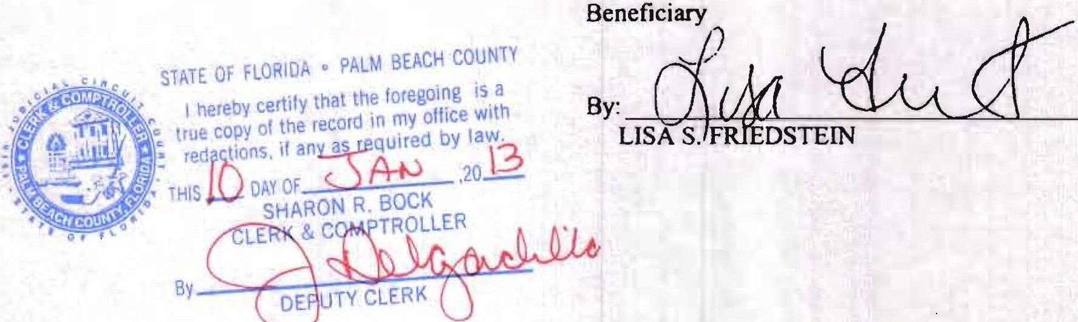

,,,_ co.u,,ty. t;fj

Your payment has been successfully processed . South County Civil Receipt Number:7354865 01/10/2013 04:43 PM
Palm Beach Countv Clerk & Comptroller, 200 W. Atlantic Ave., Delray Beach, FL, 33444
Case Nbr./Descri ption: copys
Name On Card: CANDICE BERNSTEIN
Credit Card Number: ************9892
Card Type: VISA
Item Amount: $39.00 Service Fee: $1.37 Total Charge: $40.37
South County Civil

Page 1 of 1

There is a non-refundable 3.5% fee per transaction to provide this service.
This service fee is charged by MyFloridaCounty.com.
Your Credit Card Statement will display the vendor name of MyFloridaCounty .com for billing details. For Information on refunds or for general inquiries, please call customer support on (877) 326 8689.

https://www4.myfloridacounty .com/myflc-pay/pages/receipt_frame.jsp 1/10/2013

