Tuesday, April 15, 2008

Stephen M. Hall
Assistant Attorney General III
Commonwealth of Virginia
Office of the Attorney General
900 East Main Street
Richmond, Virginia 23219

RE: Conversations of April 14, 2008 relating to Case # 07 Civ. 11196 (SAS) Eliot I. Bernstein, et al. v. Appellate Division First Department, Department Disciplinary Committee et al.

Dear Assistant Attorney General Hall:
I write to you to memorialize our unique conversations of April 14, 2008 and copy the Court, whereby you initially called returning our call regarding how you would like to be served papers. The Honorable Shira A. Scheindlin will be copied this message for admission to the Court record. We had two conversations, one in which you refused me the opportunity to patch in P. Stephen Lamont whom also is a Plaintiff in the case and then after our heated conversation, my call with P. Stephen Lamont to have witness to the rather strange tone of conversation and threats made in the prior call. Both calls turned into demands to release your clients from the federal action filed against them or else suffer possible “federal sanctions” by the judge and other haranguing statements made as assault on our integrity and mental capacities.
Request to remove defendants you represent from lawsuit

Both Stephen Lamont and I found it highly unusual that you would request removal of the defendants you represent in such a hostile tone. Of course, as we act as Plaintiff and Pro Se counsel in these matters we can understand that it is harder to distinguish the etiquette for the calls to us as opposing counsel or adversary but we were responding to a call that was meant to facilitate service papers and were in no way ready to confront the prospect of removing defendants under threat of sanctions.

We appreciate that you claim a position that your clients cannot be sued due to their “absolute immunity” but as we mentioned, this appears not to help if they aided and abetted in possible criminal conduct in a larger conspiracy to deprive us due process rights with scienter while acting in official capacities. No one, as we mentioned, we feel, is above the law and no one is removed from being held accountable, especially based on title. I found it particularly disturbing that you claim to personally know one of the defendants and would act to profess that the unknown defendant, based on your intimate knowledge of them, would never do anything to cause suit and as a result you found our claims not worthy. I would like to know which defendant you have such a relationship with is, what the nature of that relationship is and if that relationship will prejudice your representation of that person or the case.

You also made claim that one of the defendants had left the Virginia Bar Association (“VSB”) and failed to disclose who, could you please also reply to who that is so we can aid the Marshal in serving them process papers. Also, please reply if you are representing the defendants both in their official and individual capacity.

VSB DESTRUCTION OF RELEVANT FILES

Another point we discussed was the VSB’s decision to destroy documents which we had made clear to them were relevant materials not only for the ongoing patent investigations but because they knew we would be appealing the decisions as soon as we could get someone at VSB or their oversight to discuss the matters with us again. You stated that they held the documents longer than they were required but when asked what the record retention laws were, you did not know and where going to get back to us, we await the reply with that information. We find it highly suspect that with the knowledge of what we were claiming to bar officials that you made such poor choice to destroy files when your clients new of the importance of them in pending legal actions.

We asked if you knew the date and time the files were destroyed and you did not know but were checking, we await the formal reply to that. Also, could you be clear if that destruction took place before or after your involvement in the matters. We appreciate the advice to subpoena the materials and for whatever you fail to address in response to this letter you can be assured that we will.

PRO SE V. REPRESENTED BY COUNSEL

I appreciate your comments that as Pro Se we do not stand a chance when taking on high powered state bar associations and judges and that we do not know what we are doing. Very astute of you to point this out, as if we did not know but this as we mentioned will not stop our duty as citizens to fight corruption to protect our constitutional rights to invention and due process, despite the force that opposes us and their positions of influence and supposed or perceived power. We believe that the Constitution levels the playing field if followed according to law and thus will continue on despite the threats of “sanctions” you claim. The claim of “sanctions” coming from your perception that we are suing “everyone” and we can’t sue your clients because they “possibly made a bad decision” or words to that effect will have to be debated before the Court and we welcome your position at the appropriate time before the Honorable Shira A. Scheindlin.

We maintain that we are not suing “everyone”, only those that obfuscated duties and that your clients not only made a bad decision but then refused to accept further information implicating that William J. Dick had tendered documents in his bar response that led to the USPTO suspending patent applications due to possible fraud on the USPTO and the inventors and investors of the Iviewit companies. We also made them aware that bar representatives that they relied on for their decision in New York and Florida were found violating public office rules and that their conclusions could not be relied upon until at minimum such things as First Department of NY court ordered investigations either vindicated them or prosecuted them, that this was cause to reinvestigate their prior possible bad decisions. Also, information was given to them that statements made in Dick’s VSB response were found to materially contradict statements made by Kenneth Rubenstein, Brian Utley (who also wrote a personal letter attached to the Dick response) and Christopher Wheeler in depositions which materially contradicted and impeached the statements made by Dick in his response to the VSB complaint. Despite all this, investigators then began a pattern of evasiveness and refused to take action to correct a possible “bad decision” as you would have it, trying to avoid the new evidence, etc. This is crux of the argument; the refusal to take any action became inaction, which can be construed as obfuscation of duties that precluded due process which became highly suspect considering the evidence being presented of Dick’s dastardly actions through the new evidence. To be clear we are not claiming a bad decision as the entirety of our argument and if that were the case we would have reconsidered joining your defendants as interested parties versus defendants.

Finally, we ask that if you think we are not capable of representing our case as Pro Se complainants due to the complexities you asserted in threats that you request that the judge grant our request for Pro Bono counsel to aid our defense, so we can avoid the ominous federal “sanctions”. Being a seasoned veteran of the Attorney General’s office I am certain this will have a huge impact on the judge’s decision to grant such and thus we welcome such effort on our behalf. As we mentioned we are not lawyers but we are citizens guaranteed due process under law and the mere fact that we are attempting to bring down criminals cloaked in robes of justice and law acting outside public interest, is not a reason to surrender such rights and faith in our Constitution’s ability to ferret out corruptions at any level.

CLAIMS THAT WE ARE PARANOID AND THAT THOSE THAT AIDED AND ABETTED THE ALLEGED PATENT THEFT PERPETRATORS COULD NOT BE HELD ACCOUNTABLE FOR THE CAR BOMBING OF MY FAMILY’S MINIVAN AND THE UNDERLYING PATENT CRIMES AGAINST THE UNITED STATES AND THE IVIEWIT COMPANIES

I found it highly unusual that you would claim that we were paranoid to think that everyone is linked to the car bombing of my family minivan. As I explained, being a Bachelor of Science in Psychology from the University of Wisconsin, Madison, I was taught that paranoia was based on imaginary and perceived threats with no justification in reality. Both the car bombing images at www.iviewit.tv ‘s homepage and the patents on suspension by the USPTO remain steeped in reality, a reality whereby Dick, the subject of the VSB actions is responsible in part and that the claims are more than imaginary or perceived, they are factual. Further, if your clients are found to have aided and abetted in these very real and substantive facts or the covering up of them, then they will be tried whereby you will find a more adequate forum to represent their professed innocence and seek to have them removed from suit. I was disheartened by your callous disregard for the fact that my family’s lives are imminent danger and I wonder at your lack of compassion to those that come to you as a defender of their rights via your job as Assistant District Attorney when they are in danger.

I personally would have respected a more compassionate response to my very real concern for my wife and three children, whether or not you believed it had a basis in reality, and, not your attack on my sanity to defend that your clients actions could not have aided and abetted the car bombing in whatever loosely linked way that a RICO action could establish them as indirect accomplice too. I again, urged you to take this up with the judge or through a more formal legal action as a counter suit, although I again remind you that I am not a lawyer, only a Pro Se’r and that I was not offering legal advice for you or your clients in that regard.

Finally, we are uncertain if your office will be involved in investigating or prosecuting the claims that Dick tendered with his Foley and Lardner team fraudulent patent applications to USPTO which we believe is in Alexandria Virginia and wonder if your representation of the defendants, especially where one is a close friend of yours, could influence such investigation or those in your office, as we assume that examination of those fraudulent documents will be a necessary forensic process that may involve you or your offices. We welcome your contact if it remains to facilitate legal process of the paperwork, etc. for the case and again urge you to take up defenses or demands to remove defendants at the appropriate time and through the appropriate vehicles of the Court. If your clients, as we suggested, would like to tender information to exculpate themselves from the suit we are happy to listen to what they have to say in exchange for removal regarding their involvement and certainly we could do that before the judge in privacy or with proper investigatory authorities.
EXHIBIT 1 1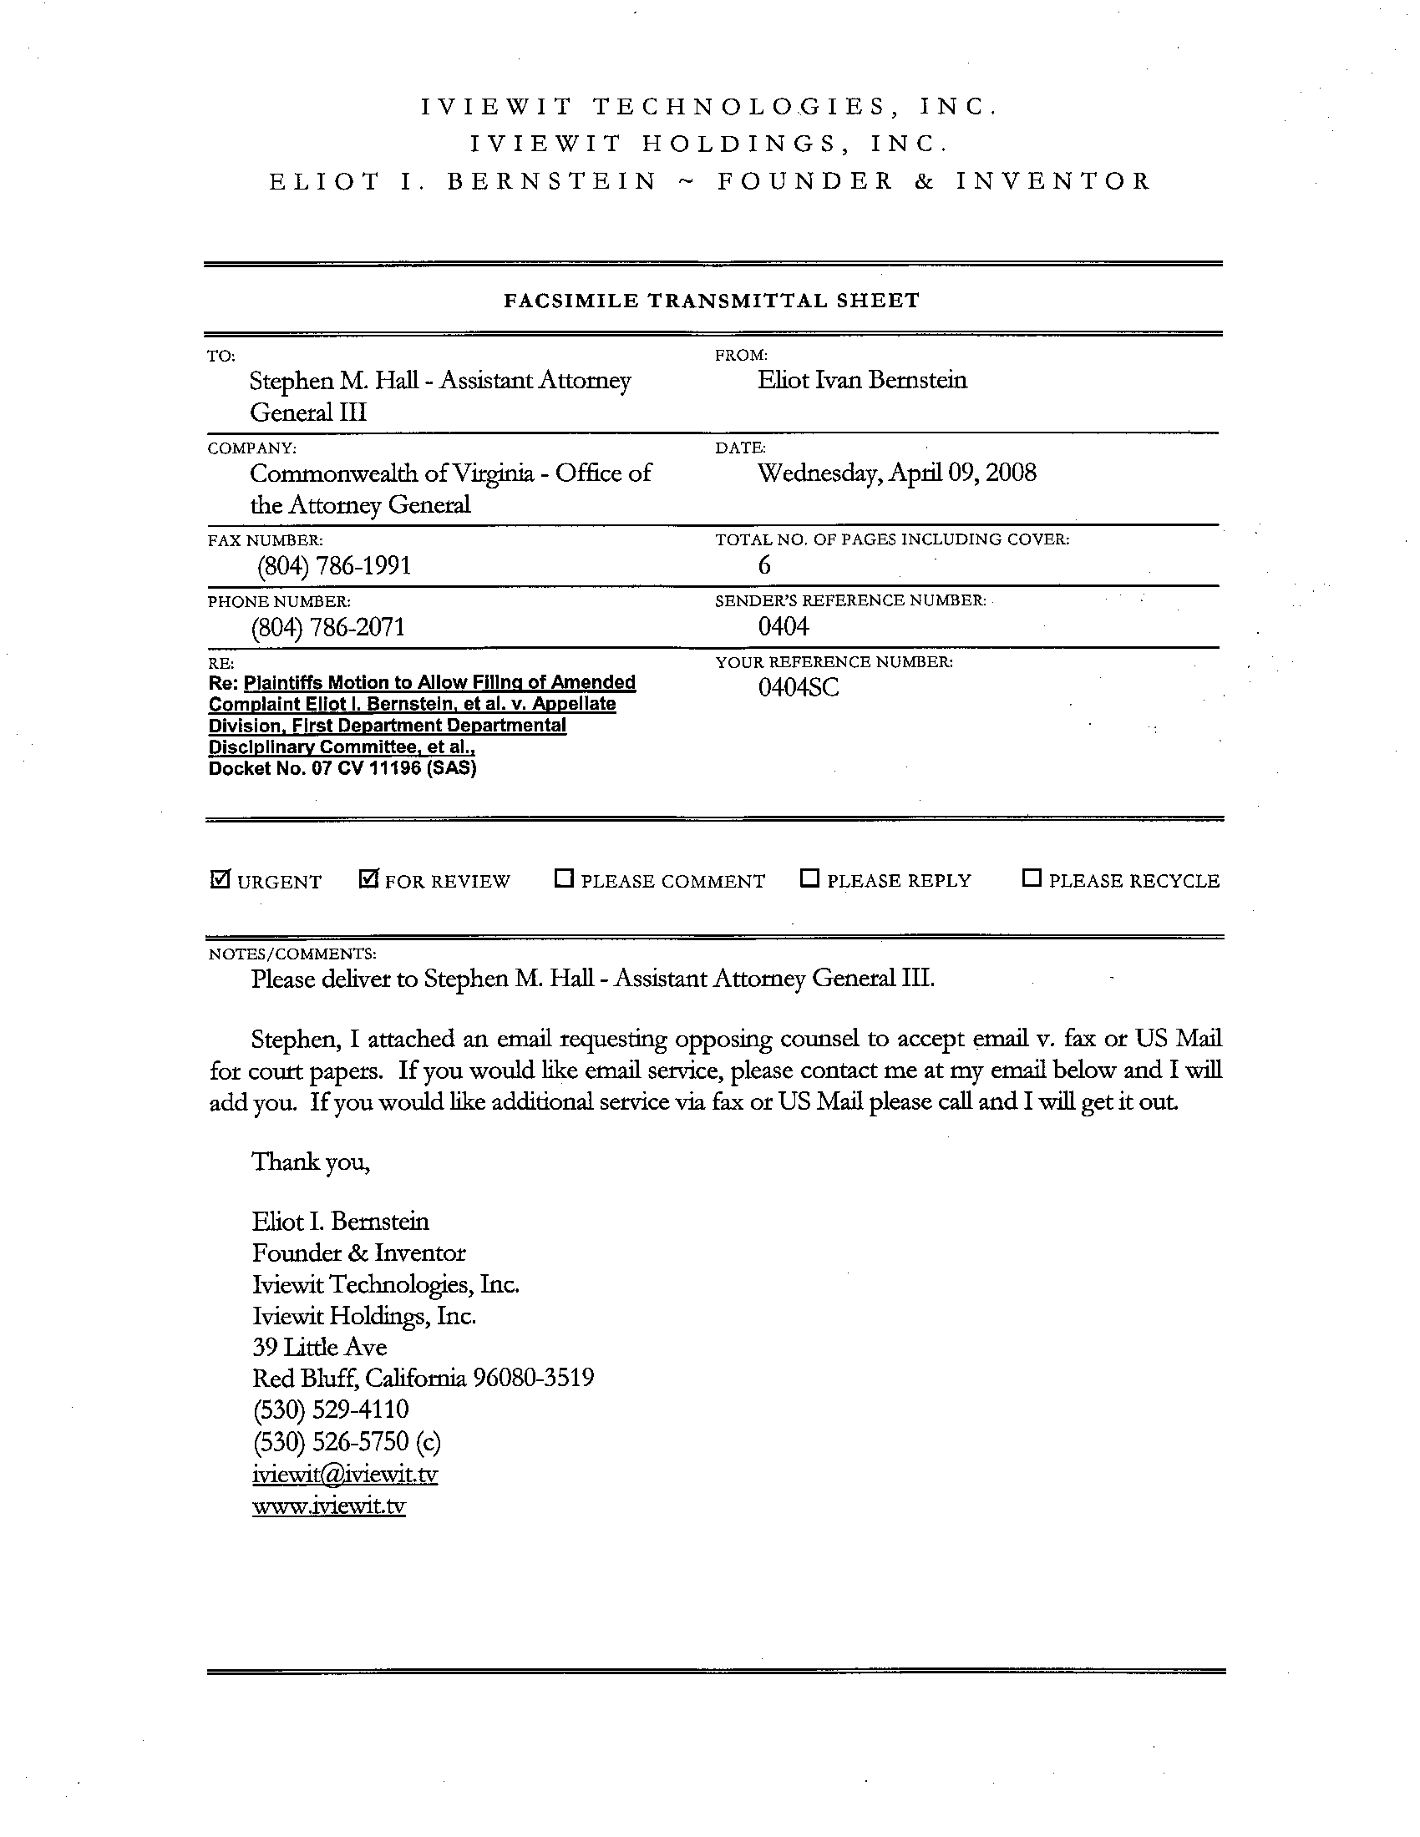
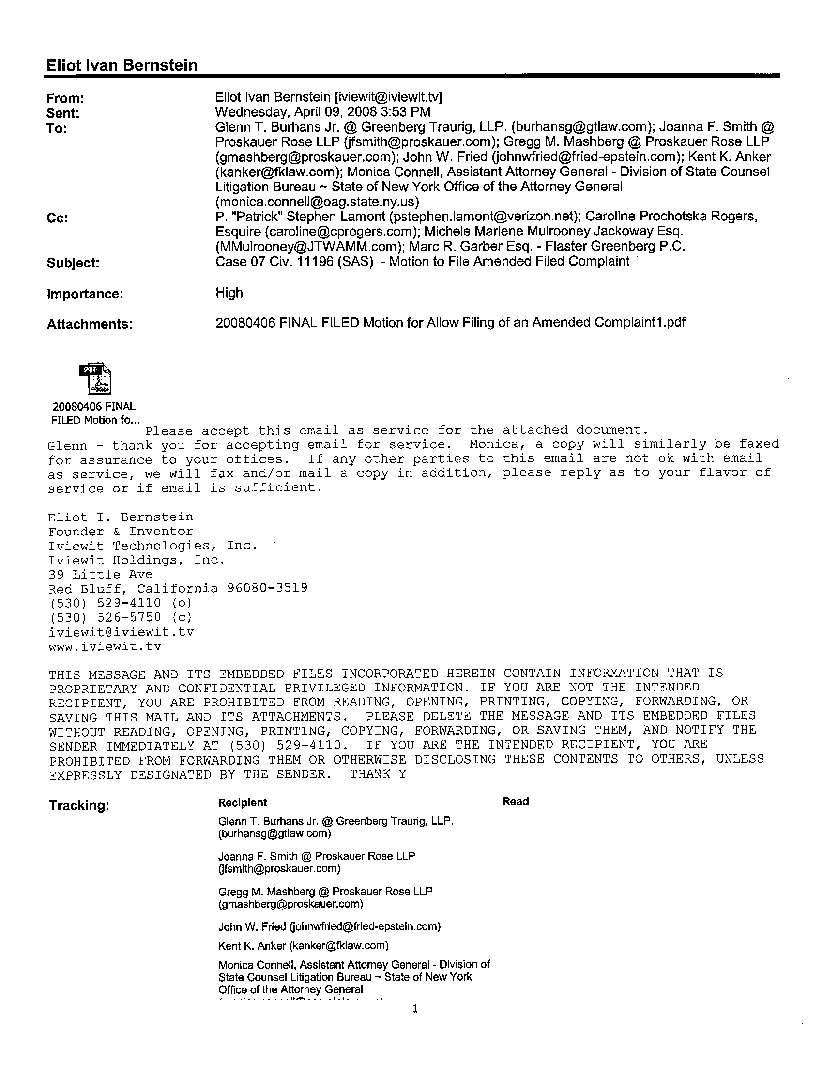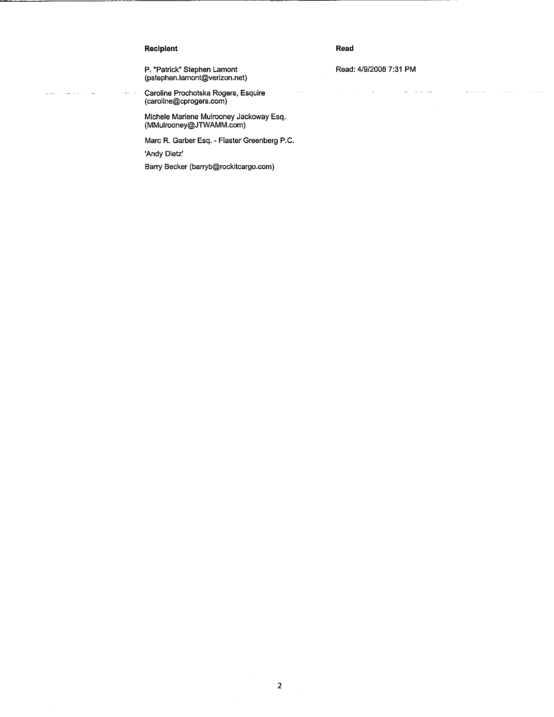

Again, thank you for your prompt reply in advance.

Cordially,
______________________
Eliot Ivan Bernstein
Pro Se Counsel

and

P. Stephen Lamont
Pro Se Counsel

cc: The Honorable United States District Court Judge Shira A. Scheindlin

Exhibit 1 – Letter regarding servicing of service papers

