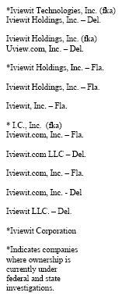

Eliot I. Bernstein

President, Founder & Inventor
Direct Dial: 561.364.4240

PRIVATE & CONFIDENTIAL

Wednesday, March 16, 2005 - 19:45:38

Re: Iviewit International Investigation

Dear Special Agent Lucchesi:

Attached is a letter from the patent office suspending the US patent for another six months, pending their review of the claims of fraud upon the United States Patent and Trademark Office (“USPTO”). I was advised by the European Patent Office (“EPO”) in trying to get similar actions instituted there, to notify the police of the crime of fraud against the EPO. I called Scotland Yard since the crime took place by London lawyers and they said since the EPO was in The Hague that I should report to them. The Hague said that the FBI should be contacting the authorities in Europe and the run around began. I am interested to know if you have any jurisdiction and I need to know because I need similar review and investigation in Europe, at the over twenty or so countries that the documents were falsely sworn to and altered there, to get the bad guys accounted for there and get my patents in suspension there before we lose permanent twenty year rights.

I have asked the Hague PD to send a letter of why they are not the agency to report fraud to, that occurred in the Hague by British lawyers against a company domiciled in The Hague. I will send over the copy when it is done. I know that you took the matter to the US Attorney a few months ago; I wonder if we have had any success that I can report to the shareholders.

As always, with best regards and thank you for your help,
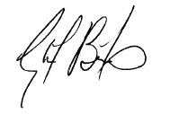
Eliot I. Bernstein
cc: Gerard Vonk – The Hague PD

